Cleckhuddersfax

E-Convenient Store

**Group 3**

***Team Members***

**Prasanna Shrestha**

**Sakriya Bajracharya**

**Sujan Pariyar**

**Swastika Adhikari**

**Utsav Sapkota**

***Table of contents***

|  |  |  |
| --- | --- | --- |
|  |  | Page |
| 1. Initiation Phase |  |  |
| 1.1 | **Project Charter** | 4 |
|  | Version Control | 4 |
|  | Project Justification | 4 |
|  | Project Scope | 5 |
|  | Project Assumption | 5 |
|  | Roles and Responsibilities | 6 |
| 1.2 | **Meeting Minutes** | 8 |
| 2. Planning Phase |  |  |
| 2.1 | **Belbin’s Analysis** | 11 |
|  | Team Belbin’s Analysis | 11 |
|  | Individual Belbin’s Analysis | 18 |

|  |  |  |
| --- | --- | --- |
| 2.2 | Skill Audit |  |
|  | Team Skill Audit | 20 |
|  | Individual Skill Audit | 21 |
| 2.3 | **Project Management (MS Project)** | 22 |
|  | Gantt Chart | 22 |
|  | Network Diagram | 23 |
|  | Timeline | 26 |
|  | Calendar | 26 |
|  | Resource Sheet | 26 |
|  | Project Task | 28 |
|  | Change Working Time | 29 |
| 2.4 | **Communication Tool Used** | 30 |
|  | Slack | 30 |
|  | GitHub | 63 |

|  |  |  |
| --- | --- | --- |
|  | Gmail | 64 |
|  | Trello | 65 |
| 3. Execution​ Phase |  |  |
| 3.1 | **Entity Relation Diagram** | 66 |
|  | EERD | 66 |
|  | ERD | 67 |
|  | Final Composite | 68 |
|  | Logical | 69 |
| 3.2 | **Use Case Diagram** | 70 |
|  | Overview Use Case Diagram | 70 |
|  | Trader Use Case Diagram | 71 |
|  | Admin Use Case Diagram | 72 |
|  | Customer Use Case Diagram | 73 |
| 3.3 | **Requirement Catalogue** | 74 |
|  | Function Requirement | 74 |
|  | Non-Functional Requirement | 79 |
| 3.4 | **Logo Design** | 80 |
| 3.5 | **Wireframes** | 81 |
| 3.6 | **Product Development** | 100 |
|  | Login Web Page | 100 |
|  | Register Web Page | 101 |
|  | Cart Web Page | 102 |

INITIATION PHASE

**Project Charter**

|  |
| --- |
| Project Title: *Cleckhuddersfax E-Convenient Store*  Project Sponsor: *The British College, Thapa thali, Kathmandu*  Project Manager: *Rohit Pandey Sir*  Team Leader: *Swastika Adhikari*  Date prepared: *2020-02-23*  Project Customer: *Citizens of Cleckhuddersfax* |

Version Control

|  |  |  |
| --- | --- | --- |
| Version | Date | Summary of changes |
| 1 | *2020-02-23* | *Initial project*  *All the vital things have been done for future scope.* |
|  |  |  |
|  |  |  |

Project Justification

|  |
| --- |
| *A group of traders or businesspersons of Cleckhuddersfax are intending to organize and build up an internet business site i.e. ecommerce website. The business website is being created to help and inspire local traders to compete against the larger supermarket and convenience stores. Their aim is to provide an advantage to the trader with a new emerging technology which appears to be useful for both trader and customer. They are planning to provide a great chance to customers to order and purchase things in a relatively brief period of time from the ease of their comfort zone. This ecommerce platform incorporates all five traders: butchers, greengrocer, fishmonger, bakery and delicatessen within the Cleckhuddersfax area in UK. This ecommerce platform provides an ideal space for all types of traders to show the best of their self on the internet to grab the attention of their target customers and beat the heated competition. This platform helps the local trader to grow as well as benefit the client in the certain area. The website helps to promote the local tradition of area as well as help the local traders to compete against the bigger business-like supermarket and stores without losing their valuable times for their family and friends. This website has three interfaces. One for customer, one for traders and one for management (admin).An admin login can access any of trader accounts. Every five trades have different login credentials which help them to access their database. Trader can also view every day report and update the details of their trader account. Trader will be provided with weekly finance report of all the orders that are delivered only. This website will have cart functionality where customer will get an option to add favourite products to cart. The payment method is a PayPal which is convenience and more secure way to pay online. The site will assist the customer to shop easily without worrying about running out of products. They don’t need to physically move around and waste valuable time to buy one specific product. This ecommerce website provides convenience to buy goods or services without causing any physical restrictions to the costumers and even helps to save money as well as precious time.* |

Project Scope

|  |
| --- |
| *Objectives*   * *Attract local people who cannot shop during a normal opening hour to order and purchase things in a brief period of time.* * *Help the local traders to compete against the bigger business without losing their family time.* * *Promote the local tradition of area.* * *Introduce the customers to high quality limited as well as unique products and fresh goods.* * *Expand trade by adding more traders within a group.* * *Three days a week to collect the products ordered.* * *Provide a wonderful opportunity to customers to browse and buy products from the ease of the comfort zone.* * *Eliminate the travel time and cost for customers.* * *Create simple user interface to understand by all types of user, trader and accessible through web interface and most popular browsers.* |
| *Customer Interface*   1. *Select the products from 5 traders in the initial phase.* 2. *Sort the products by shop or by product type.* 3. *Capture the heritage of the Cleckhuddersfax area.* 4. *Interface viewable on all major browsers and will be compatible in both mobile and desktop view.* 5. *A cart function that can hold the products from all the traders.* 6. *Registration system in order to place an order.* 7. *Login system in order to access their basket/cart by customers.* 8. *Review and update customer account details.* 9. *Confirm the changes made in customer registration and account update through the emails that they used for registration.* 10. *Pick up the orders in three slots in three different days i.e. 10-13, 13-16, 16-19 in the days Wednesday, Thursday and Friday.* 11. *Place the orders 24 hours before the desired pickup time and day.* 12. *PayPal function for the payment.*   *Trader Interface*   1. *Manage product and information.* 2. *Able to add, delete and update product through trader account. When a Trader adds a product, the product will have a Unique ID, Short Name, Description, Item Price, Min Order, Max Order, Allergy Information which must be added by the Trader.* 3. *Login the Database using trader account that shows the reports of the available stock and report of orders.* 4. *Unique login Credentials of every trader which shows their details only.* 5. *Admin login that can access the whole system.*   *Management Interface*   1. *Dashboard that has a range of daily and periodic reports.* 2. *Daily report on the orders placed that contain the products and quantities which has been ordered and also shows which delivery slots are used.* 3. *Weekly finance report which shows the number of products that is sold along with the payment for the last 7 days which will only include the orders that have been delivered.* 4. *Access all of the traders accounts.* 5. *Monthly report of the product sales which can be sorted alphabetically; total numbers of orders per products or total income per product* |
| *Major Deliverables*   1. *E-Commerce website with customer, trader and management interface.* 2. *Management interface connected with database.* 3. *Registration system to place an order by customer.* 4. *Single basket to add products from different traders.* 5. *Login system to access the cart.* 6. *Website supporting a maximum of ten shops for initial pilot project.* 7. *Traders’ interface that allows add/delete/update products on their corresponding shops.* 8. *Responsive design viewable on mobile as well as desktop devices and viewable on the most popular browsers.* 9. *User-friendly navigation of products by shop or product type for customers.* 10. *An admin login for management interface that can access any of the trader accounts.* 11. *A maximum of 20 orders per slot for 3 collection slots 10:00-13:00, 13:00-16:00, 16:00-19:00 on Wednesdays, Thursdays and Fridays which must be at least 24 hours after placing the order.* 12. *PayPal is used for online payment which is secure.* |

Duration

|  |
| --- |
| *Initial prototype Presentation - 2020-03-24*  *Deployment for testing - 2020-05-02* |

Estimated Budget

|  |
| --- |
| *Hours per day per person: 3 – 4 hours*  *Hours per week per person: 18 – 24 hours*  *Team of 5 members*  *Hence the total hours till 12th week: 18*5*12 = 1080 hours max: 24* 5* 12 = 1440 hours* |

Roles and Responsibilities

|  |  |
| --- | --- |
| Name | Role |
| *Prasanna Shrestha* | *Resource Investigator/ Shaper / Team Worker* |
| *Sakriya Bajracharya* | *Complete Finisher / Specialist / Co-ordinator* |
| *Sujan Pariyar* | *Monitor Evaluator / Co-ordinator/ Shaper* |
| *Swastika Adhikari* | *Implementer / Resource Investigator / Specialist* |
| *Utsav Sapkota* | *Plant / Team Worker / Monitor Evaluator* |

Communication and Collaboration Tools

|  |
| --- |
| * *Communication - As a team we will be communicating using slack. The workplace of slack allows us to organize communications and share information, files and more all in one place. It also has most powerful feature i.e. integration with third party services. The integration we will use to share our files with our team members is GitHub. Using GitHub, it is easier to collaborate with team members so we will be using it as a repository.* * *Team Meetings - Face-to-face meeting with team members will be held twice a week i.e. every Monday and Thursday at 8:40 am. Face-to-face meetings allow for clearer communication and often end up being more positive and more credible than online conversations.* * *Documentation - A shared One Drive space will be used to store all the documentations generated on the project.* * *Project Tracking – Trello will be used to track the progress of the project.* |

# Meeting Minutes



**Location:**

The British College, Kathmandu

**Cleckhuddersfax E-Convenient Store**

# AGENDAS, DECISIONS AND ISSUES

# 

|  |  |  |  |  |  |  |
| --- | --- | --- | --- | --- | --- | --- |
| Duration | Topic / Discussion | Date | Facilitator | Status | Time | Meeting Type |
| 50 Min | Review of needed Items and Resources, Project Charter Discussion | 18/02/2000 | The British College | Complete | 11:30 AM – 12:20 PM | Information Sharing |

# ATTENDEES

# Prasanna Shrestha, Sakriya Bajracharya, Sujan Pariyar, Swastika Adhikari, Utsav Sapkota

Introductions were made at the first meeting, required materials and software provided by our project manager Sir Rohit Raj Pandey was noted and shared in the meeting, followed by a discussion of Project charter, in which the scope of project, project brief and means of communication were discussed. As means of communication, Slack and Trello were approved unanimously.

|  |  |  |  |  |  |  |
| --- | --- | --- | --- | --- | --- | --- |
| Duration | Topic / Discussion | Date | Facilitator | Status | Time | Meeting Type |
| 1 Hr. | Team Contract, Belbin Analysis, Skill Audit Analysis, Next Meeting Purpose and Agendas | 24/02/2020 | The British College | Complete | 11:30 AM – 12:30 PM | Information Sharing  Decision Making |

# ATTENDEES

# Prasanna Shrestha, Sakriya Bajracharya, Sujan Pariyar, Swastika Adhikari, Utsav Sapkota

After the first effective meeting, the team scheduled next meeting on Trello in a week for Belbin Analysis. The team sat together in the conference hall facilitated by The British College and started discussion. After quickly finishing up with individual Skills Audit, out team figuratively graded themselves which was reviewed by each other in the team. A final cumulative grade of the team was then listed, and Team Skills Audit was complete. Discussions were made for the team contract and Belbin analysis. For the team contract, leaderships structure, decisions making policy, and different strategies required for the completion of the project were discussed. Meeting day, time and location was finalized according to the decision of all members. Out of the discussion, individuals from the team noted their primary, secondary and least likely roles accordingly. Though some changes were made, the primary roles stayed unchanged as per the meeting. After discussion was complete, team sat for a cup of tea and decided on next meeting purpose and agenda.

|  |  |  |  |  |  |  |
| --- | --- | --- | --- | --- | --- | --- |
| Duration | Topic / Discussion | Date | Facilitator | Status | Time | Meeting Type |
| 3 Hr. | Discussion on ERD, Functional Requirements, Non-Functional Requirements and Use Case Diagrams | 02/03/2020 | The British College | Complete | 11:30 AM – 02:30 PM | Status Update  Problem Solving |

# ATTENDEES

# Prasanna Shrestha, Sakriya Bajracharya, Sujan Pariyar, Swastika Adhikari, Utsav Sapkota

The agenda of this meeting was slightly different than the rest. Our project manager sir had issued an execution phase in design where Use Case diagrams and Entity Relationship Diagrams were to be made. After quickly finishing up with functional and non-functional requirements discussions, our team rushed to study room at college premise to start and help each other in making Entity Relationship Diagram of the project. After finishing a trial design of ERD, we visited our supervisor Sir Rohit Raj Pandey who eventually was free and in spite of his busy schedule, he dedicated his precious time to help and provide us with wonderful new ideas and variations that could come up. We got new insights as to what could be added and removed from our initial design. We edited our Entity Relationship Diagrams according to the feedback of our Project Manager and started working to make EERD and final Composite. Likewise, we also discussed shortly on the design of use case diagrams. The final design was once again reviewed by the team before final submitting was done.

|  |  |  |  |  |  |  |
| --- | --- | --- | --- | --- | --- | --- |
| Duration | Topic/ Discussion | Date | Facilitator | Status | Time | Meeting Type |
| 2 Hr. | Discussion on Wireframes, Logo, Templates and MS Project | 12/03/2020 | The British College | Complete | 8:40 AM – 10:40 AM | Information Sharing |

# ATTENDEES

# Prasanna Shrestha, Sakriya Bajracharya, Sujan Pariyar, Swastika Adhikari, Utsav Sapkota

After a tedious yet fruitful meeting, our team sat down together for template sampling, logo designing and wireframing. Everyone opinion and ideas were considered to make a logo design for the project. The team locked down to a common template and started on building wireframe by gaining ideas from the template. As brilliant might it sound, template sampling wasn’t the only challenge. We had to study its compatibility, responsive designs, license and many more factors that could impact our entire project. Our team has discussed and decided to include an added wireframe for invoice, cart, login and signup functionalities along with CRUD for customer and trader interface and search features in template. Meanwhile in the meeting, the team has decided to push its efforts in wireframing and MS Project.

PLANNING PHASE

tEAM BELBIN’s ANALYSIS

|  |  |  |
| --- | --- | --- |
| Version:1.0 **Belbin’s Analysis**Date reviewed:02/27/2020 | | |
| Primary role | Prasanna Shrestha | Resource Investigator |
| Sakriya Bajracharya | Complete Finisher |
| Sujan Pariyar | Monitor Evaluator |
| Swastika Adhikari | Implementer |
| Utsav Sapkota | Plant |
| Secondary role | Prasanna Shrestha | Team Worker |
| Sakriya Bajracharya | Specialist |
| Sujan Pariyar | Co-Ordinator |
| Swastika Adhikari | Resource Investigator |
| Utsav Sapkota | Team Worker |
| Least likely role | Prasanna Shrestha | Shaper |
| Sakriya Bajracharya | Co-Ordinator |
| Sujan Pariyar | Shaper |
| Swastika Adhikari | Specialist |
| Utsav Sapkota | Monitor Evaluator |
| Do you think the descriptions of these roles are an accurate description of your behaviour in teams? How do you see yourself differently? | Prasanna Shrestha | I have been working on the office environment for 2 years. I can motivate my team and can handle the pressure. Moreover, I’m a good listener and idealistic which will be plus point for my team. |
| Sakriya Bajracharya | Yes, I do think that the description of these roles is an accurate description of my behaviour in teams, as I have the keen eye to complete the things that I have started and I always want to become better in the task that I am assigned to. |
| Sujan Pariyar | Yes, I do think these roles are an accurate description of my behavior in team because in team we have to do the complex decision making for the success of the team project and I see myself confident and capable of making such decisions. |
| Swastika Adhikari | Yes, I am constantly anxious to investigate new thoughts. I generally work aiming to change the plans and thoughts formed in my mind into actions. I like the things to be done in a deliberate and composed manner. I work planning to be finished on schedule. Similarly, I am curious to investigate accessible options and ready to work as much possible to help the team accomplish its objective. I have a solid curious sense and an availability to see the conceivable outcomes in anything new. |
| Utsav Sapkota | Yes, I can reflect back on my actions on past projects and with fairly enough confidence, I can proclaim my roles as plant and team worker as primary and secondary roles respectively. I am quite creative in solving problems in unconventional ways and can put new ideas on desk, I am also a resourceful person and a free-thinker who also happens to think outside the box without letting mind wander away from project. |
| Are there roles identified by Belbin that you might like to develop in yourself more? Which ones and why? | Prasanna Shrestha | Yes, the role of co-ordinator is the one which I would like to develop on because by developing these skills I would be more confident of my talent and work for the goal conveniently. |
| Sakriya Bajracharya | Yes, I would like to develop more of co-ordinating things as I my mind is more spread out and I am not able to focus on a single task very persistently. |
| Sujan Pariyar | Everyone has something to learn and Yes, there are some role that I would like to develop in myself and among them complete finisher is that role because It becomes little mess at the end of the task. |
| Swastika Adhikari | Yes, I want to develop thought-oriented role i.e. Plant because I generally wish to become imaginative and solve the difficulties and issues faced by the group. I would like to be exceptionally innovative and great at taking care of issues in unpredictable manners. Likewise, I like to build up my ability for complex and strategic planning. I also intend to produce potentially remunerating ideas. |
| Utsav Sapkota | Yes, there are two roles I would like to groom myself to perform better in. It is Monitor Evaluator, my least likely role which I wish to develop so that I can have impartial judgement, deliver critical analysis and can provide a logical eye to the team. Along with it, I also wish to develop in me a Team Worker role so that I can surround myself with team members and communicate for conflict resolution, omit out misinterpretations to maintain effective communication within the team which helps the team to achieve a targeted goal easily without much hurdles in an allocated timeframe. |
| What possible situations in the coming months can you identify where you could work on developing these skills? | Prasanna Shrestha | Sometimes team member could feel hard to solve errors, gets demotivated then I would find a good way to solve the problems and motivate my team. |
| Sakriya Bajracharya | Possible situation when I might be able to work on developing these skills are when I have to become the team leader as the leader in our group is changed biweekly and I have to take on leadership role to further enhance my skills. |
| Sujan Pariyar | I think delay of the project and difficulties for error handling can be seen in coming months and for that we have decided for biweekly team meeting and timely informing the team member along with asking them for the assistance if needed. |
| Swastika Adhikari | The situations when any member of my team cannot solve the problems and challenges during the project I think I could motivate myself in order to solve the issues and build up my skill. |
| Utsav Sapkota | One of the possible situations could be on the presenting days of the final project. I shall be more confident on my part of the presentation. I would also put in extra effort on project planning and project monitoring phases in coming days. |
| Considering your team working, how do you think you could improve your effectiveness in group work and in contributing to the success of teams that you work in? | Prasanna Shrestha | According to my roles mentioned on the previous table, I am a good motivator, designer, can easily get involved with new people for research and exploration. I always do my best to solve the problems which would be effective to get success of my team. |
| Sakriya Bajracharya | I think that I can push my teammates harder so that they are able to complete the tasks that are assigned to them in said time. I want to help them by bringing in more creative ideas. I will also help them in tasks that they are stuck in if help is required. |
| Sujan Pariyar | By communicating with the team and instant informing about the problems raised will improve my effectiveness in group work. |
| Swastika Adhikari | I think I could improve the effectiveness in my group by transforming thoughts and ideas built in my team into plans and manageable projects and making sure all the things are done. I favour difficult work and handle issues in a deliberate manner. I will systematically set the tasks that need to be worked on. I focus on recognizing and working for the group. |
| Utsav Sapkota | I could use innovative ideas other than to just follow the bandwagon and help the team in any way possible. I could also improve my communication skills to confront opposition parties in team. As stated earlier, I could maintain effective communication within the team which would eventually help the team to achieve a targeted goal easily without much hurdles in an allocated timeframe. |
| Are the results of this inventory consistent with how you worked in the Foundation Project in your small groups for discussions and presentations? | Prasanna Shrestha | Yes it is consistent. It will be great knowledge for the real life project scenario. I think after working on this foundation project I will be more confident, handle pressure and good coordinator too. |
| Sakriya Bajracharya | Yes, so far, the results of this inventory is consistent with how I have worked in the foundation of the project but I feel that I can improve even more so that the group can benefit even more by removing any hiccups that are encountered during the project. |
| Sujan Pariyar | Yes, somehow the results of this inventory are consistent with our work in the project but there is some lag which we will sort as soon as possible and achieve are goal and make our project a success. |
| Swastika Adhikari | Yes, the results of this inventory are consistent. In the event that I feel inconsistent during the project I will be motivating myself and finishing my task in an appropriate manner to reach at the target of the project. |
| Utsav Sapkota | Yes, so far it has been consistent but there is always a place for improvement. We will eliminate our inconsistencies and by far, overcome our personality traits and preconceived notions to stick to our roles and goals in project. |
| How well did you contribute to group presentations? | Prasanna Shrestha | I will contribute my 100 percent for the group presentation according to requirement. |
| Sakriya Bajracharya | I want to contribute fully by being dedicated in the project, making sure that all resources are utilized and the full potential of my team members are utilized. |
| Sujan Pariyar | I want to give the best out of me in the group presentation. I will provide the requisites and will be confident, punctual, well-dressed during the group presentations. |
| Swastika Adhikari | I want to contribute my best with as much efforts as possible. I want to develop team mentality and play a positive role. I will be active in communicating, creating thoughts and settling on the choices and plan for the group presentations. |
| Utsav Sapkota | I am fully dedicated to present our team project with variety of resources, proper attire, proper response to questionnaires and confidence. |

INDIVIDUAL BELBIN’s ANALYSIS

|  |  |  |
| --- | --- | --- |
| Version:1.0 **Belbin’s Analysis** Date reviewed: 2020-02-27 | | |
| Primary role | Swastika Adhikari | Implementer |
| Secondary role | Swastika Adhikari | Resource Investigator |
| Least likely role | Swastika Adhikari | Specialist |

**Name: Swastika Adhikari**

|  |  |  |
| --- | --- | --- |
| Do you think the descriptions of these roles are an accurate description of your behaviour in teams? How do you see yourself differently? |  | Yes, I am constantly anxious to investigate new thoughts. I generally work aiming to change the plans and thoughts formed in my mind into actions. I like the things to be done in a deliberate and composed manner. I work planning to be finished on schedule. Similarly, I am curious to investigate accessible options and ready to work as much possible to help the team accomplish its objective. I have a solid curious sense and an availability to see the conceivable outcomes in anything new. |
| Are there roles identified by Belbin that you might like to develop in yourself more? Which ones and why? |  | Yes, I want to develop thought-oriented role i.e. Plant because I generally wish to become imaginative and solve the difficulties and issues faced by the group. I would like to be exceptionally innovative and great at taking care of issues in unpredictable manners. Likewise, I like to build up my ability for complex and strategic planning. I also intend to produce potentially remunerating ideas. |
| What possible situations in the coming months can you identify where you could work on developing these skills? |  | The situations when any member of my team cannot solve the problems and challenges during the project, I think I could motivate myself in order to solve the issues and build up my skill. |
| Considering your team working, how do you think you could improve your effectiveness in group work and in contributing to the success of teams that you work in? |  | I think I could improve the effectiveness in my group by transforming thoughts and ideas built in my team into plans and manageable projects and making sure all the things are done. I favour difficult work and handle issues in a deliberate manner. I will systematically set the tasks that need to be worked on. I focus on recognizing and working for the group. |
| Are the results of this inventory consistent with how you worked in the Foundation Project in your small groups for discussions and presentations? |  | Yes, the results of this inventory are consistent. In the event that I feel inconsistent during the project I will be motivating myself and finishing my task in an appropriate manner to reach at the target of the project. |
| How well do you want to contribute to group presentations? |  | I want to contribute my best with as much efforts as possible. I want to develop team mentality and play a positive role. I will be active in communicating, creating thoughts and settling on the choices and plan for the group presentations. |

SKILL AUDIT

TEAM SKILL AUDIT

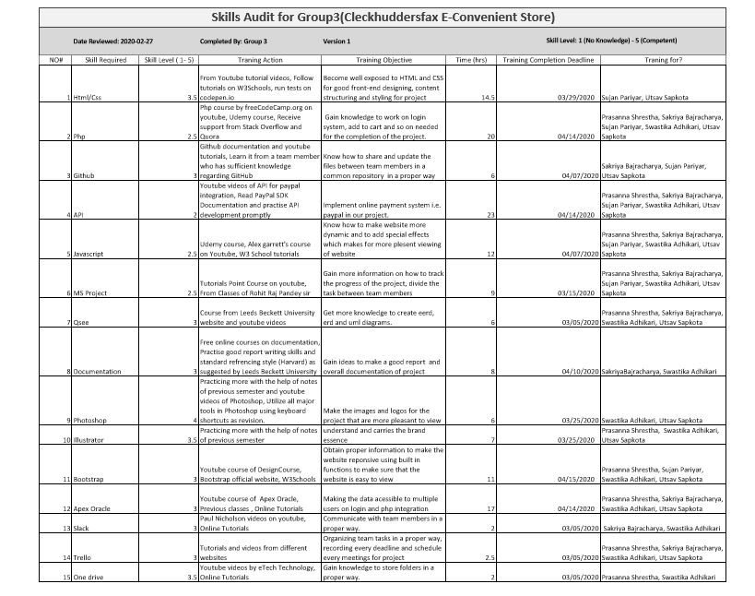

INDIVIDUAL SKILL AUDIT

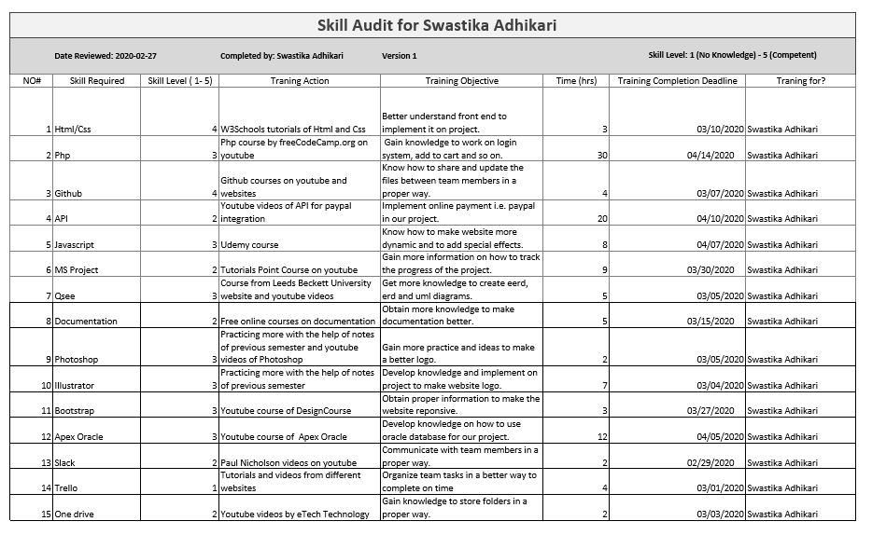

MS PROJECT

GANTT CHART







NETWORK DIAGRAM

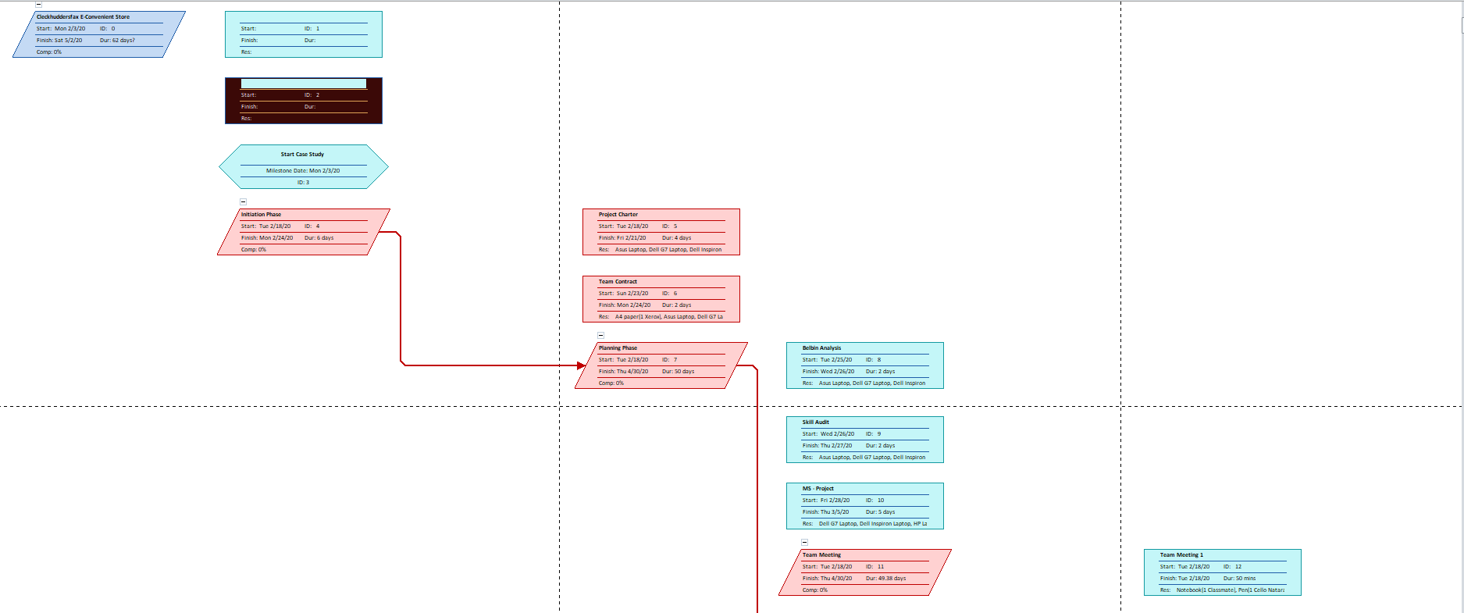

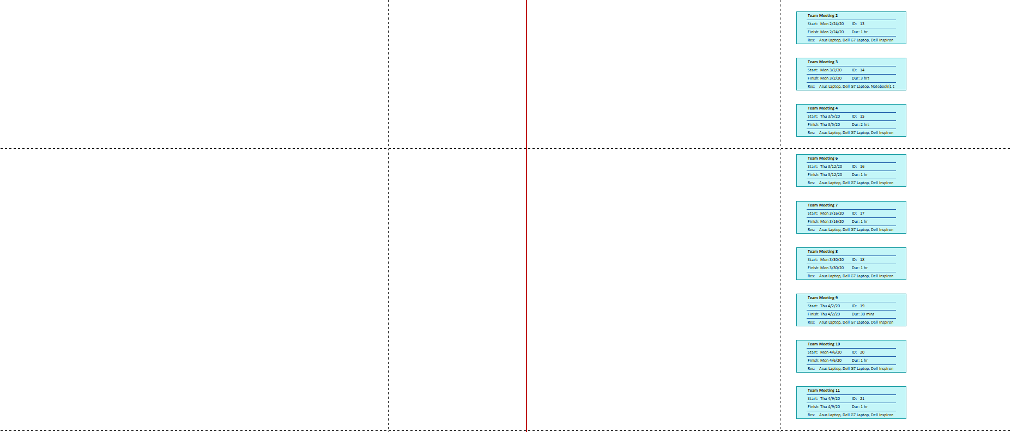

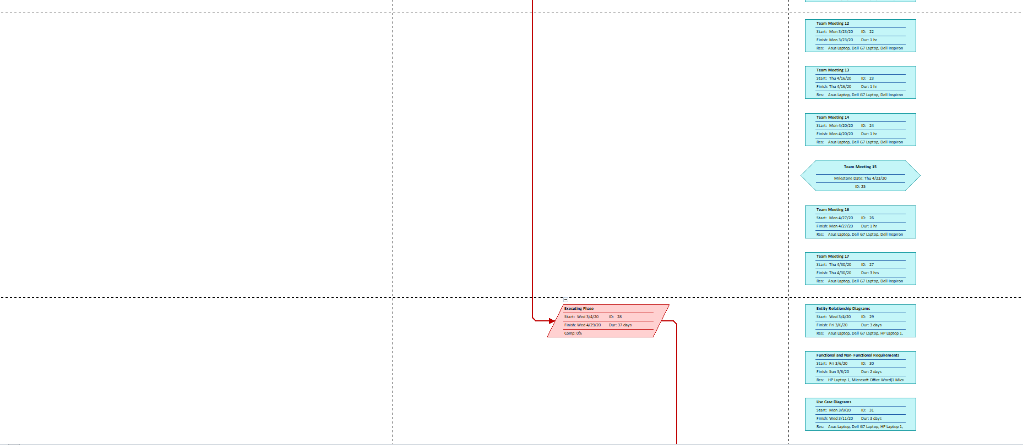

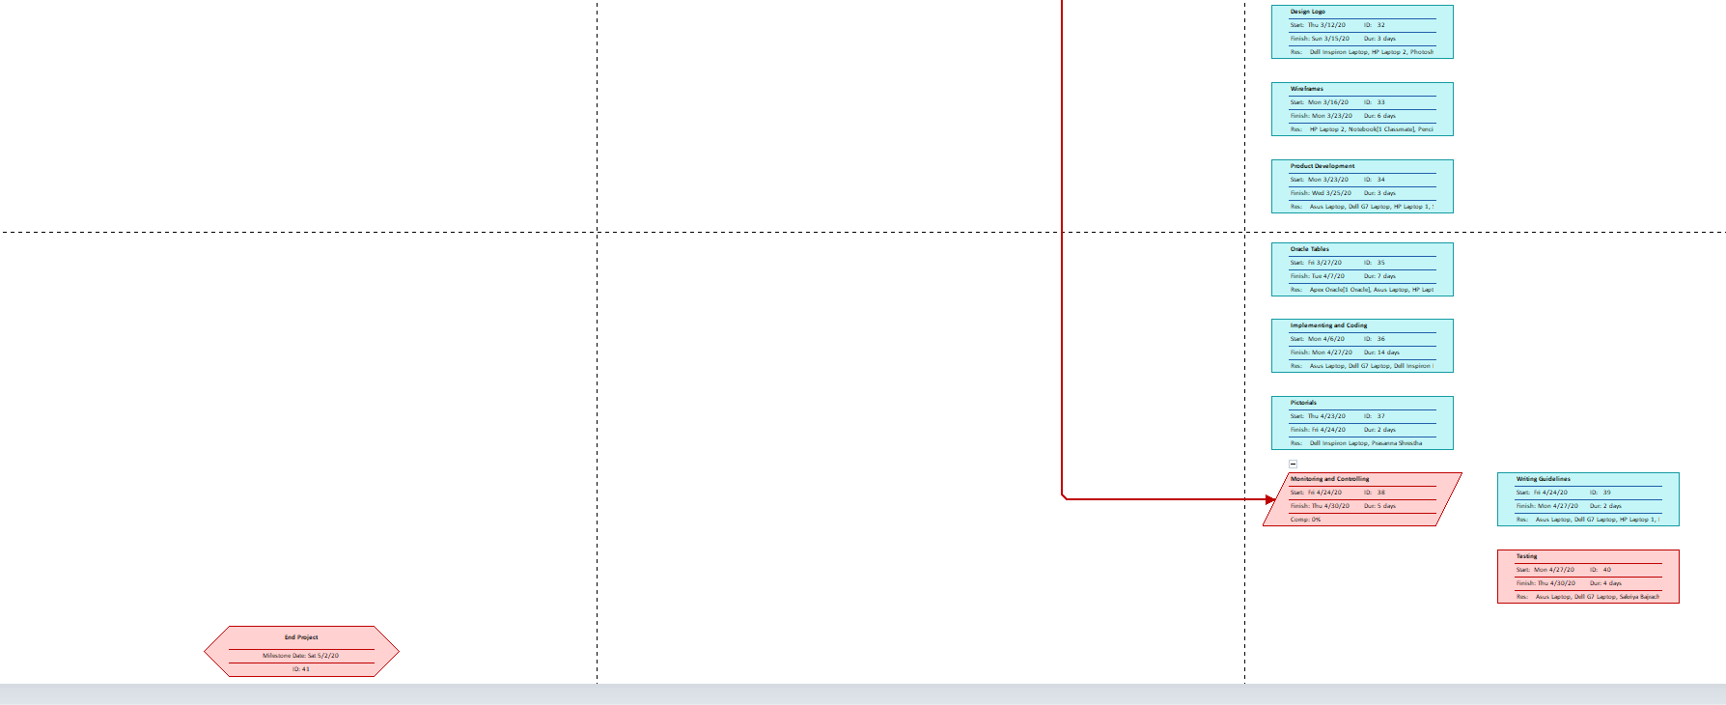

TIMELINE

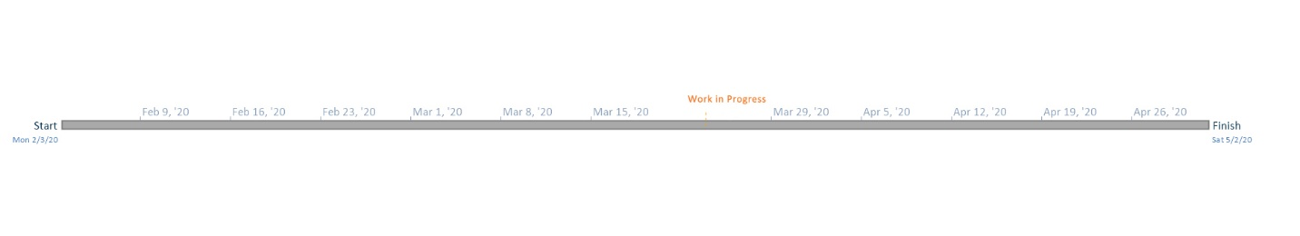

CALENDAR 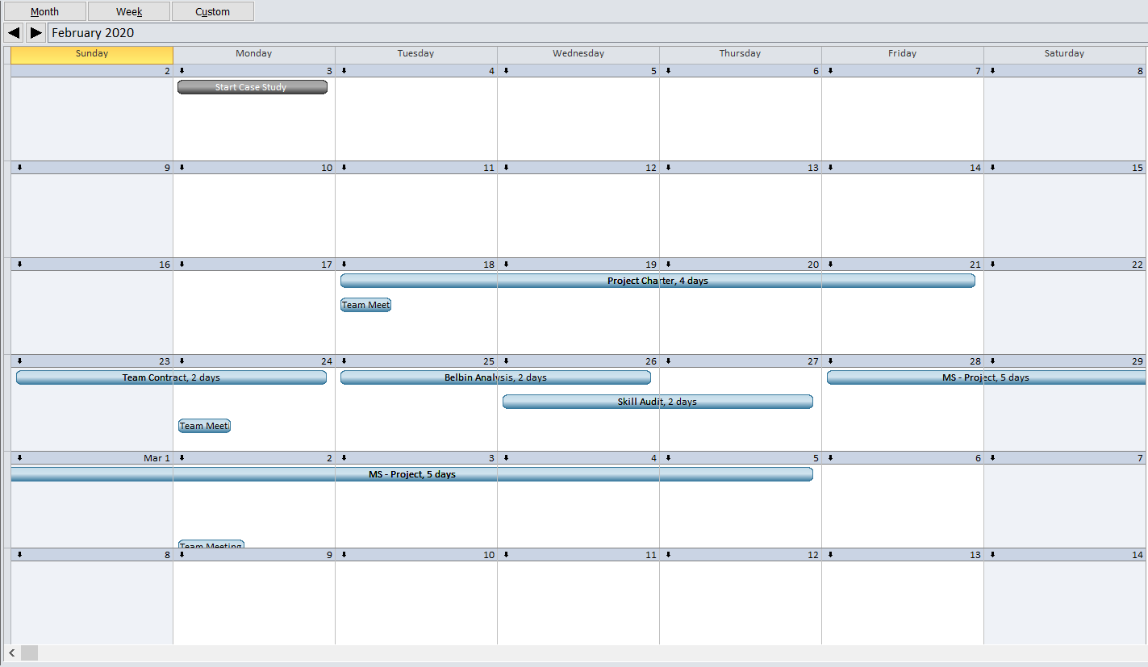

RESOURCE SHEET





PROJECT TASK





CHANGE WORKING TIME

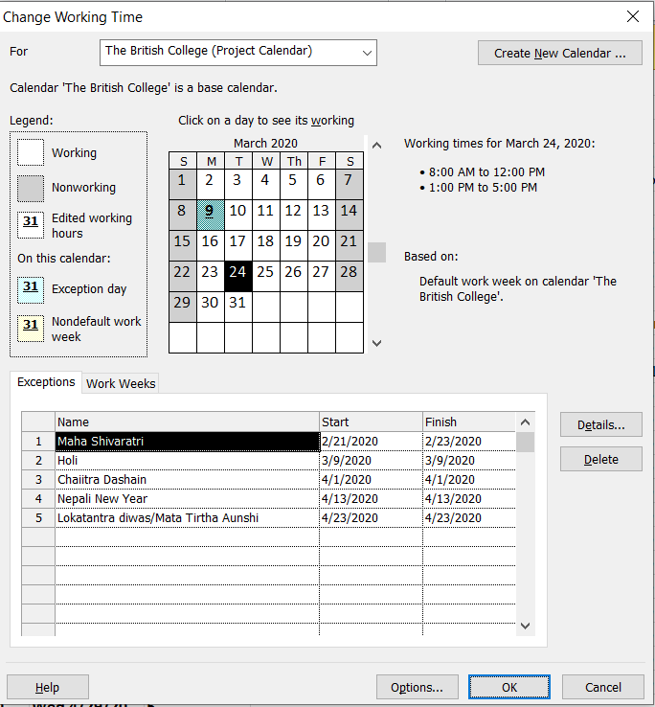

COMMUNICATION TOOL USED

SLACK

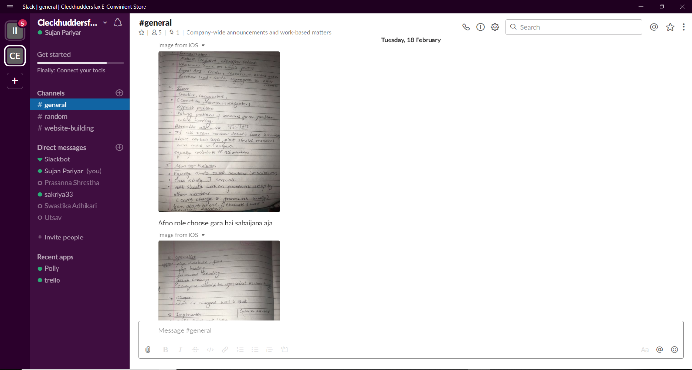

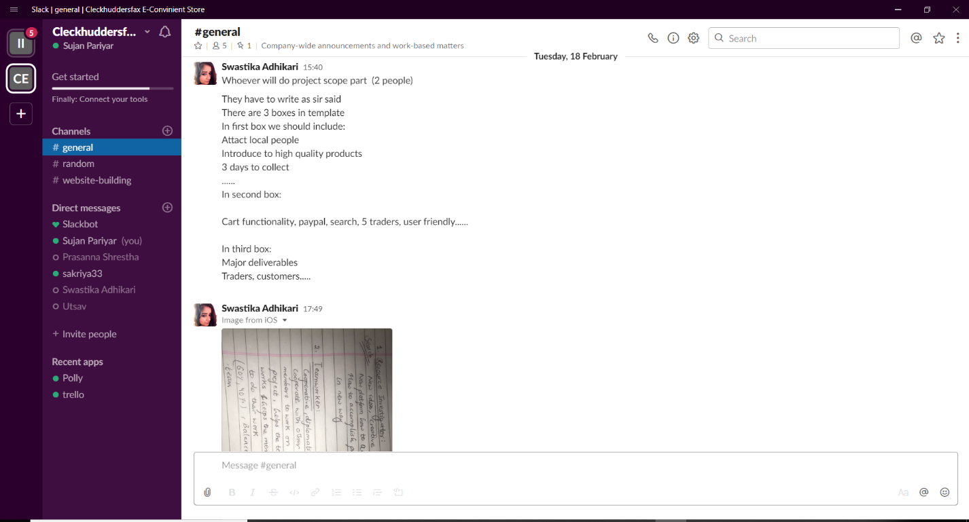



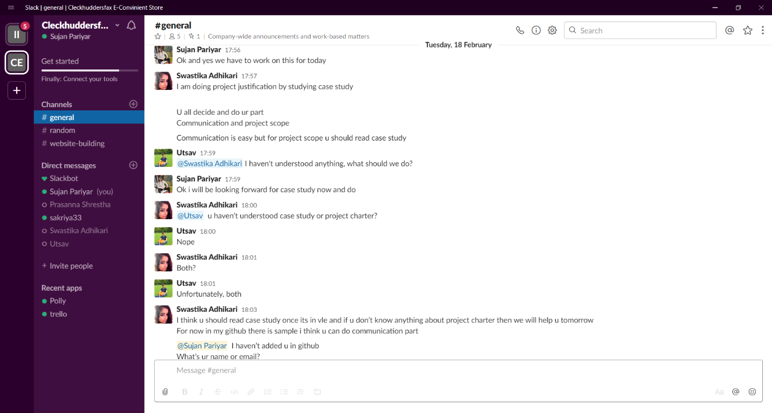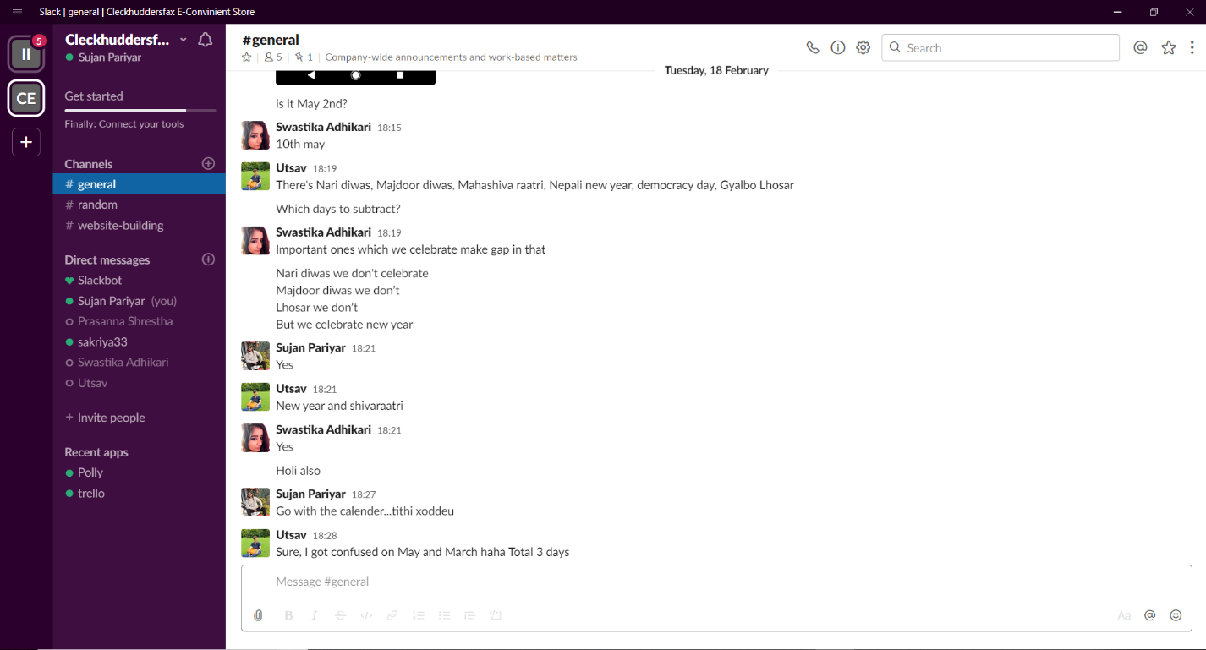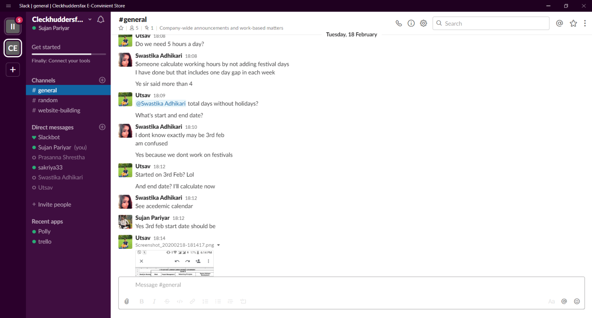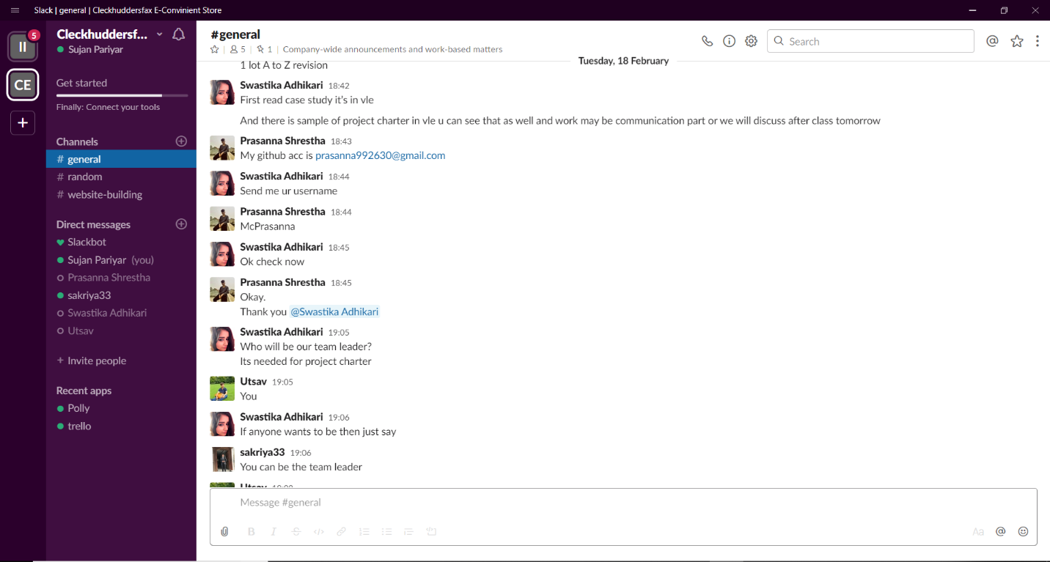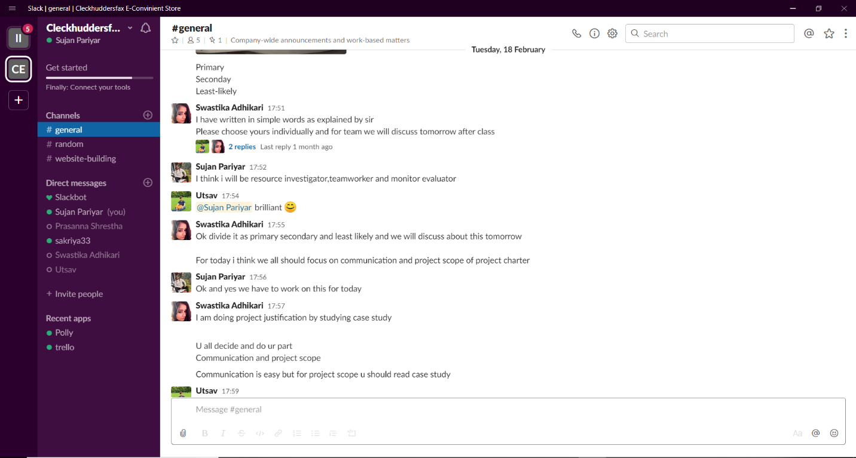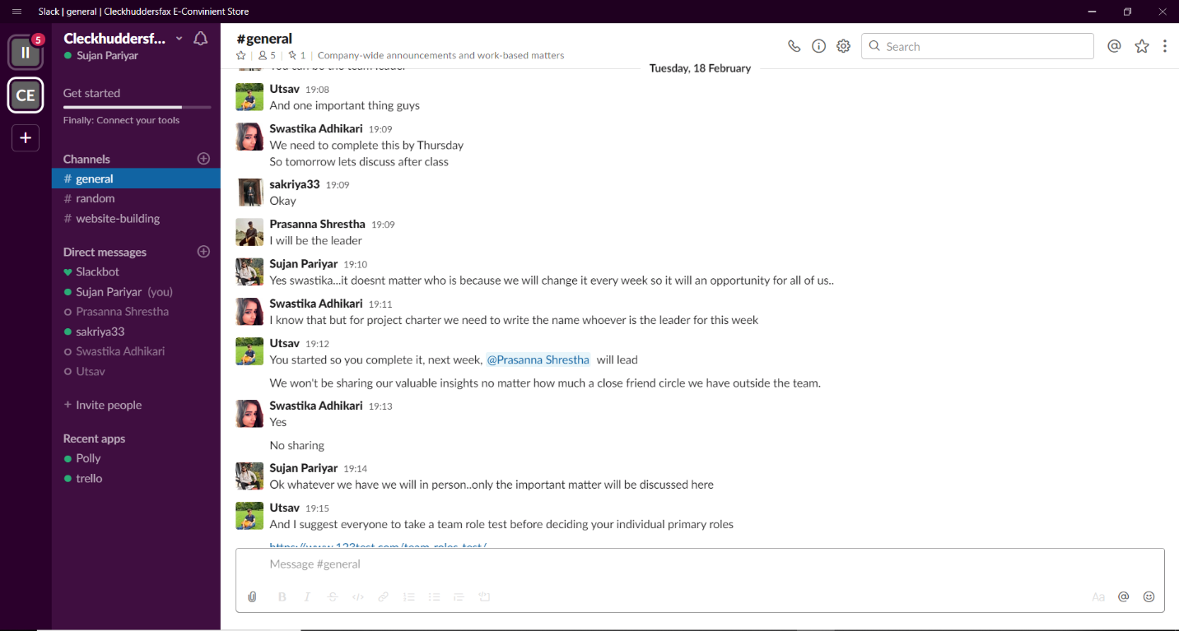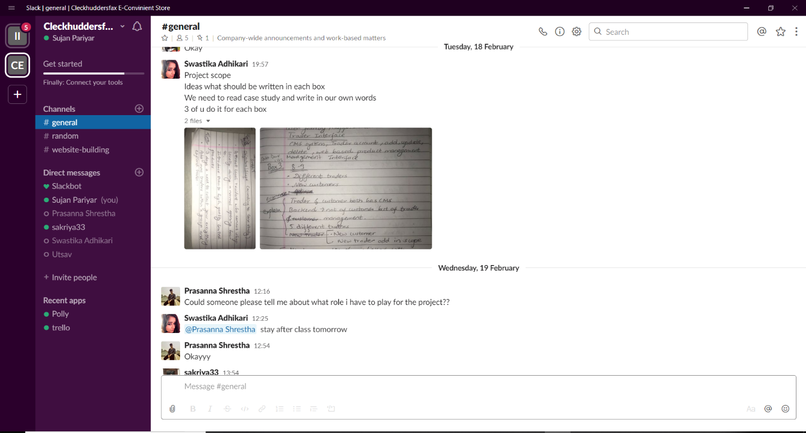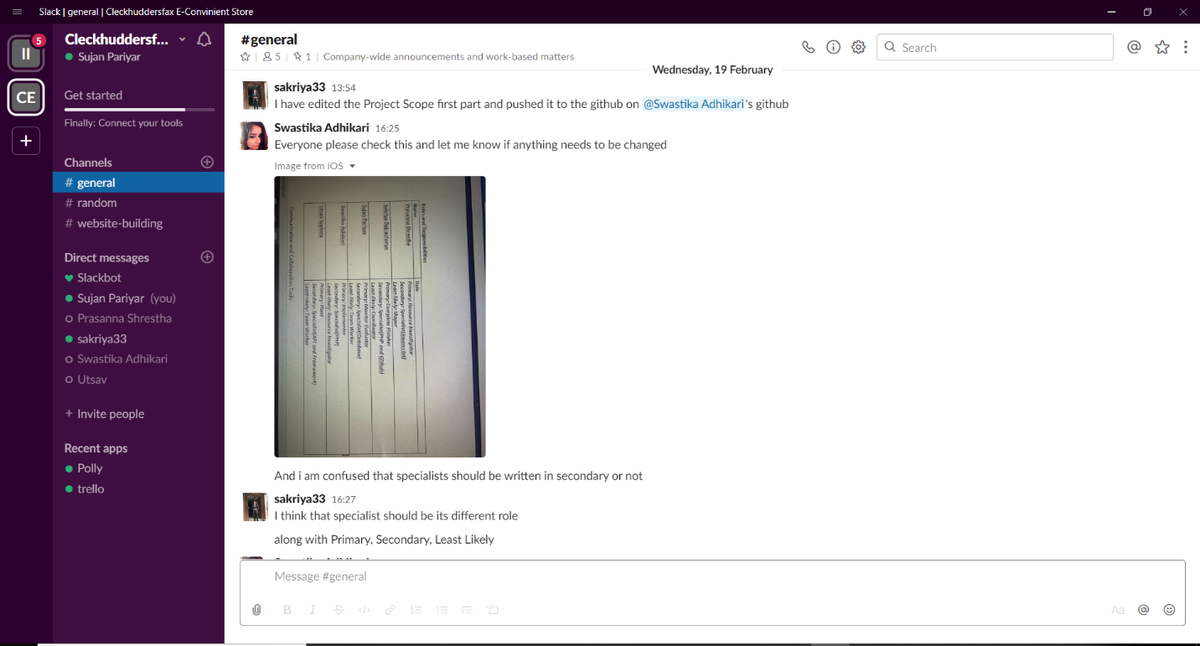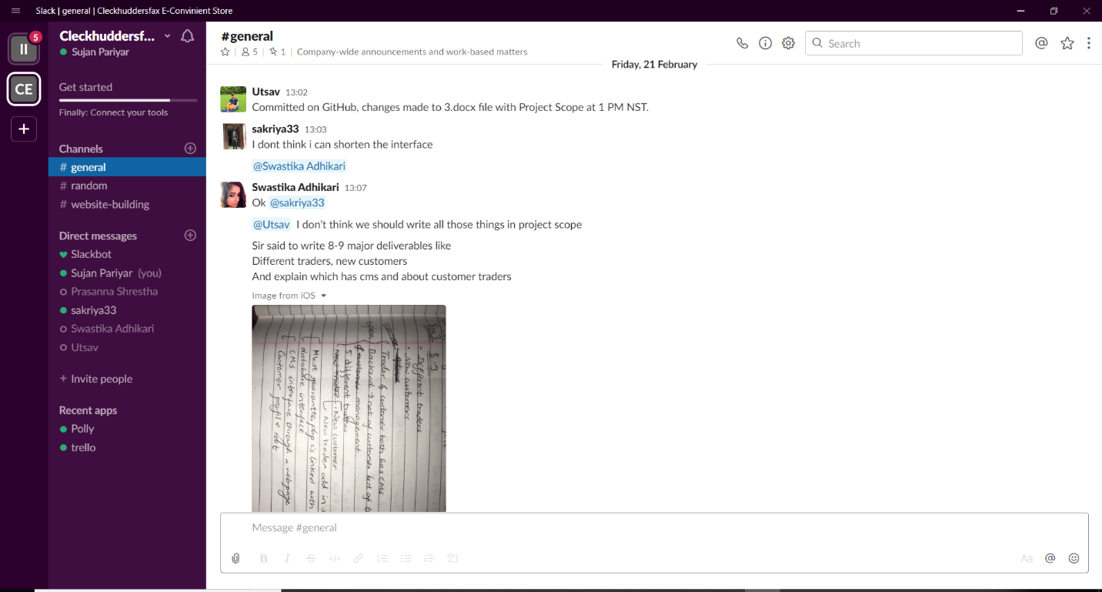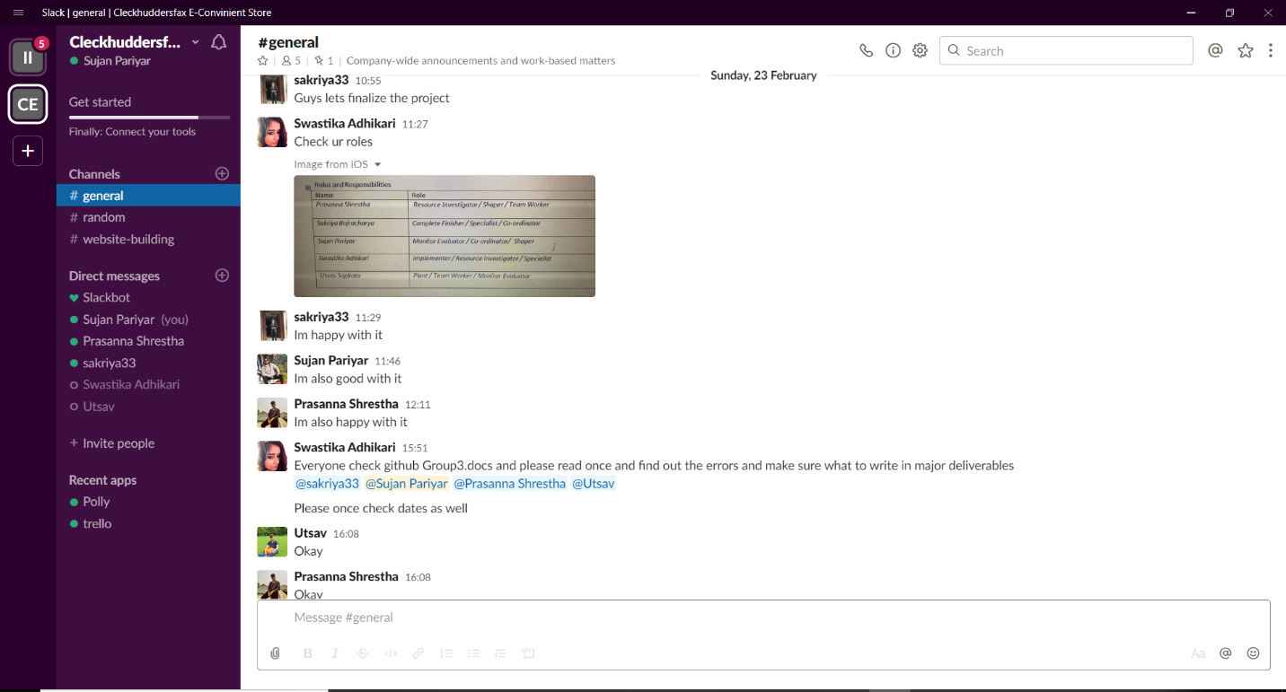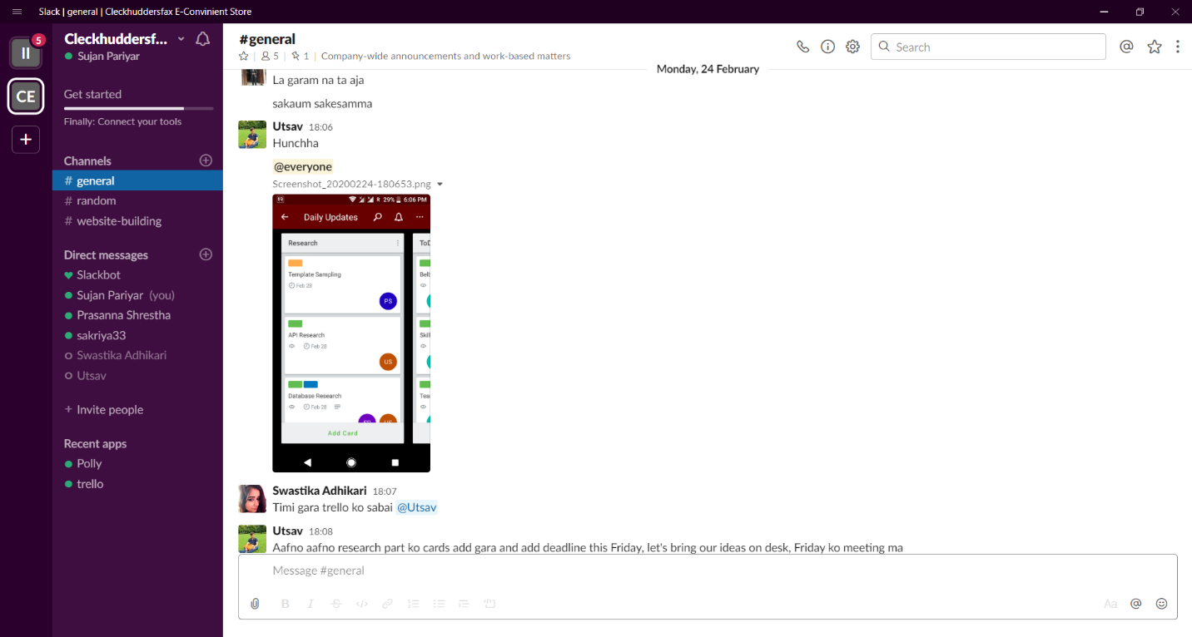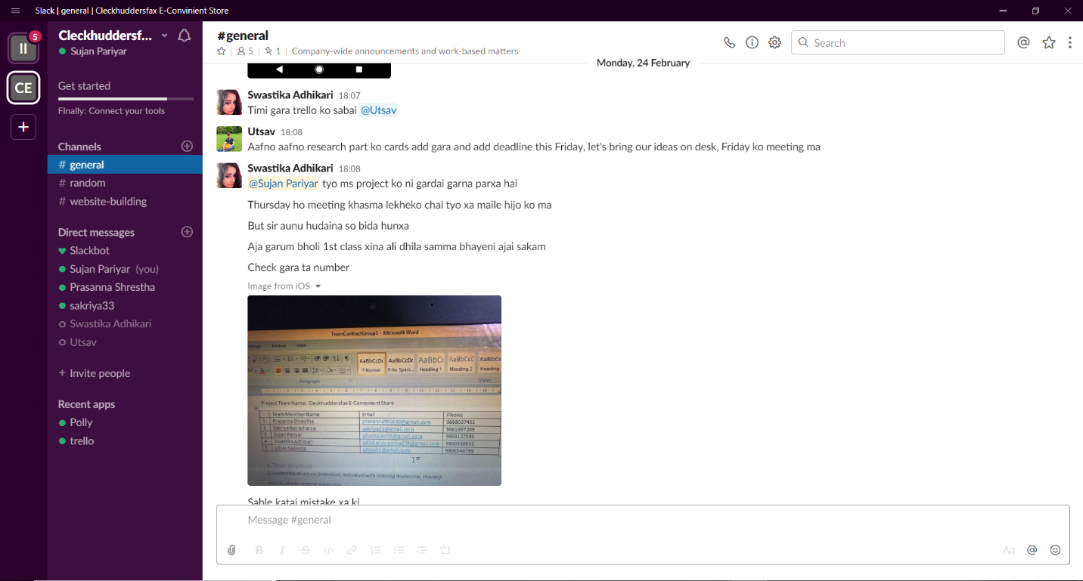

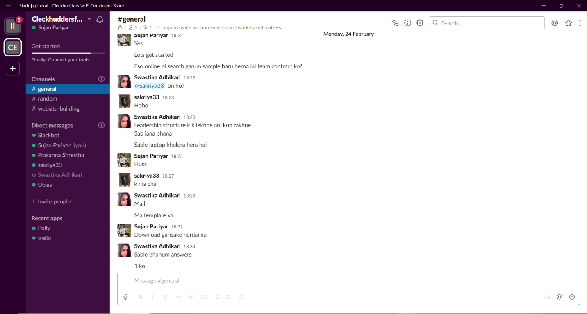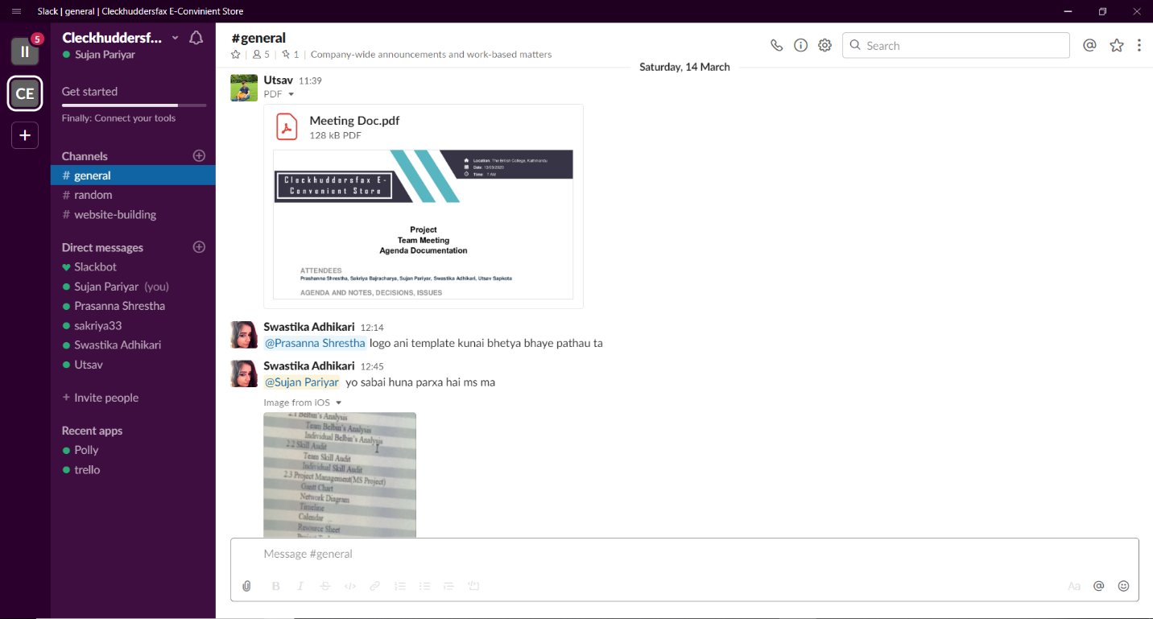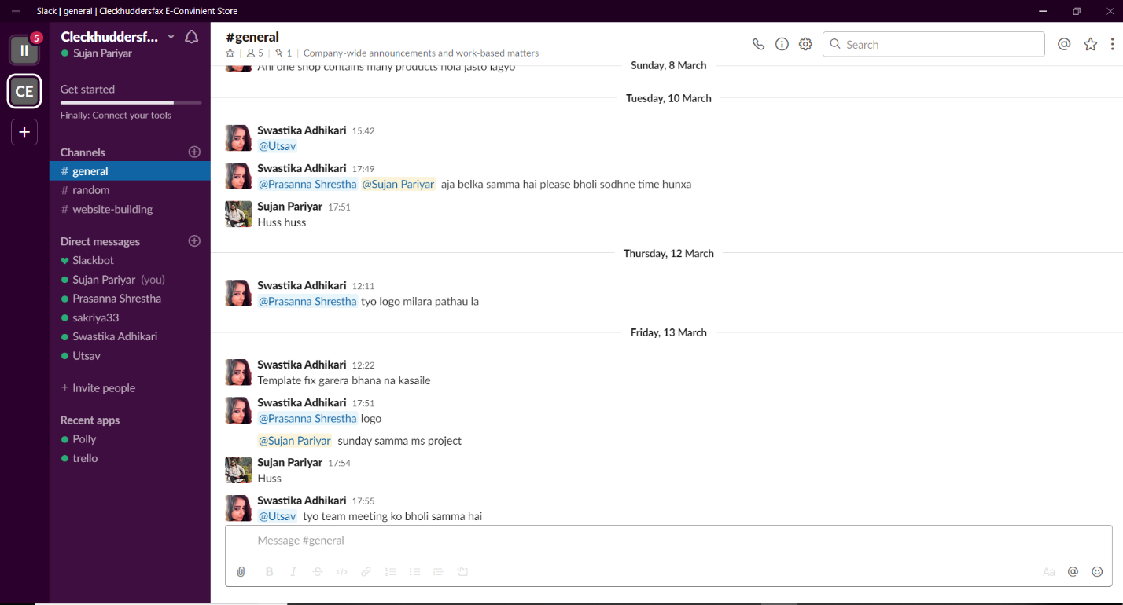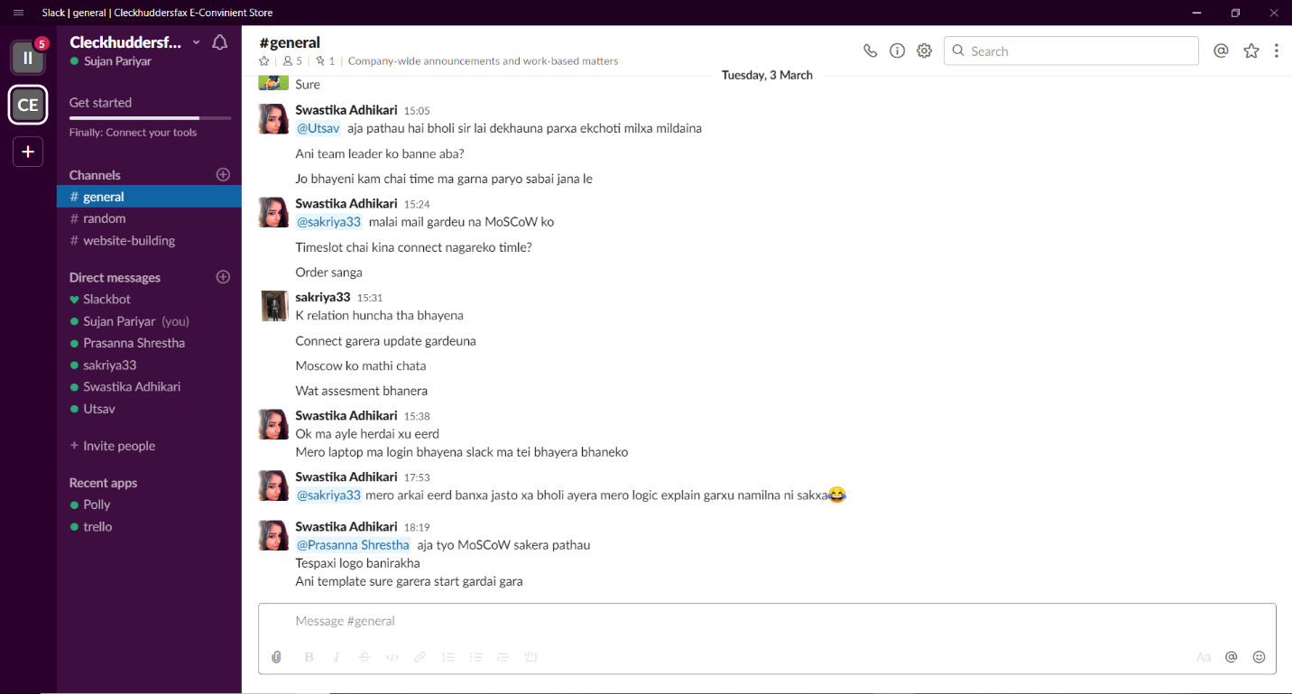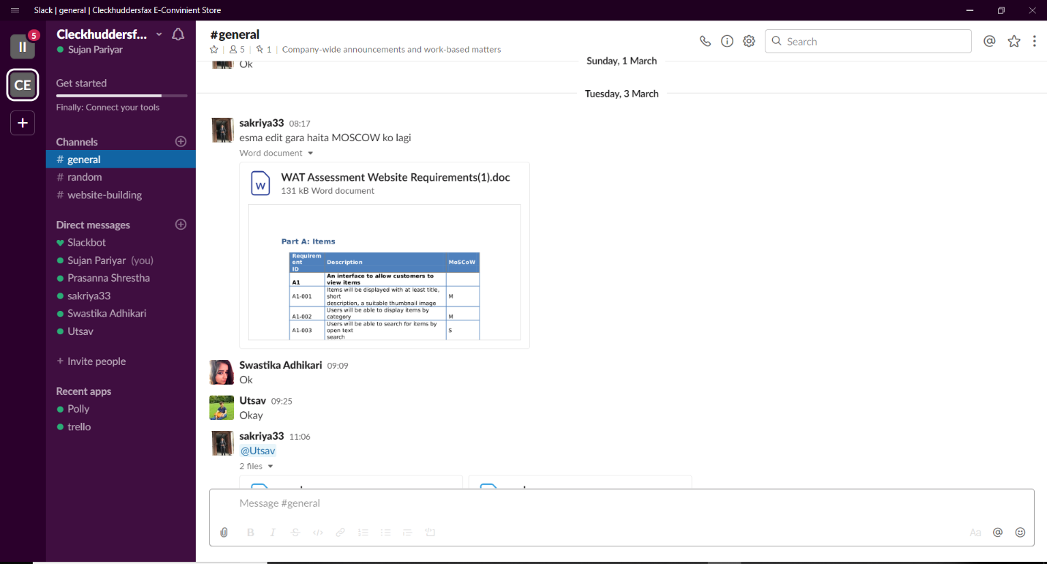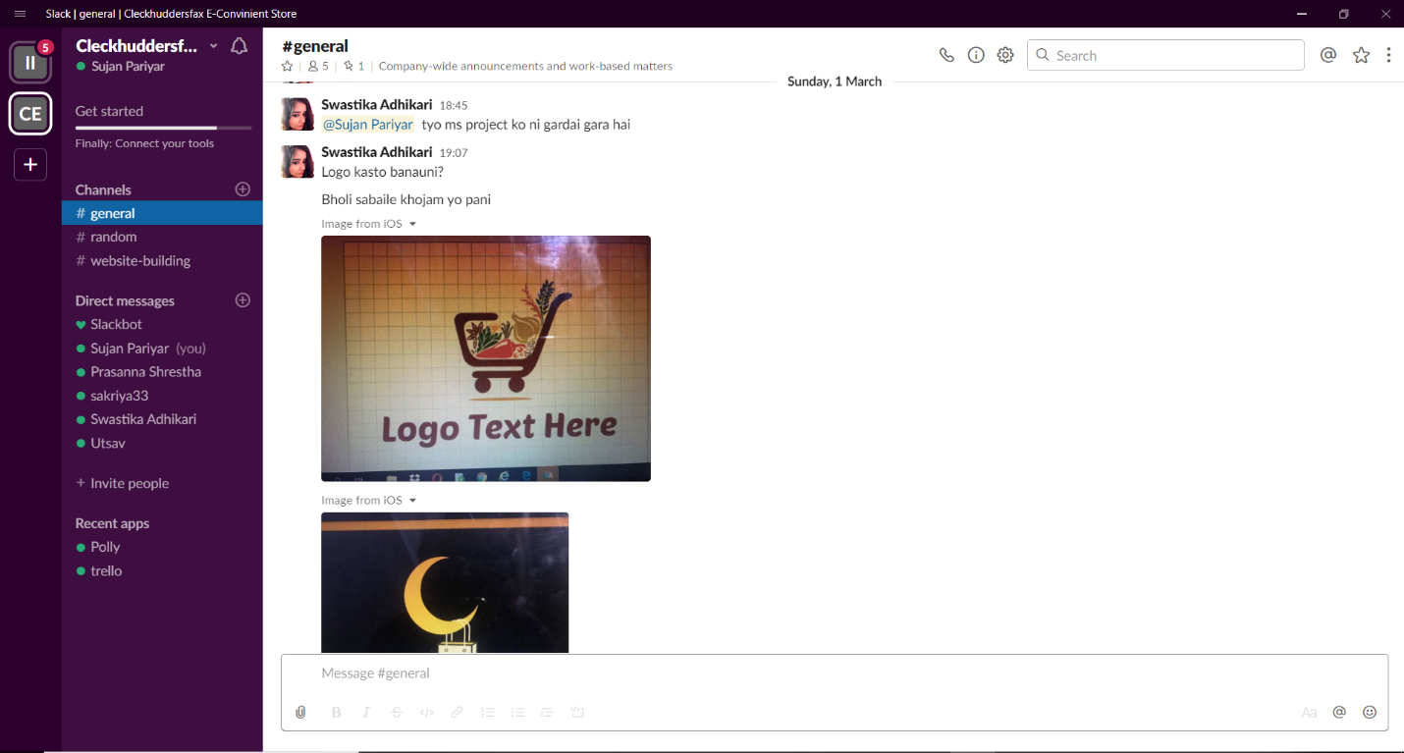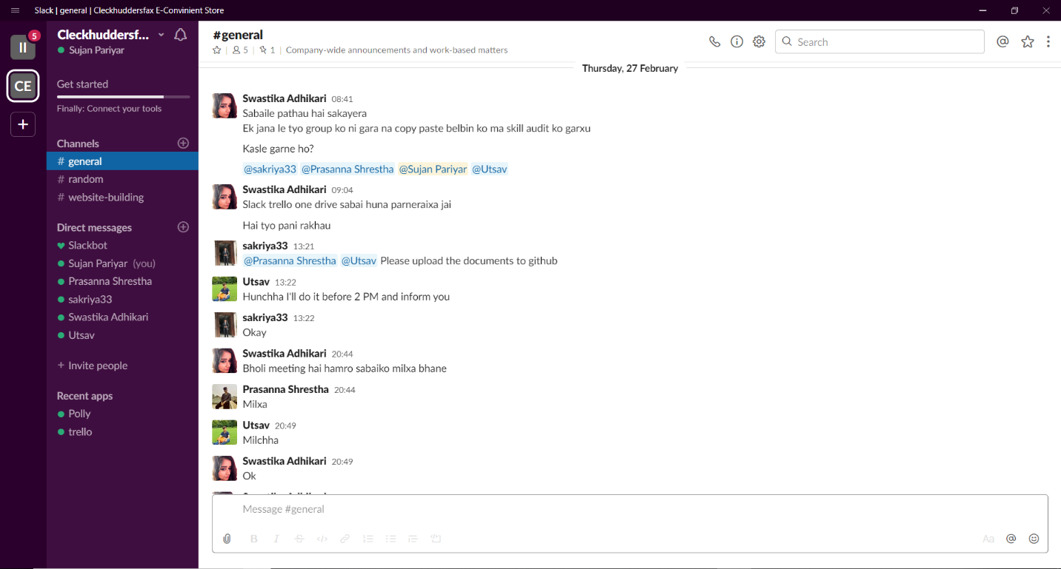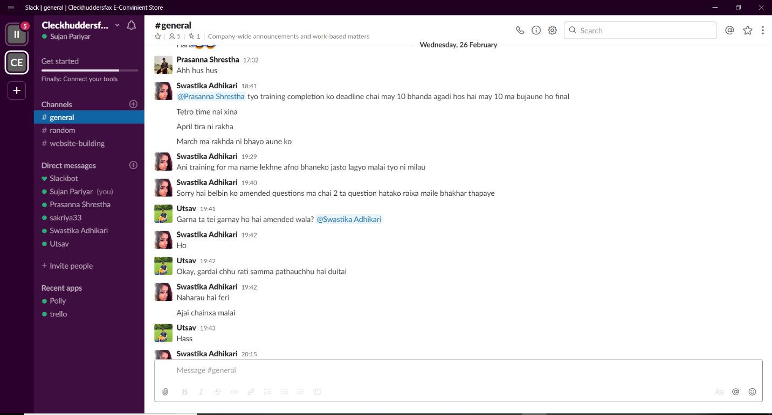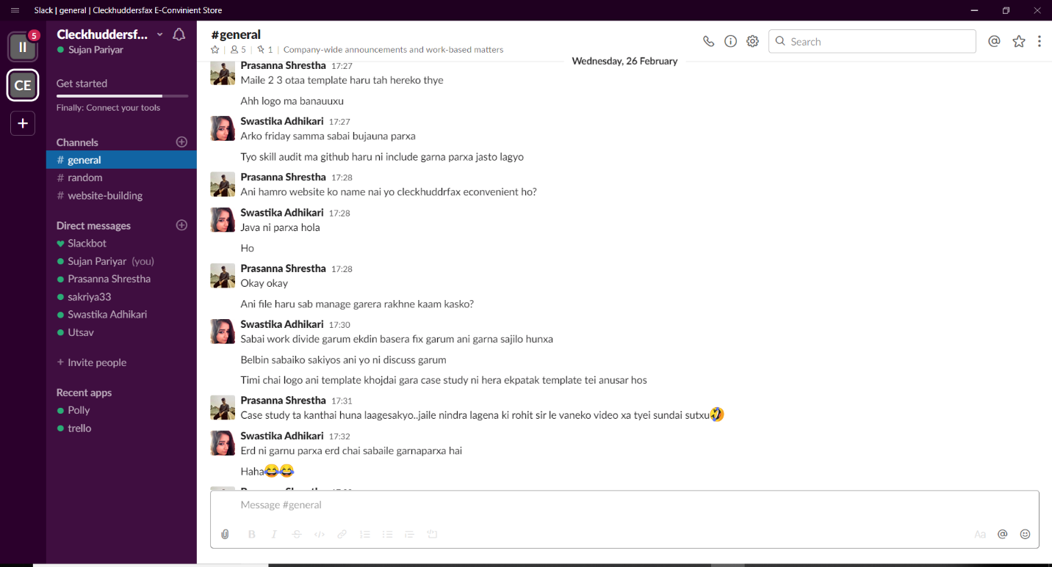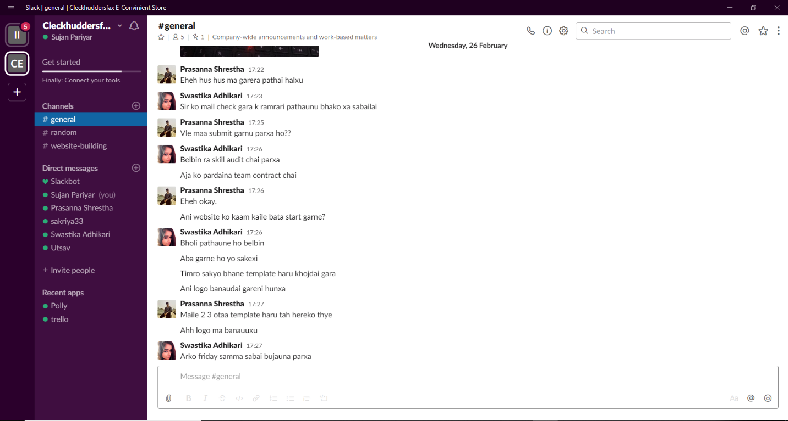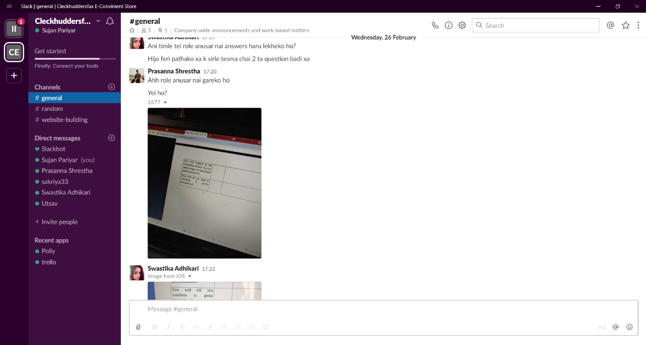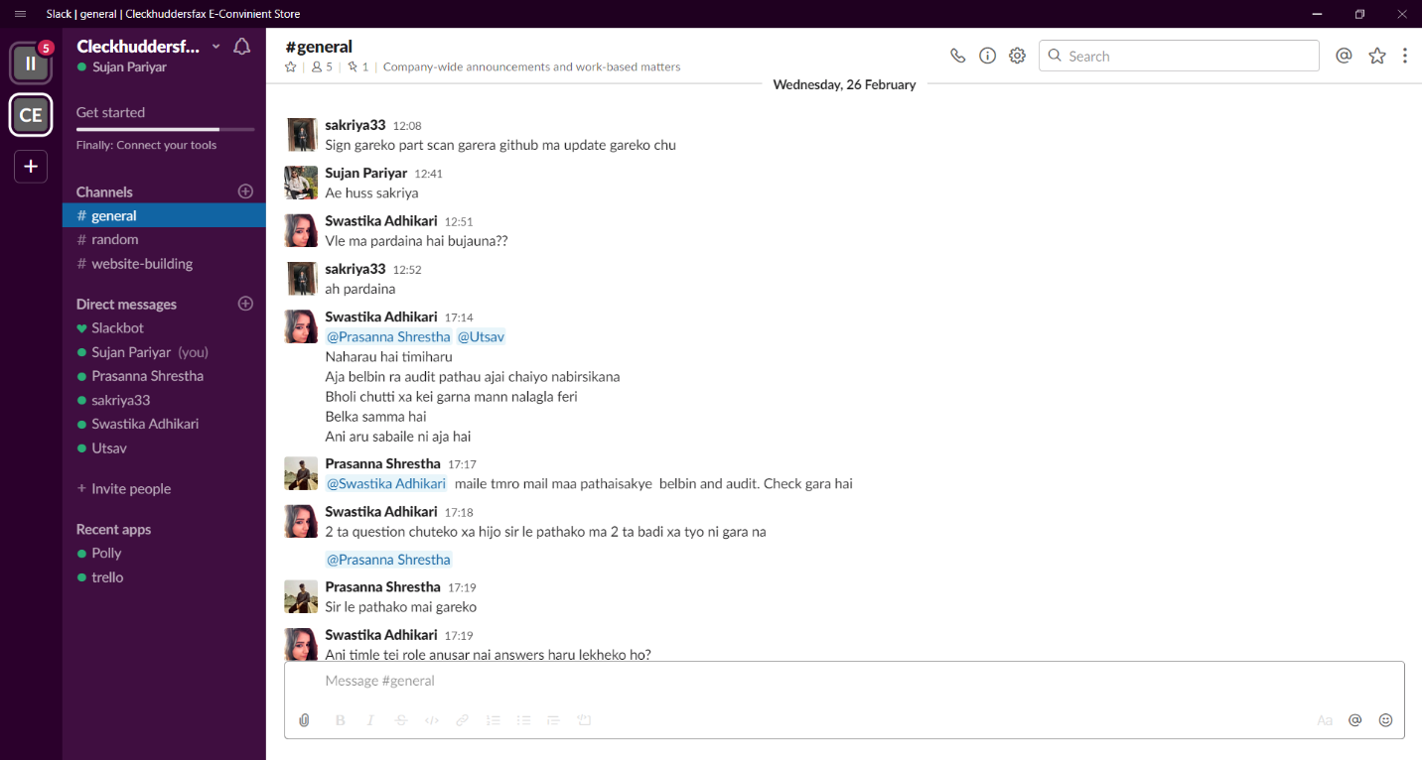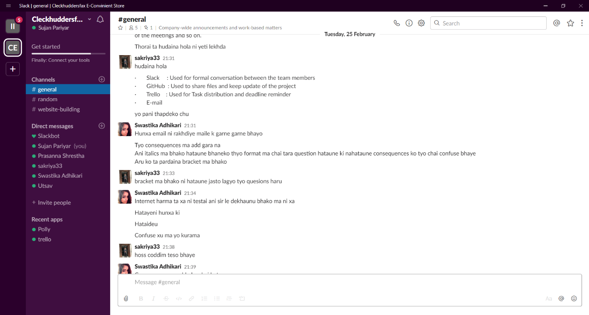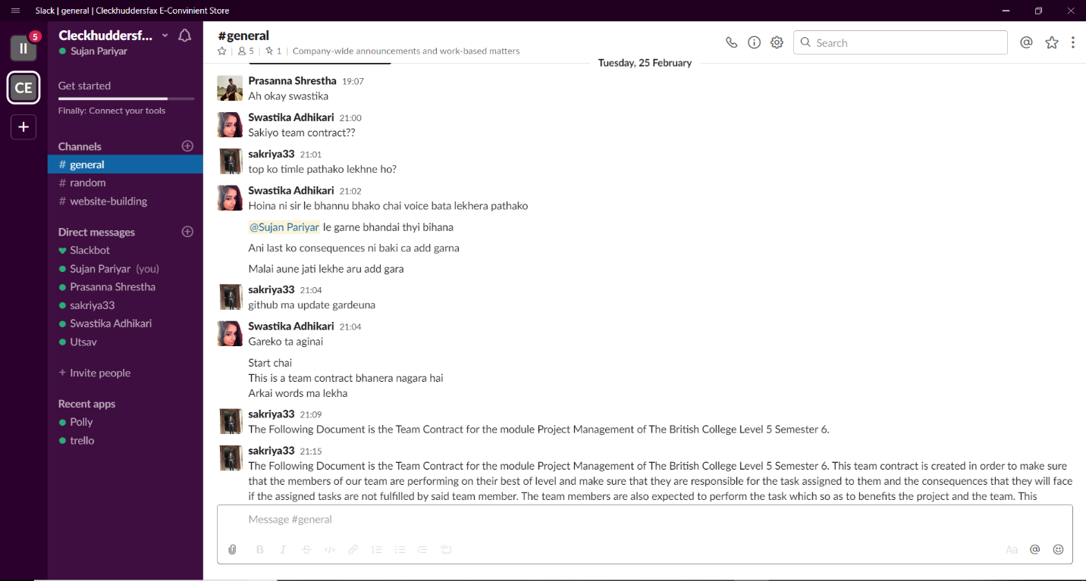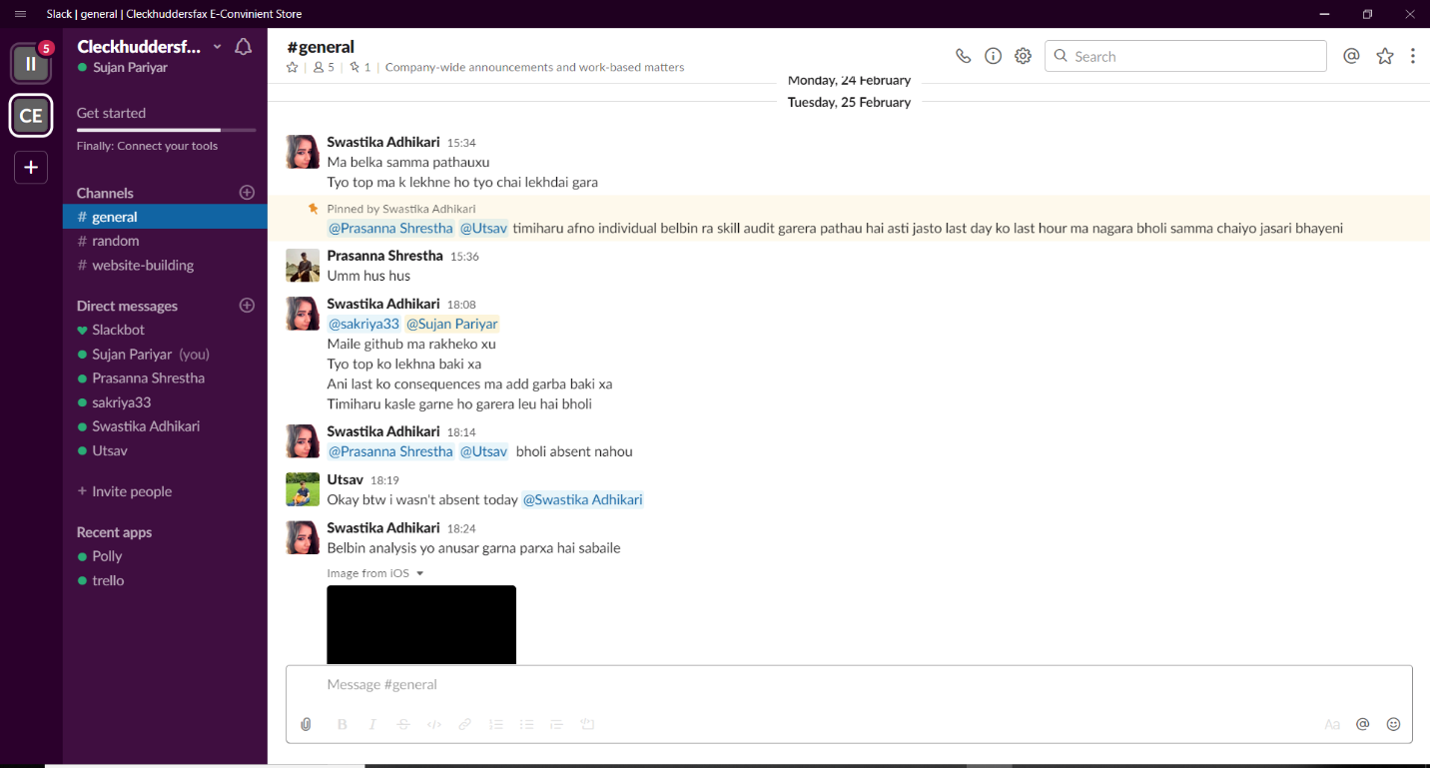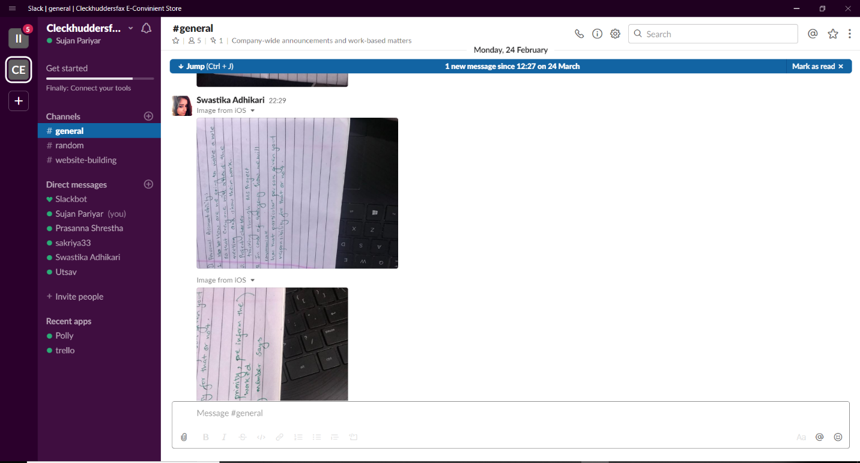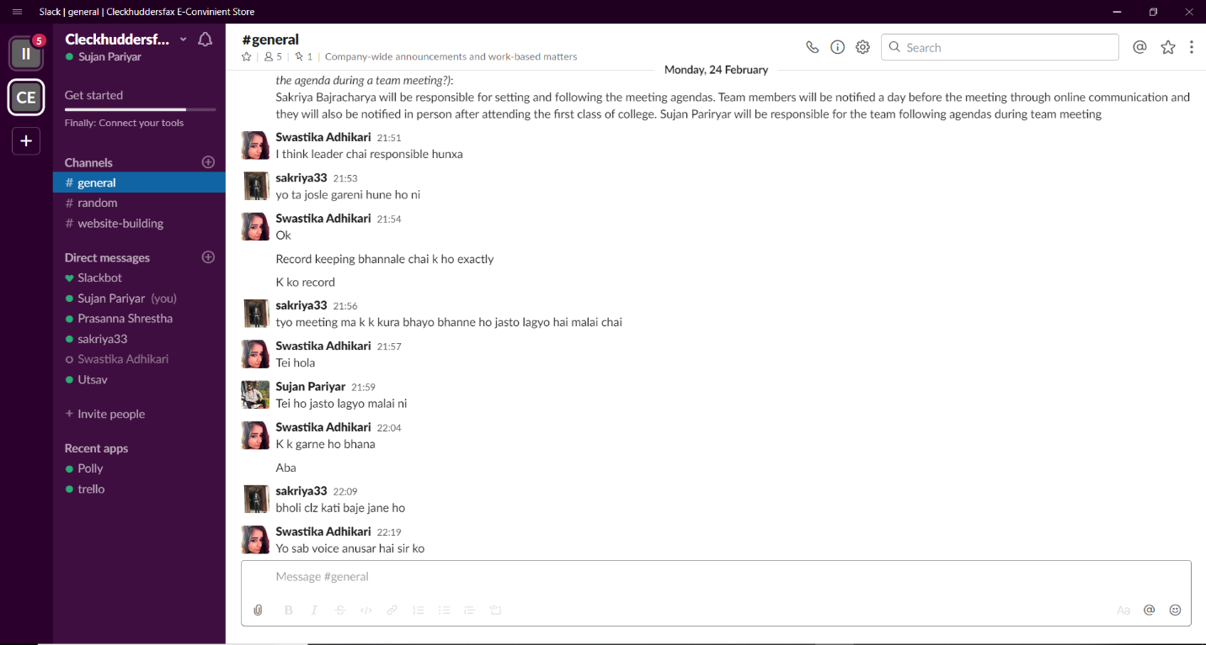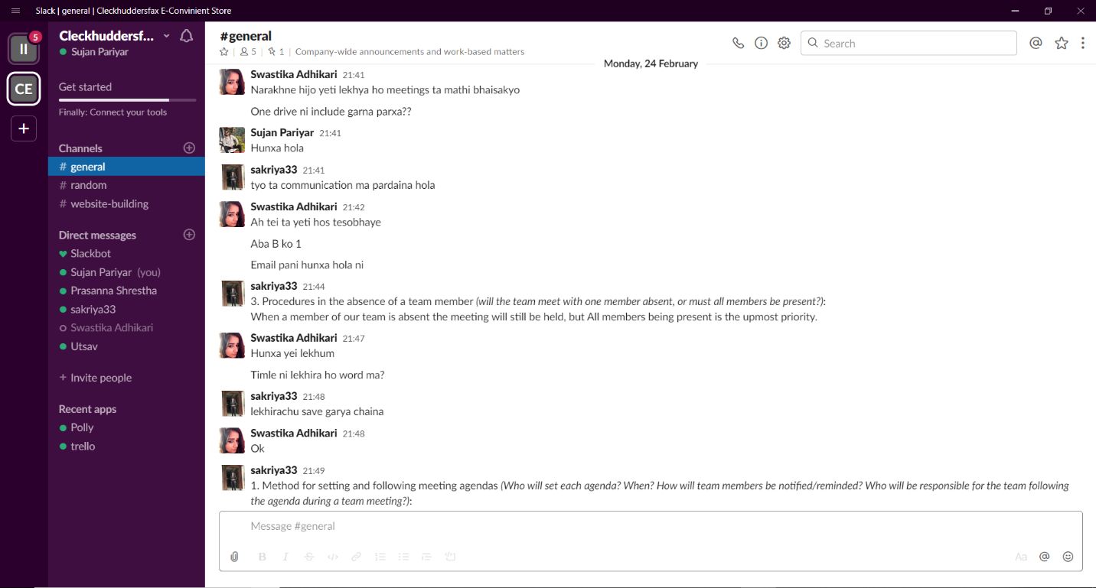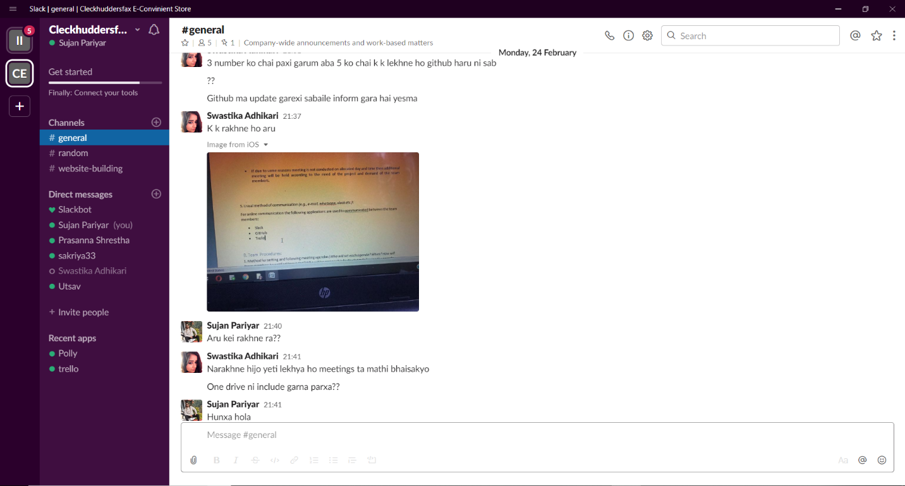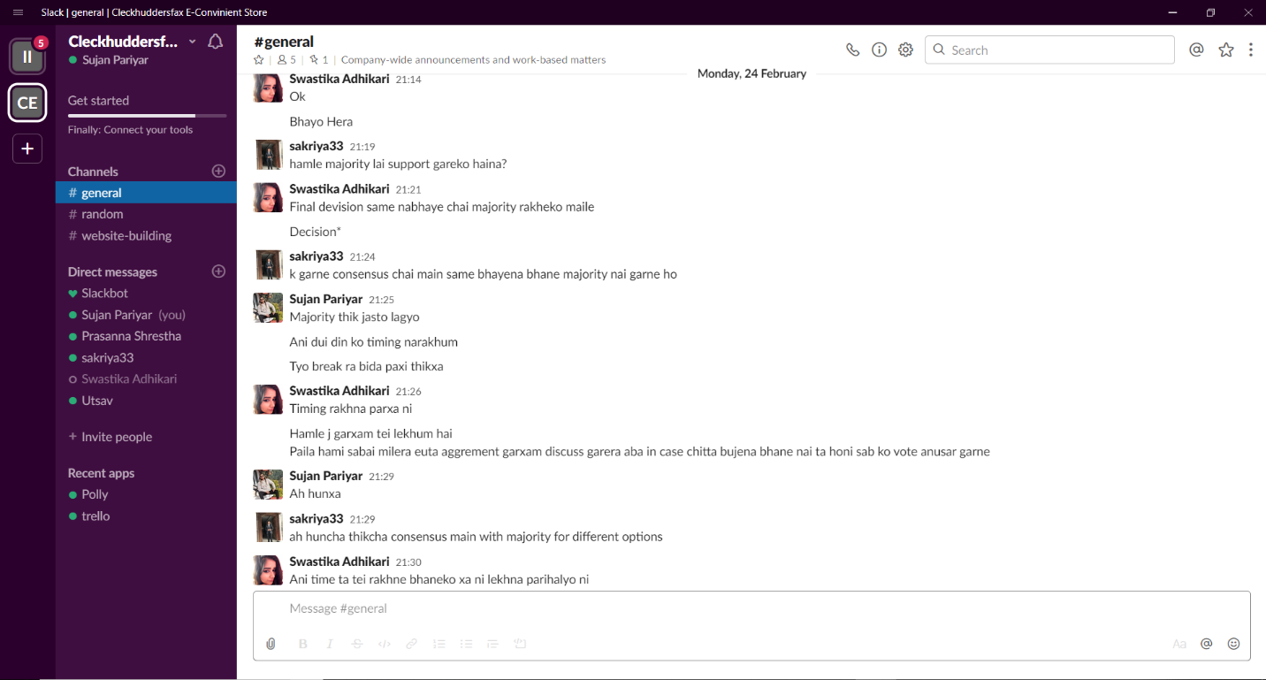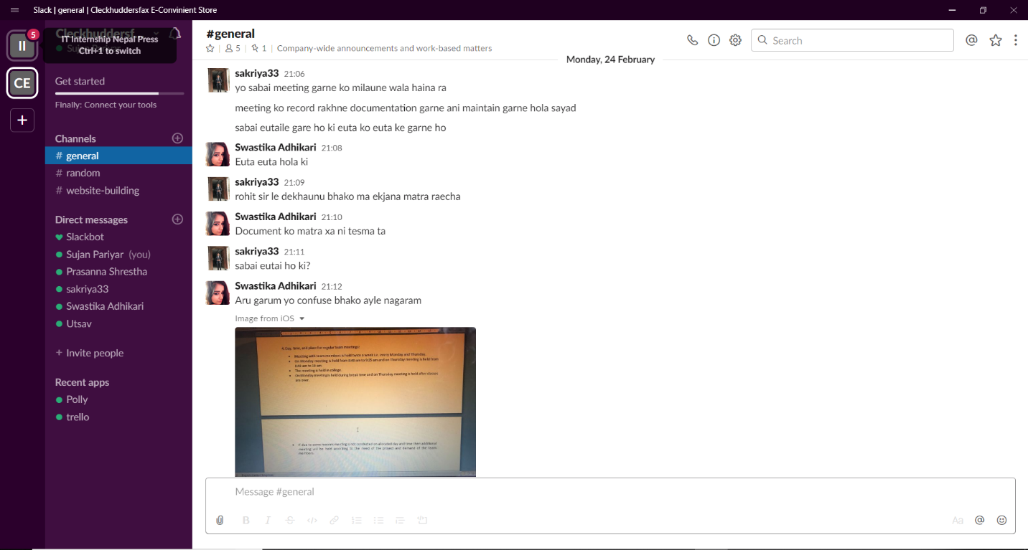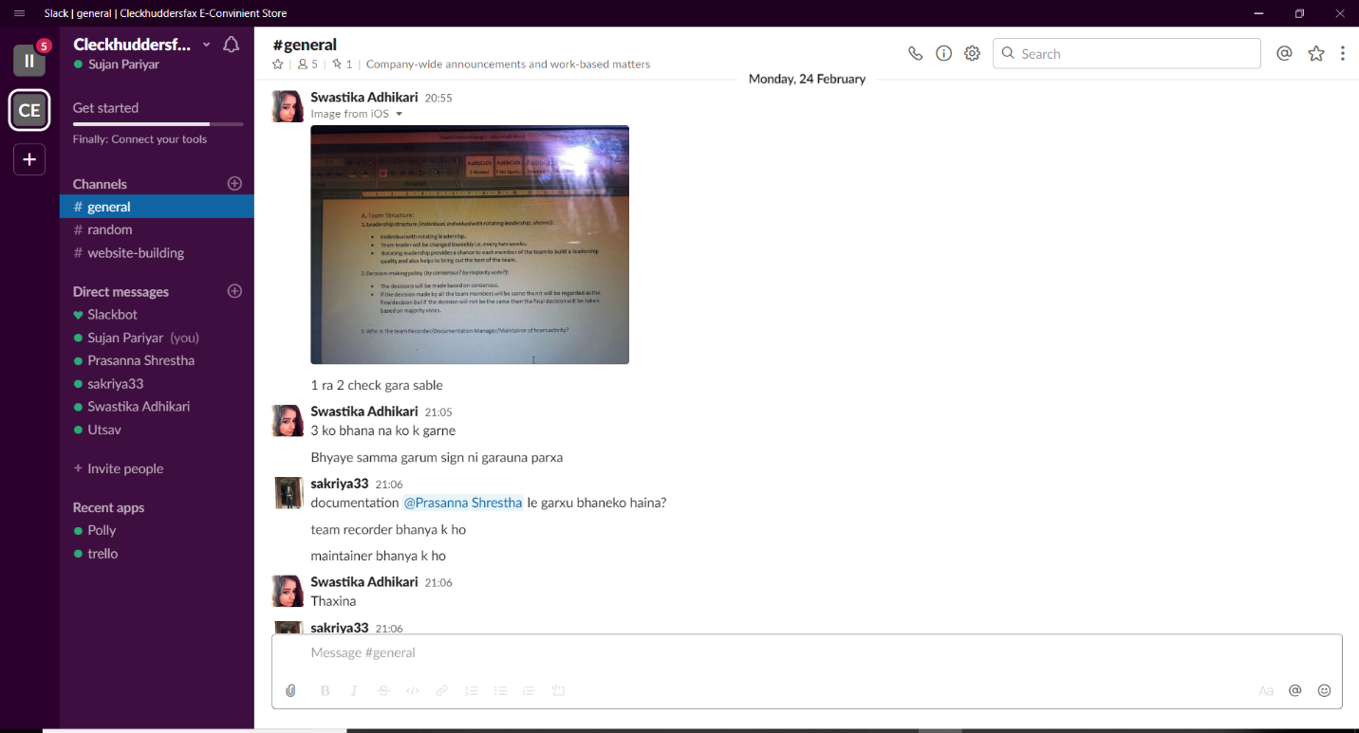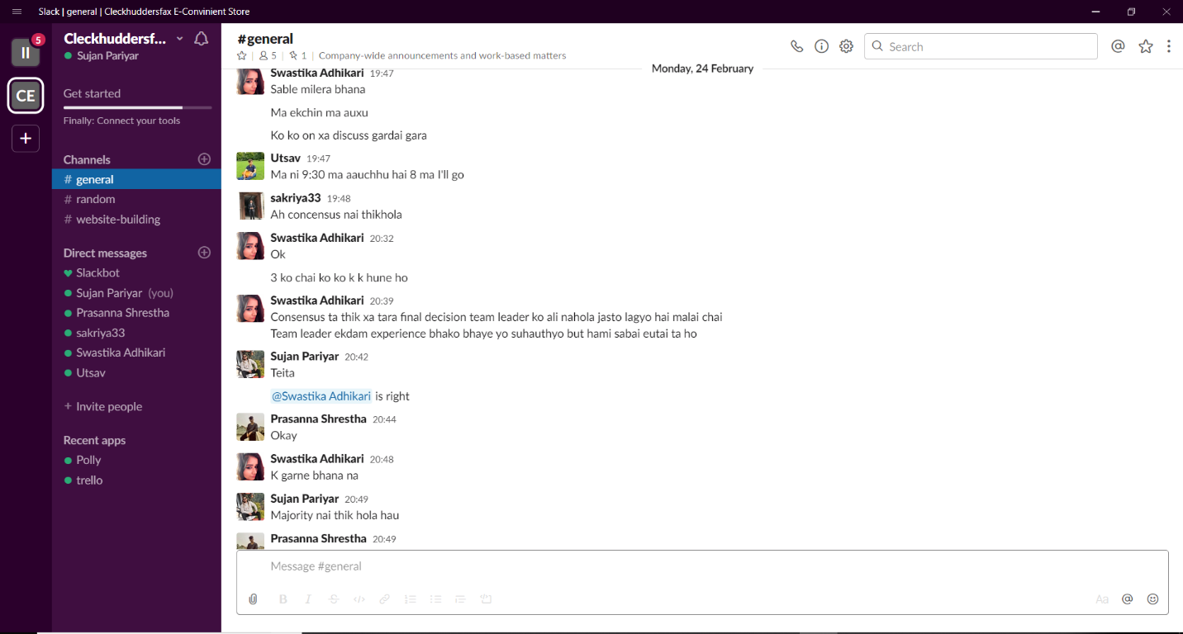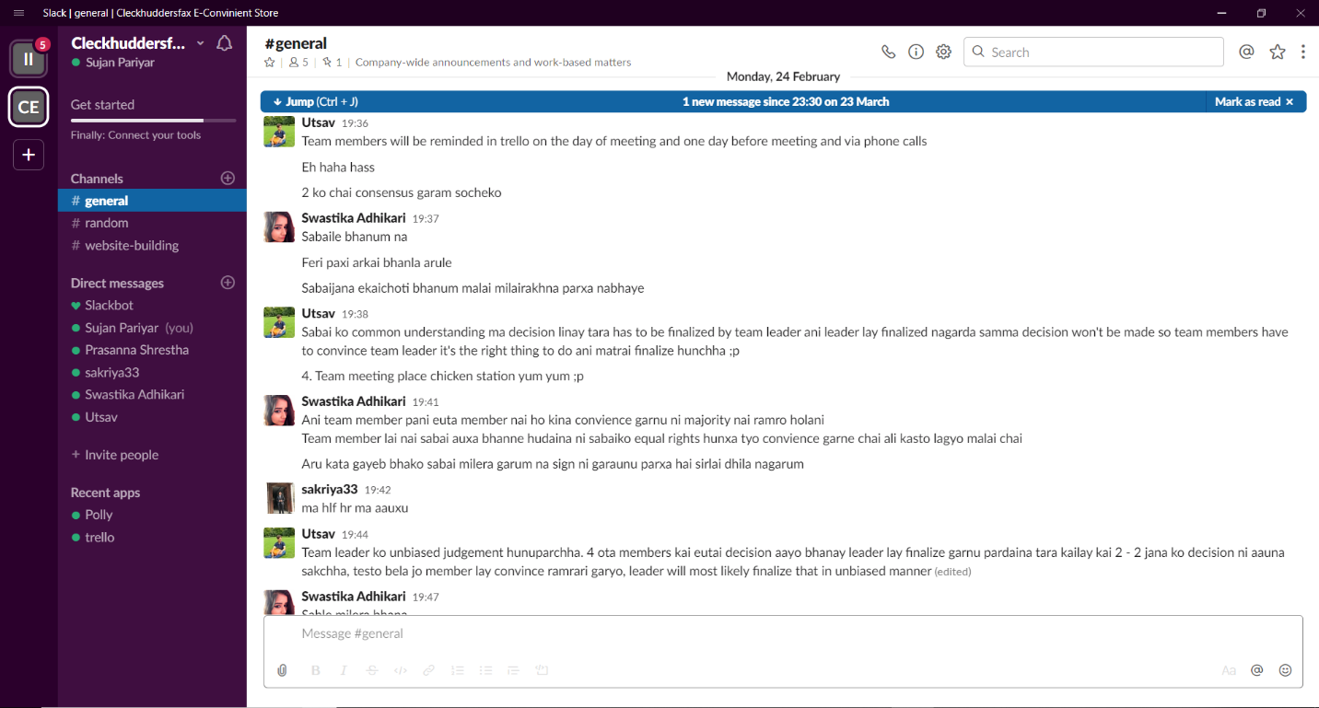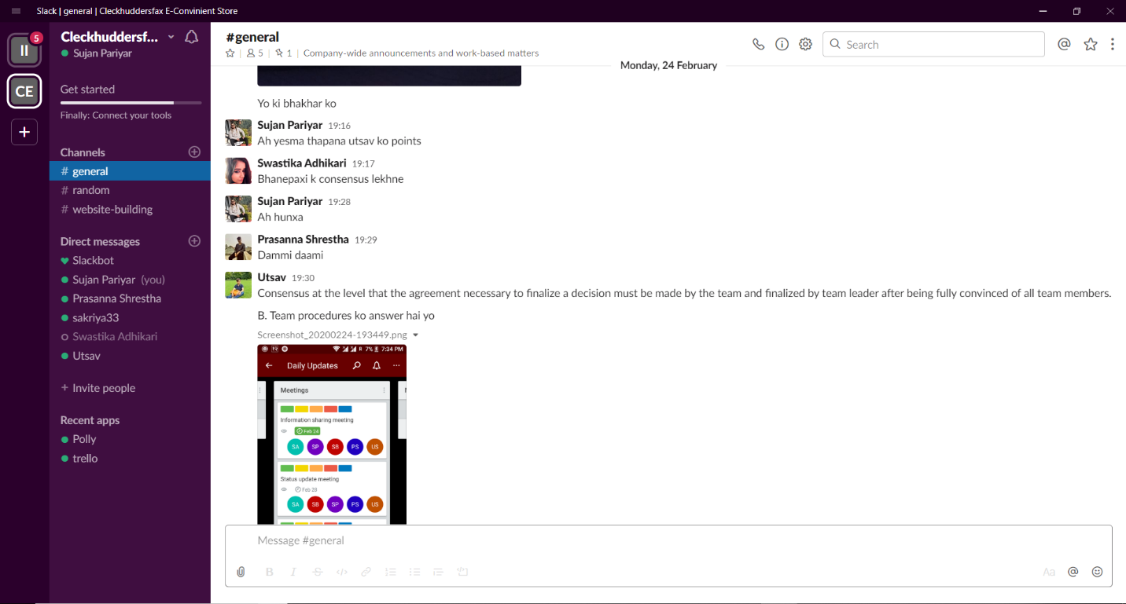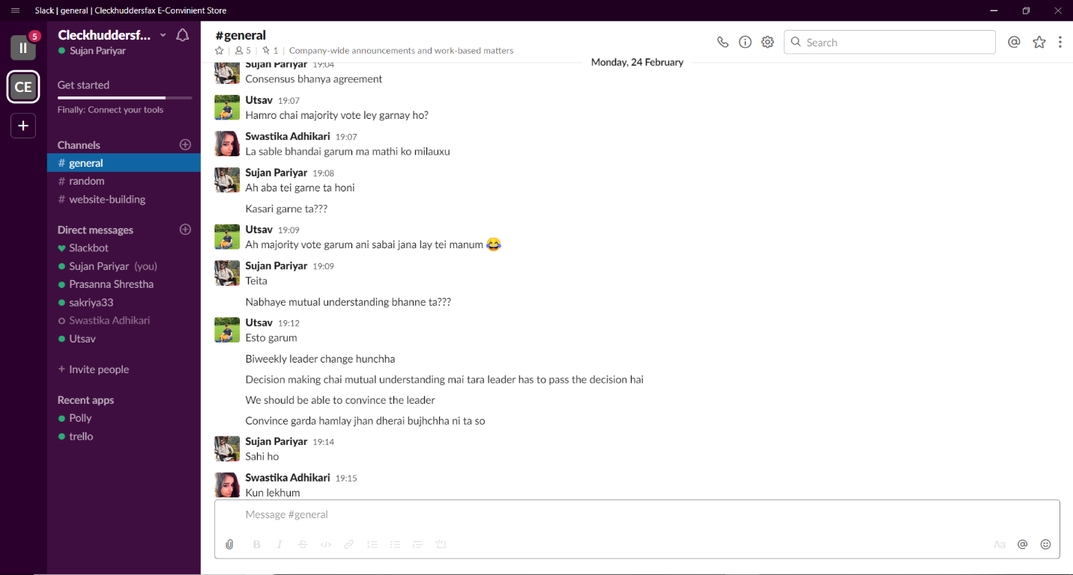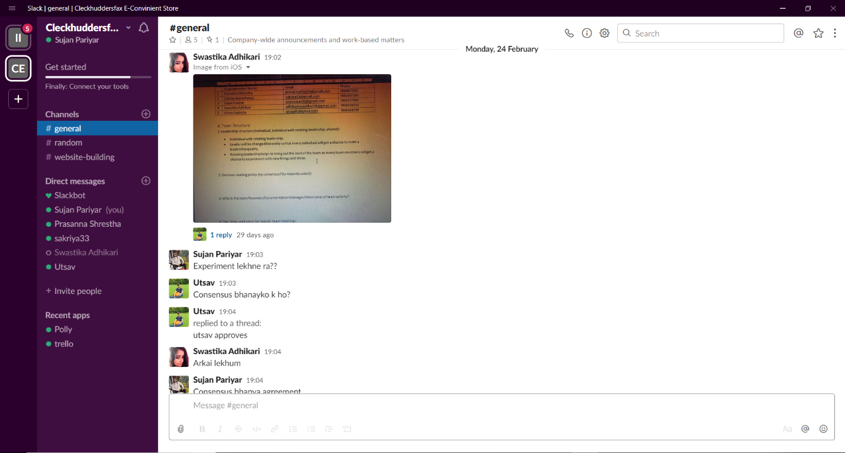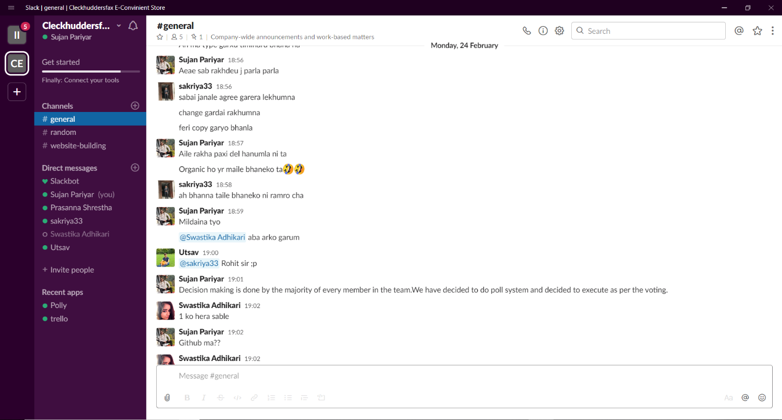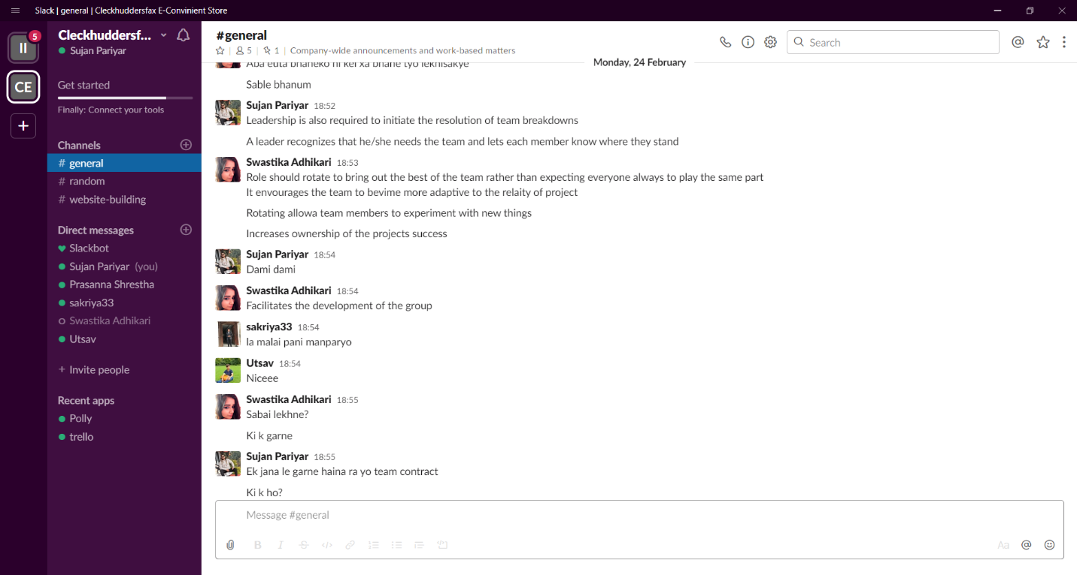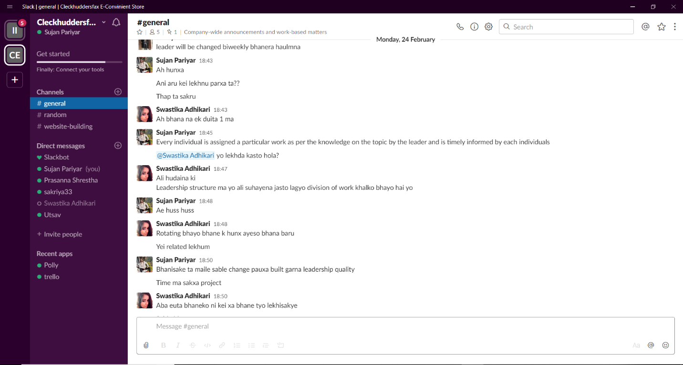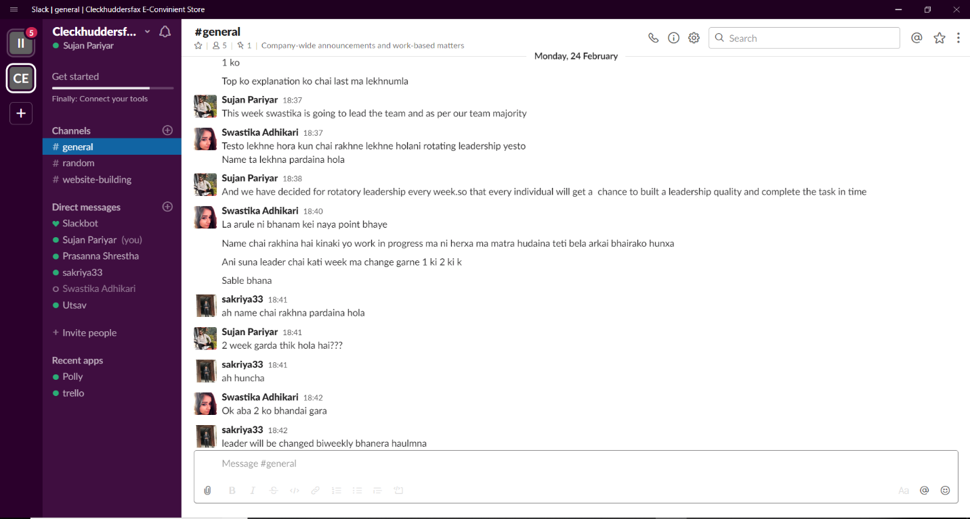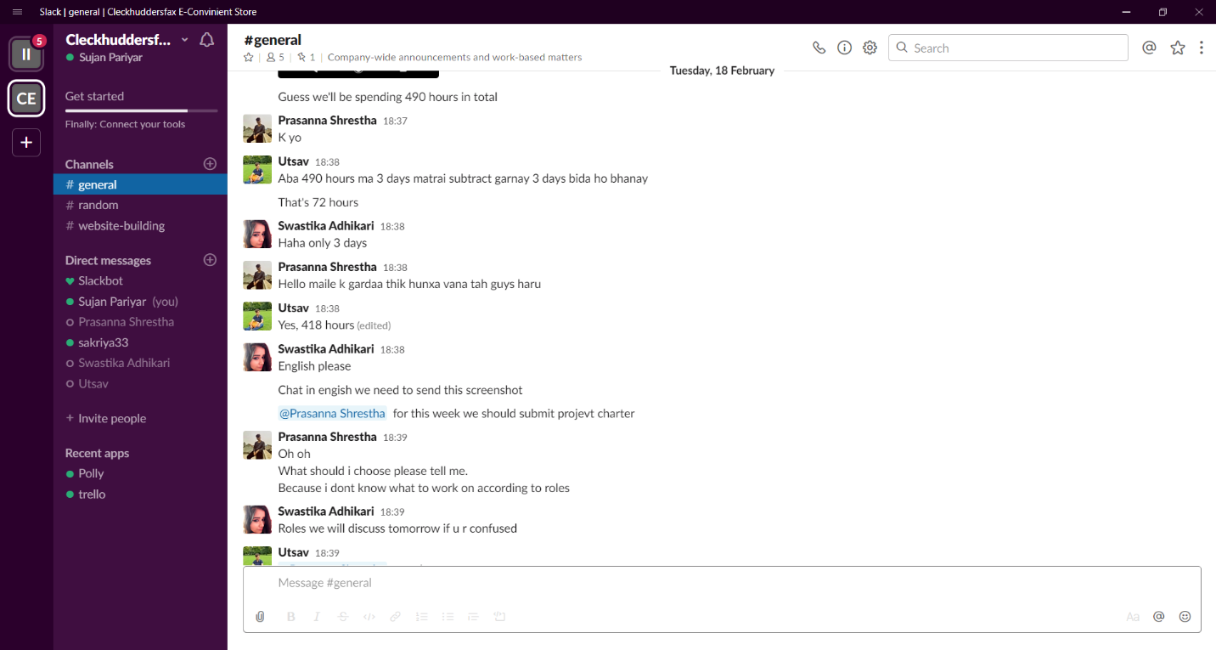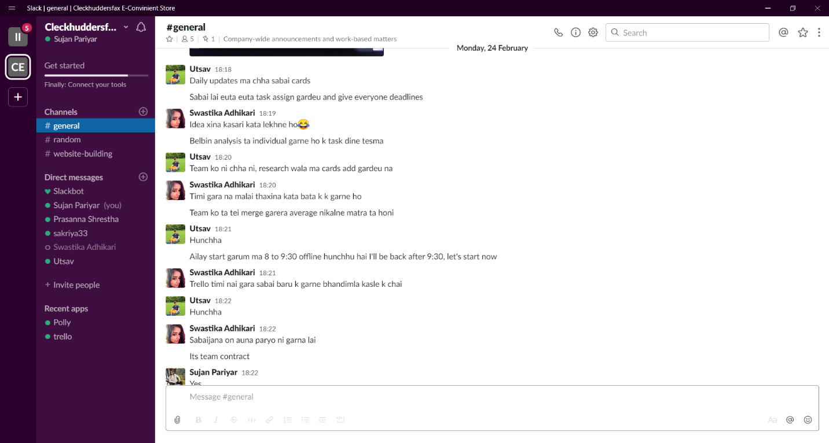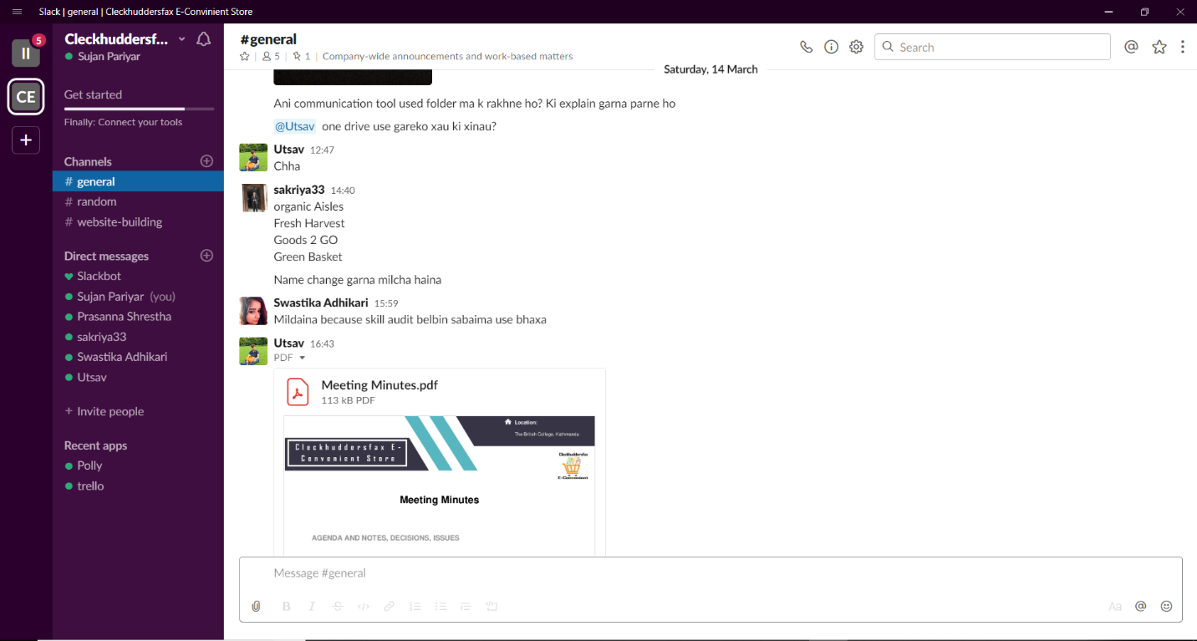

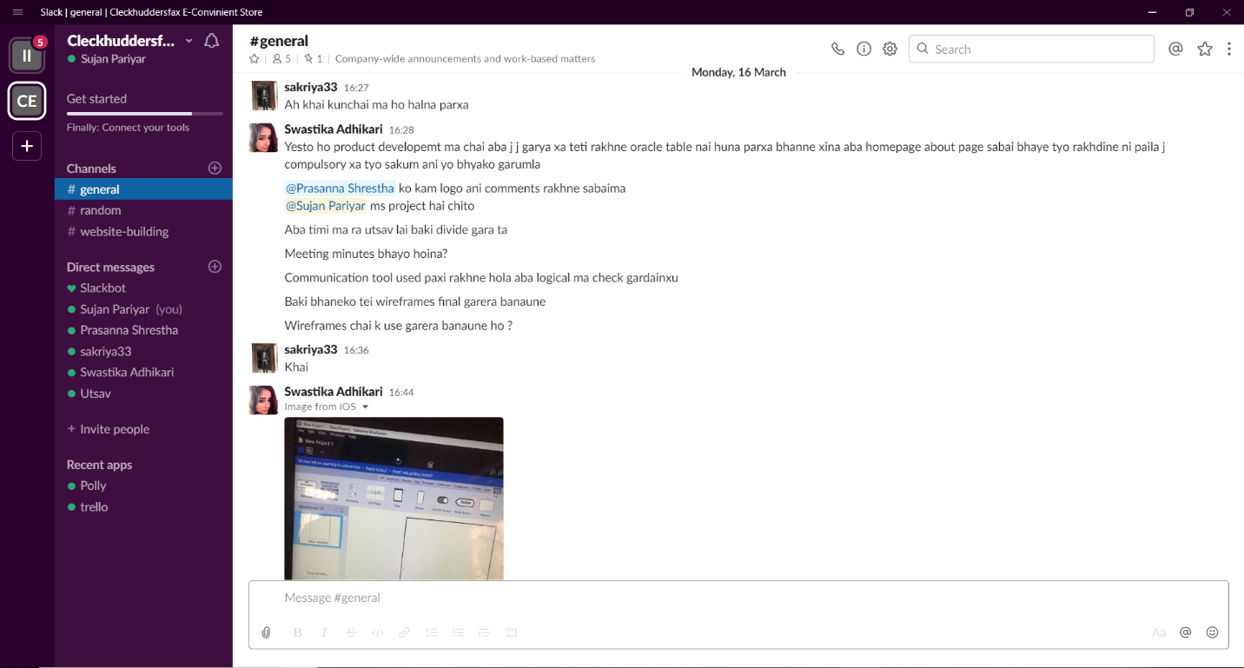

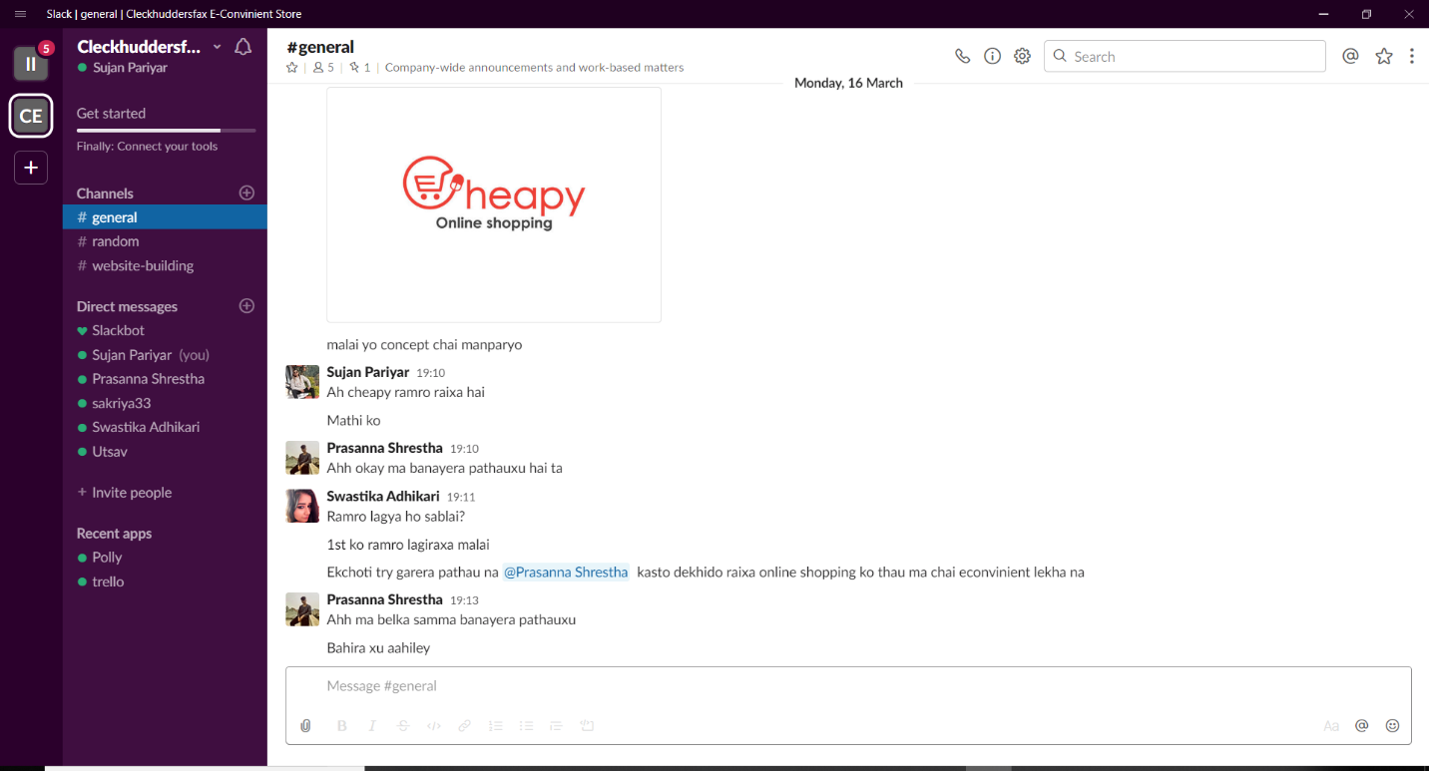

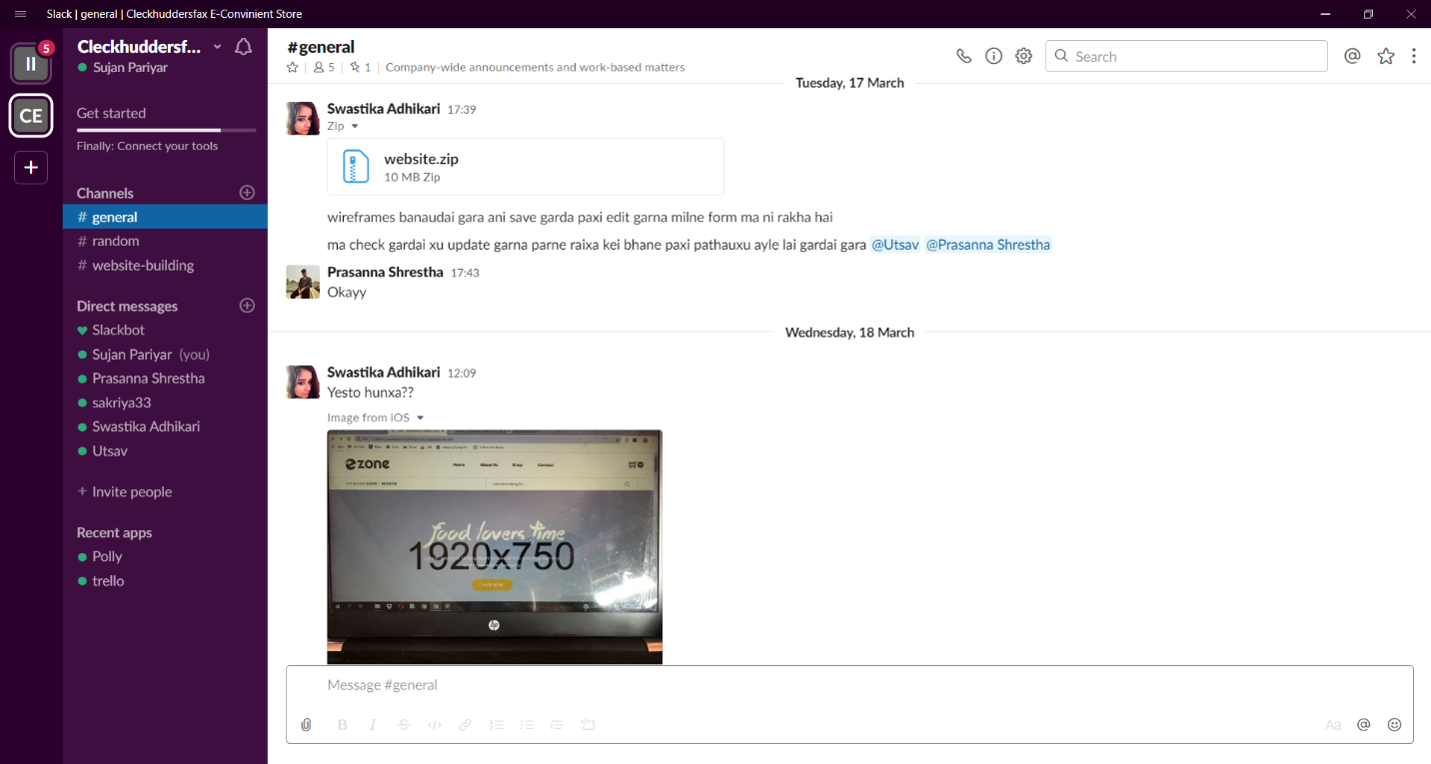

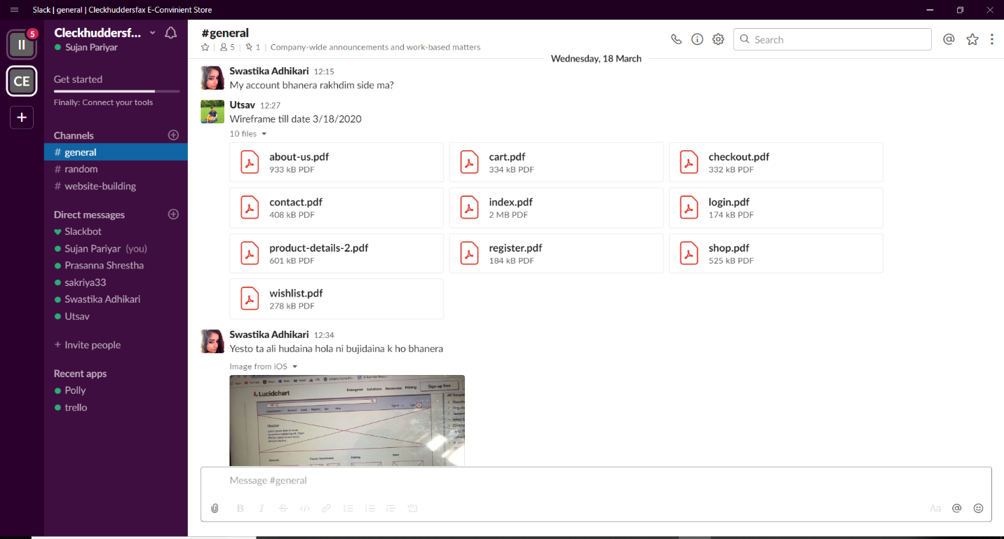

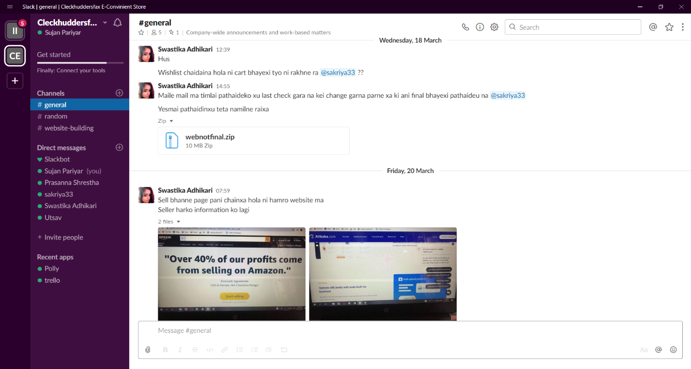

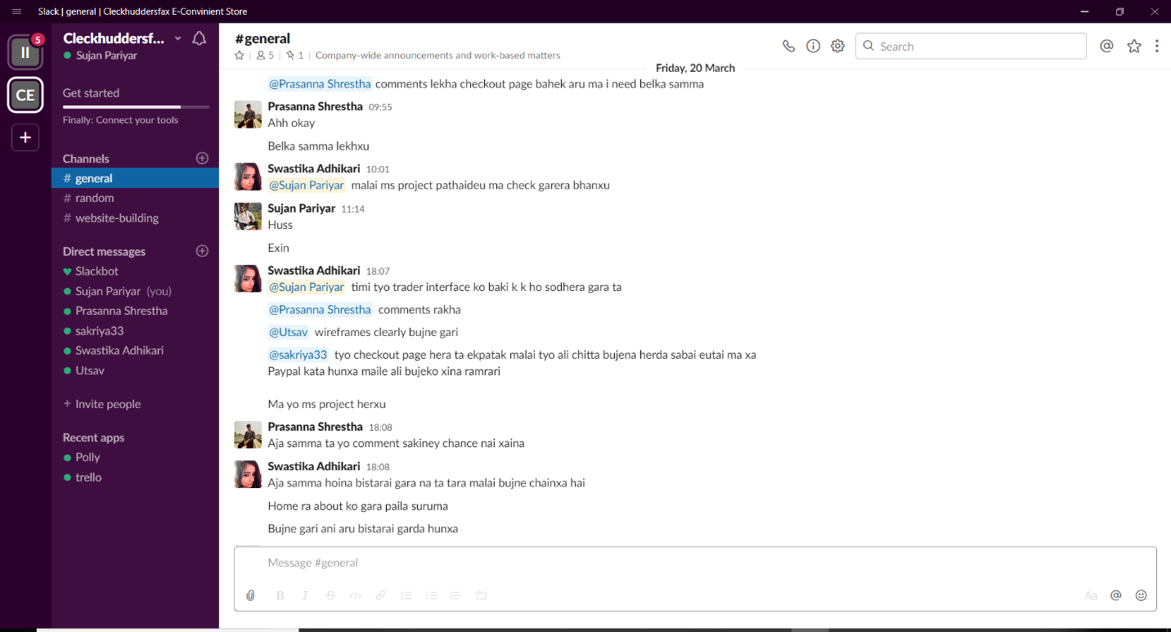

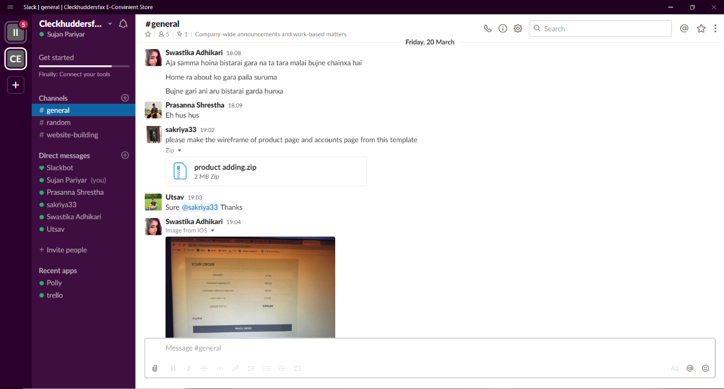

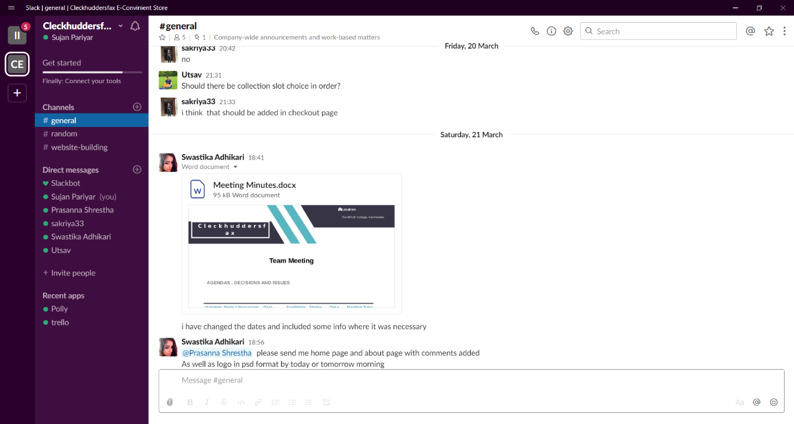

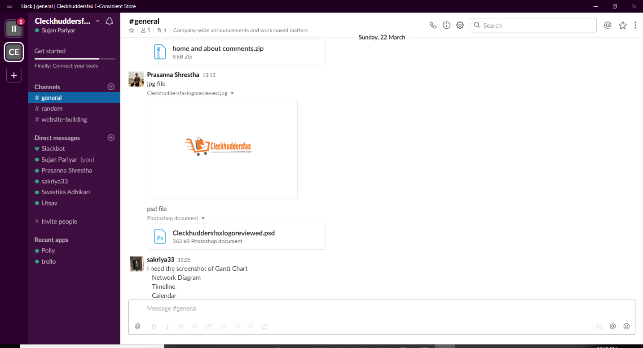

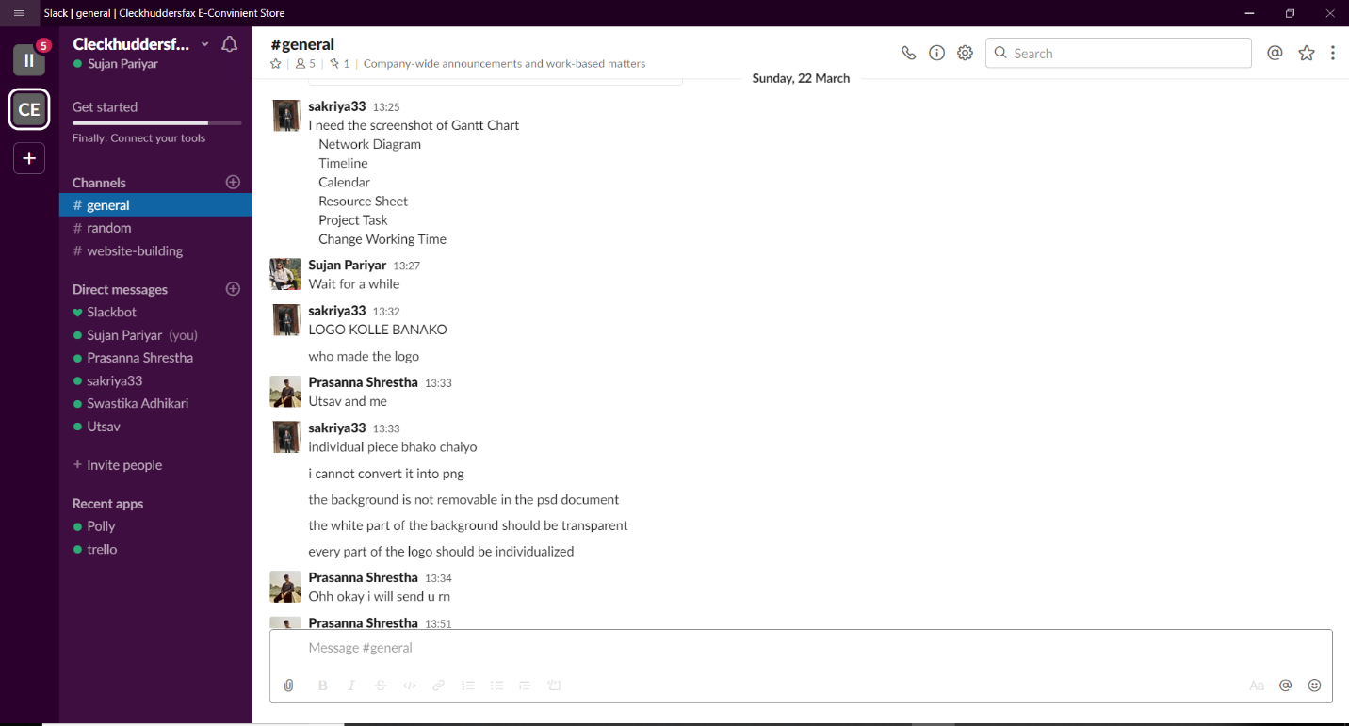

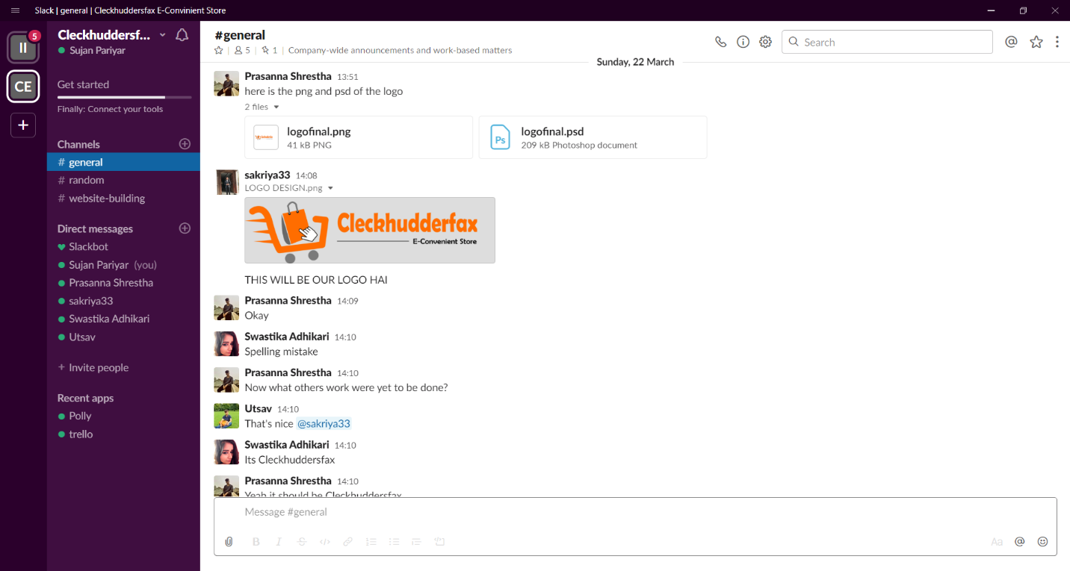

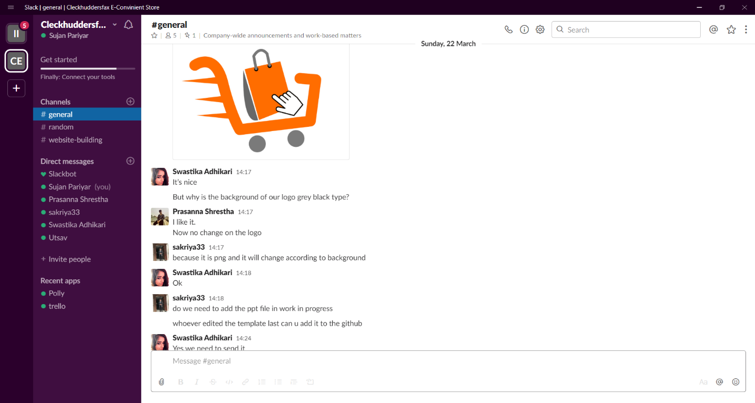

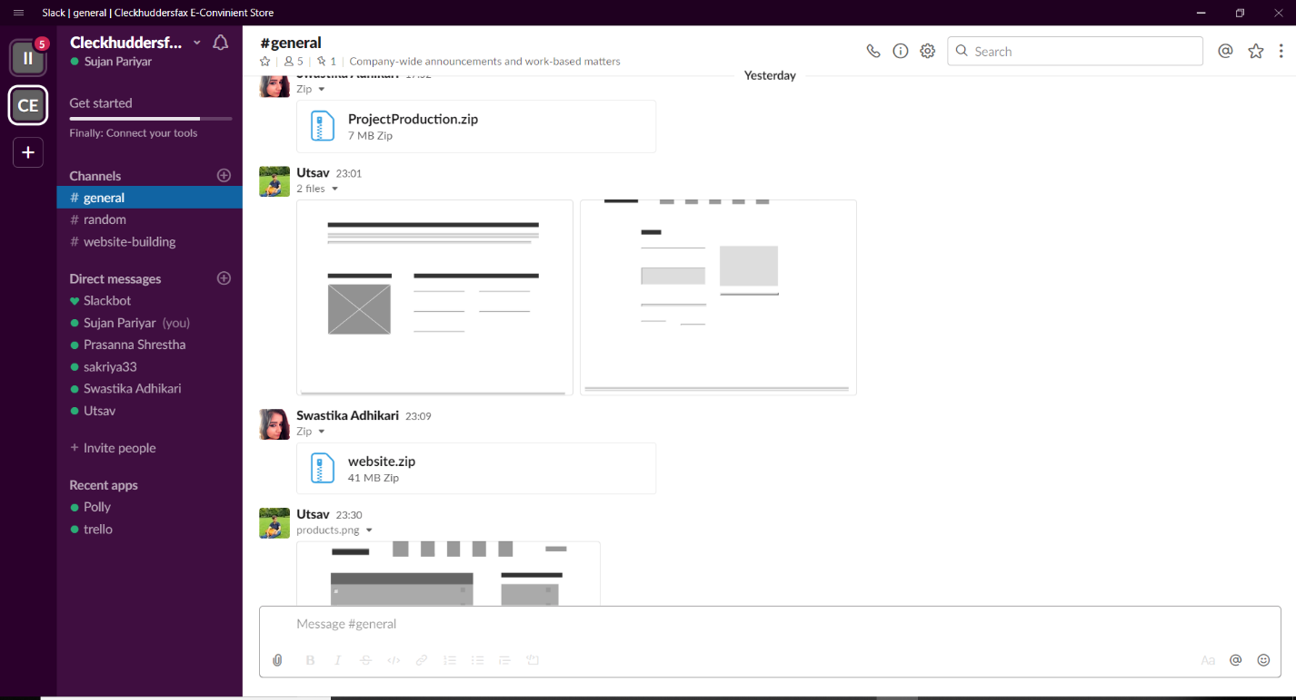

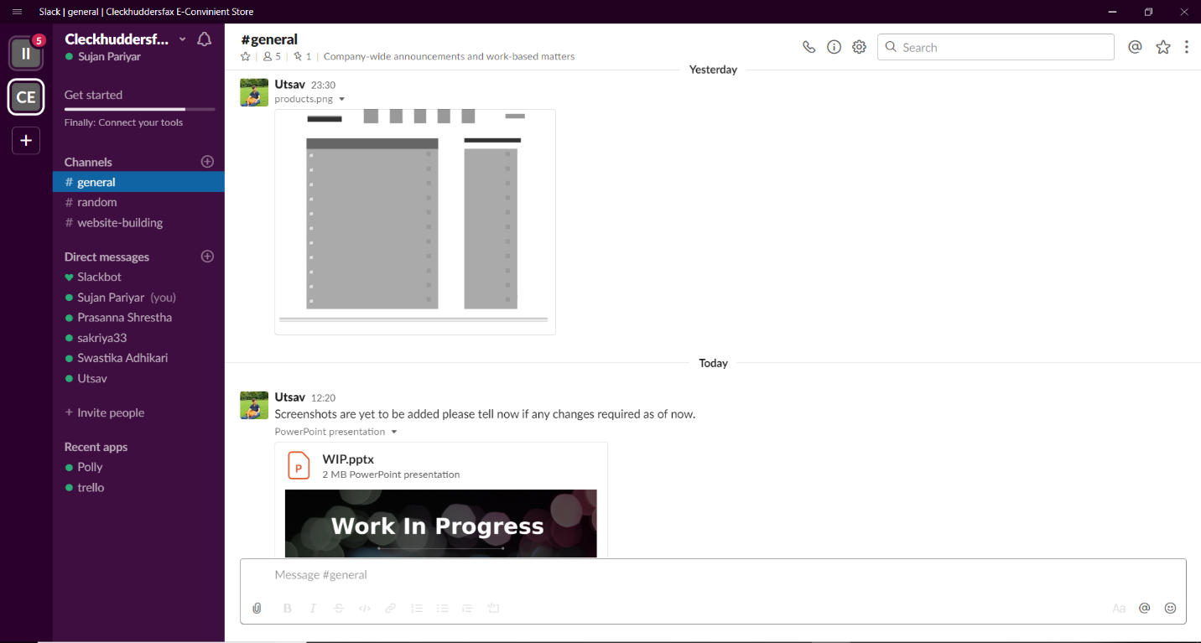

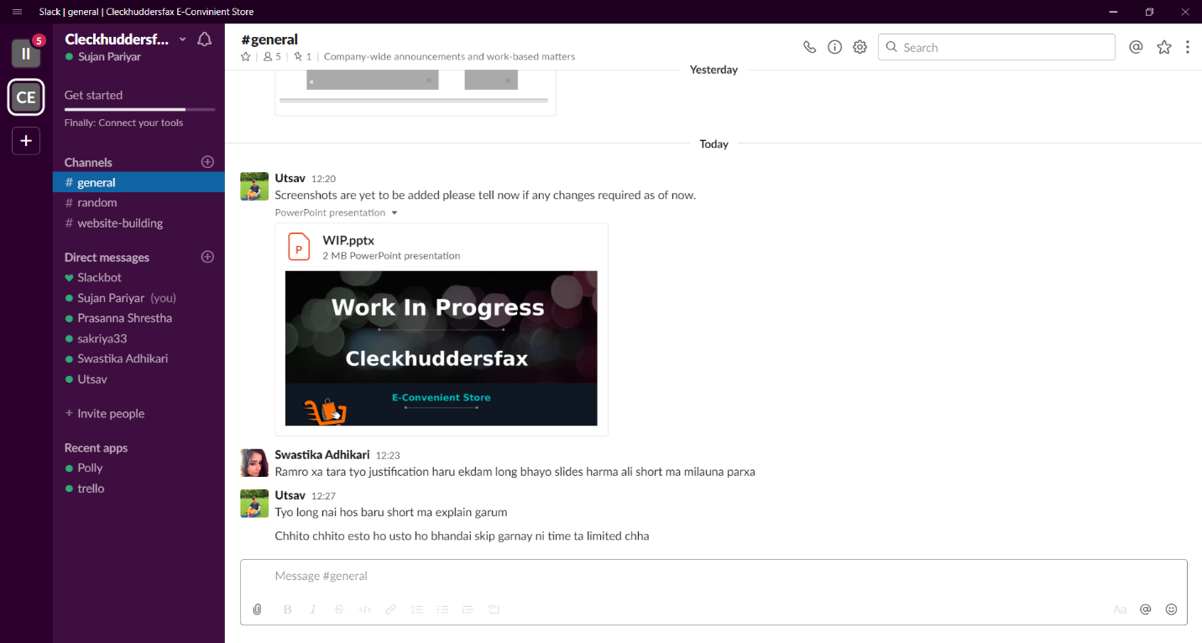

GITHUB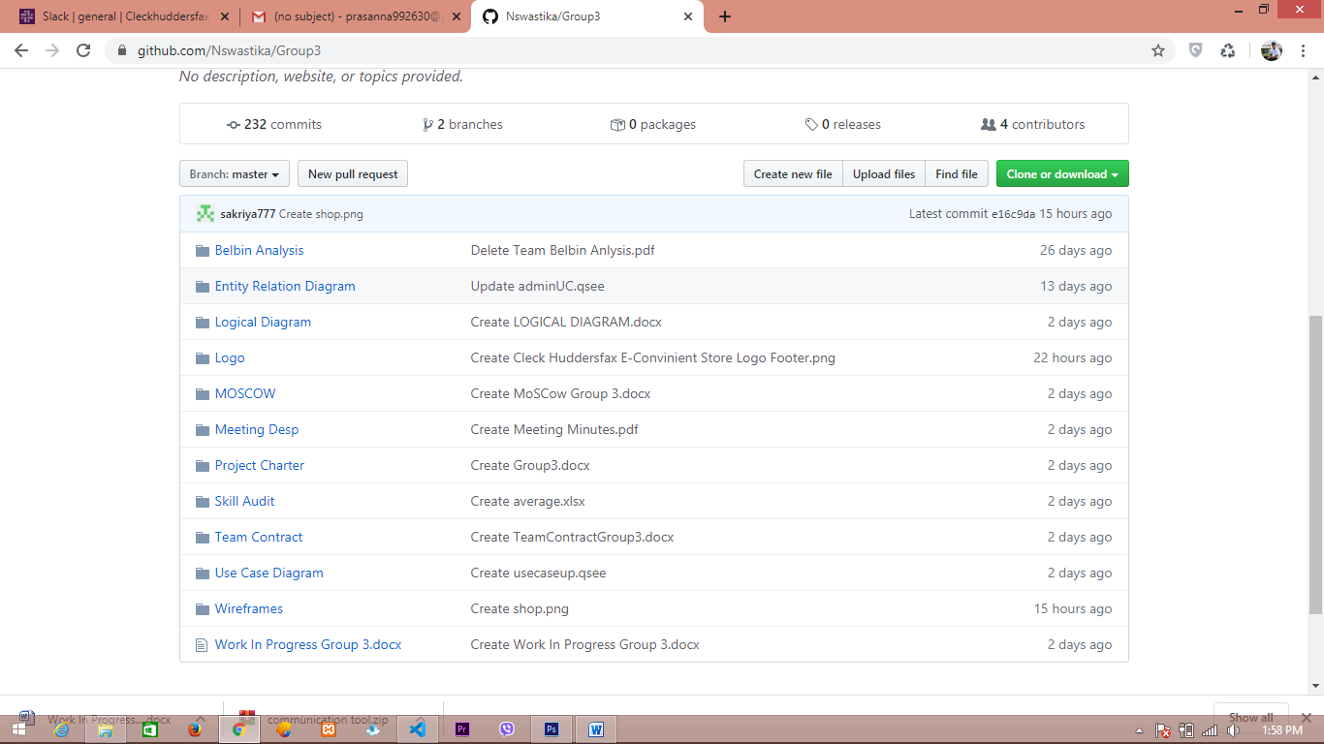

GMAIL

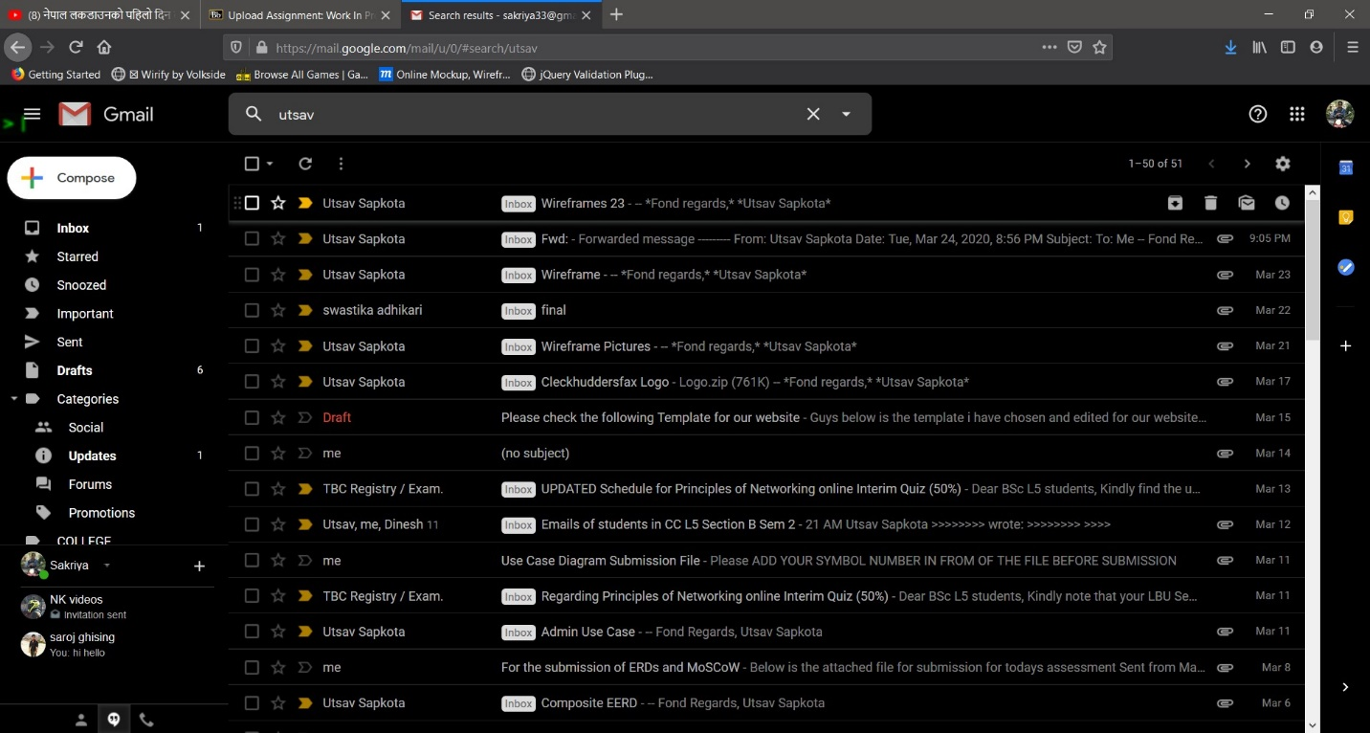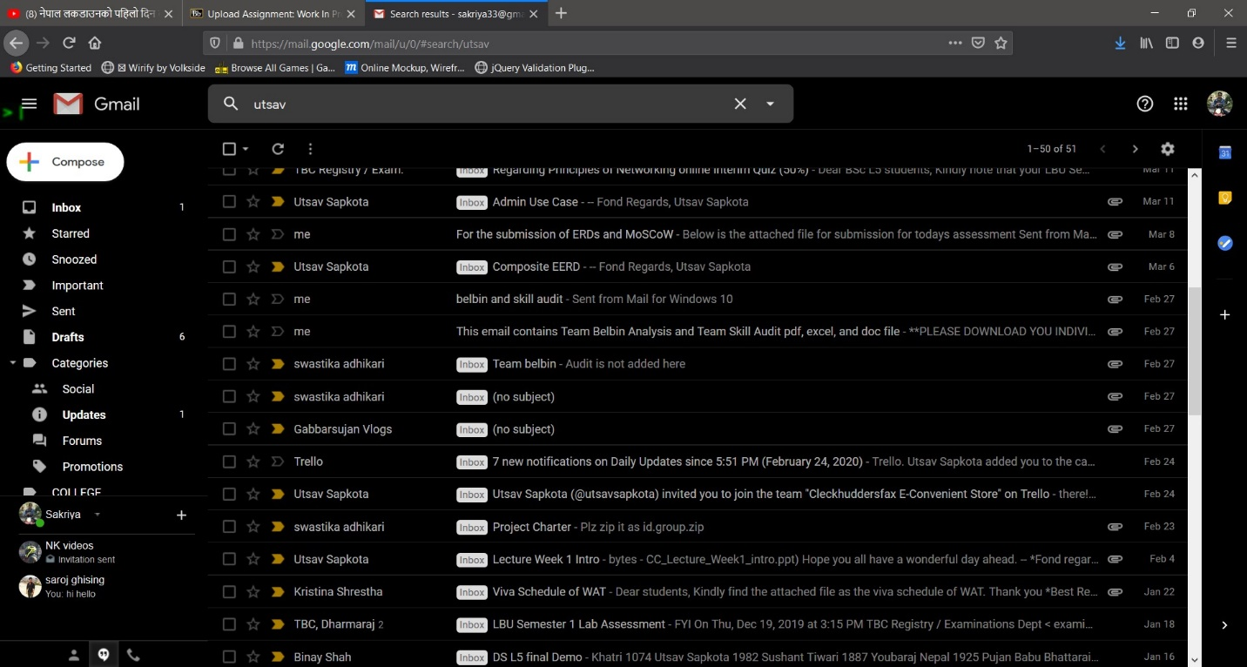

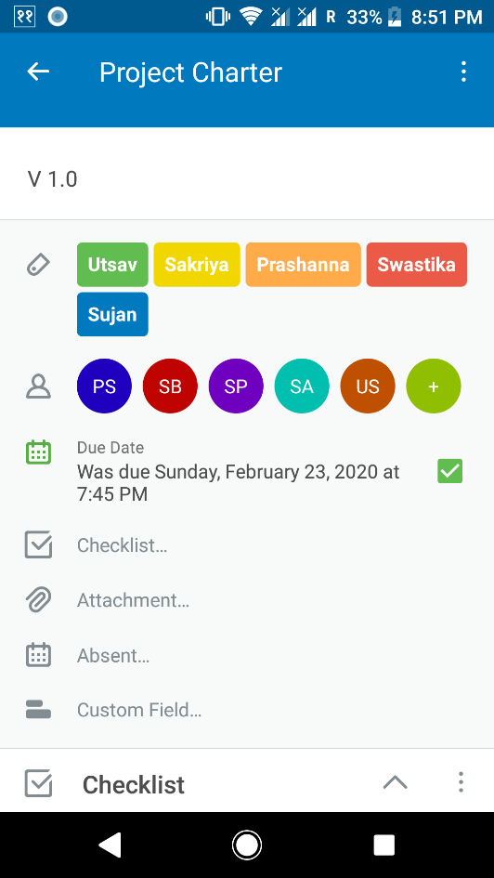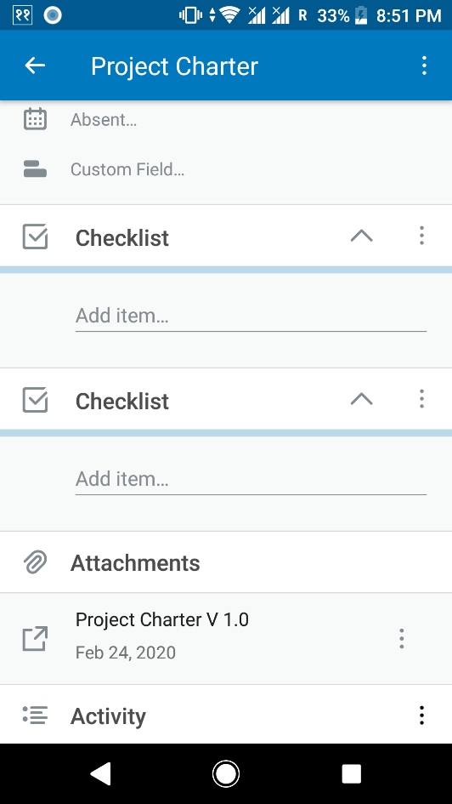TRELLO

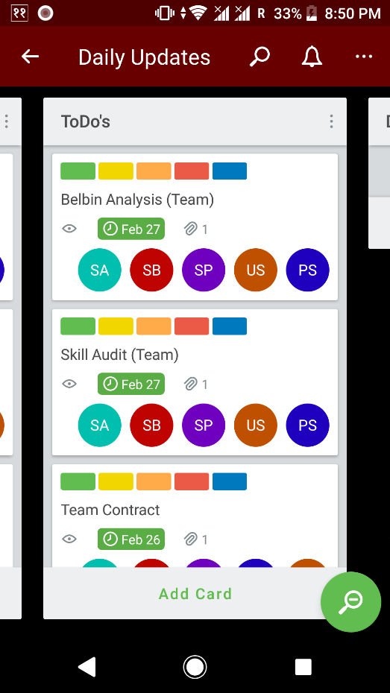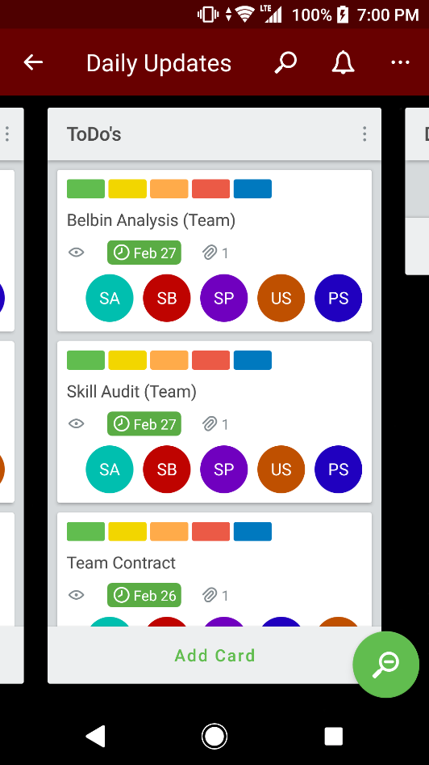

EXECUTION PHASE

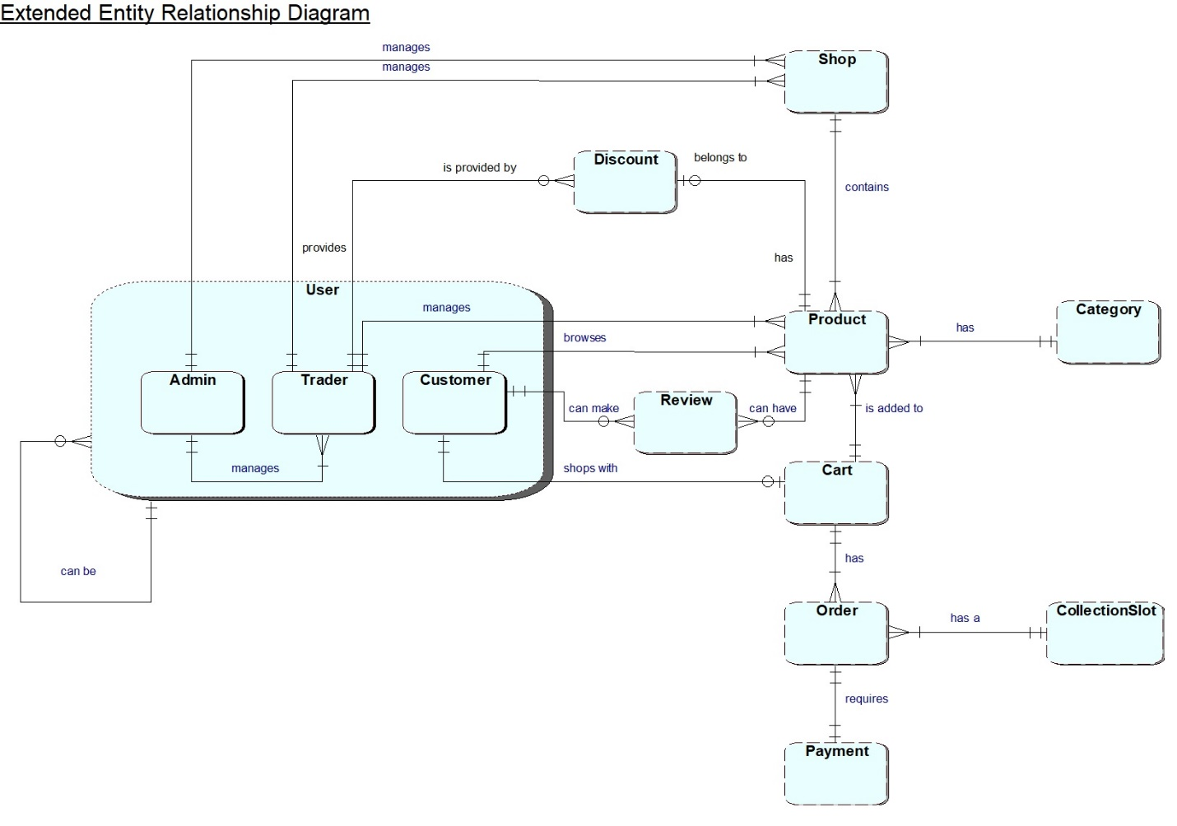EERD

ERD

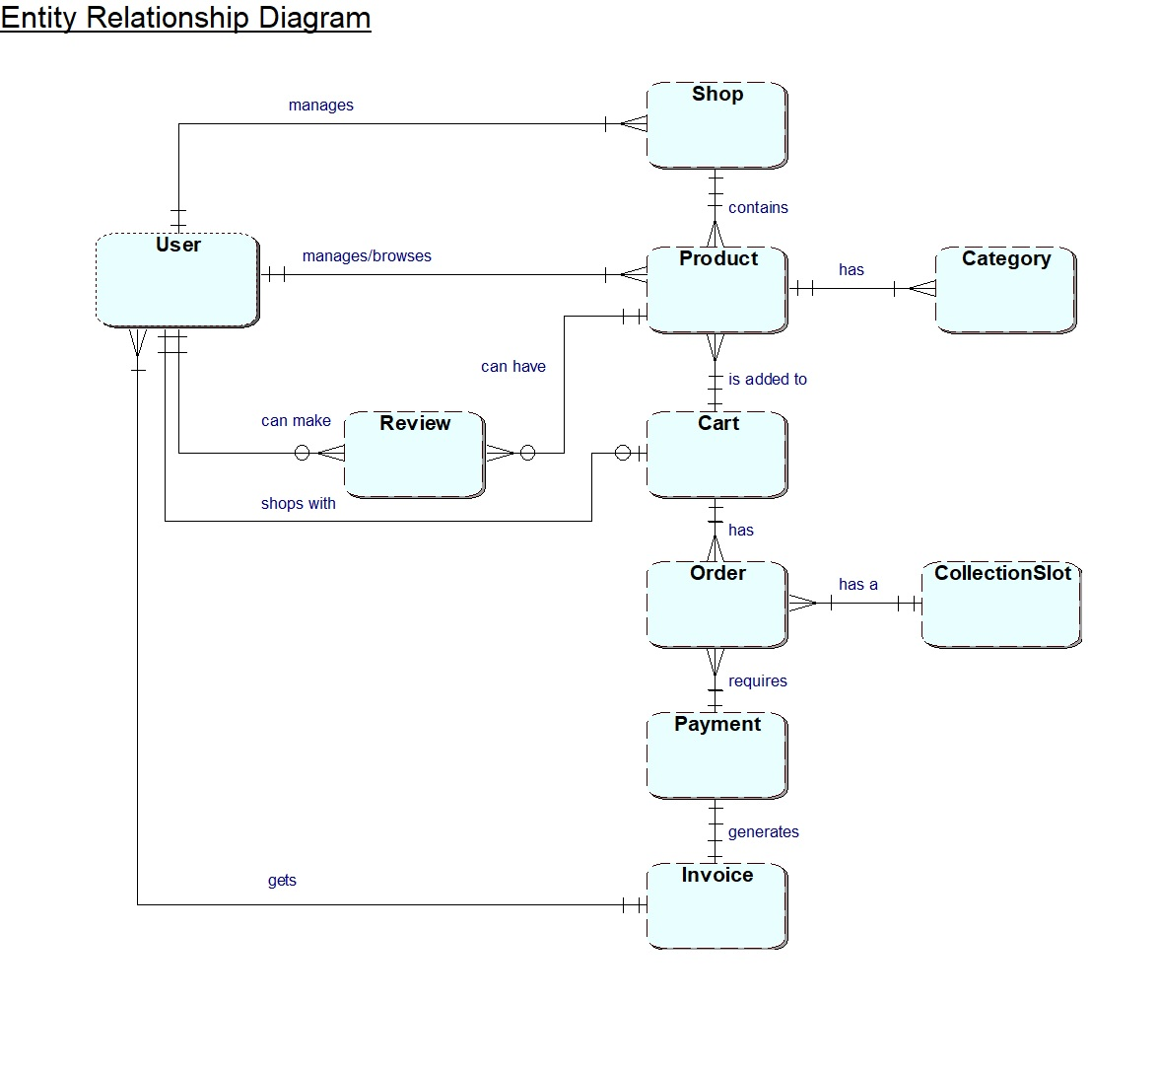

COMPOSITE DIAGRAM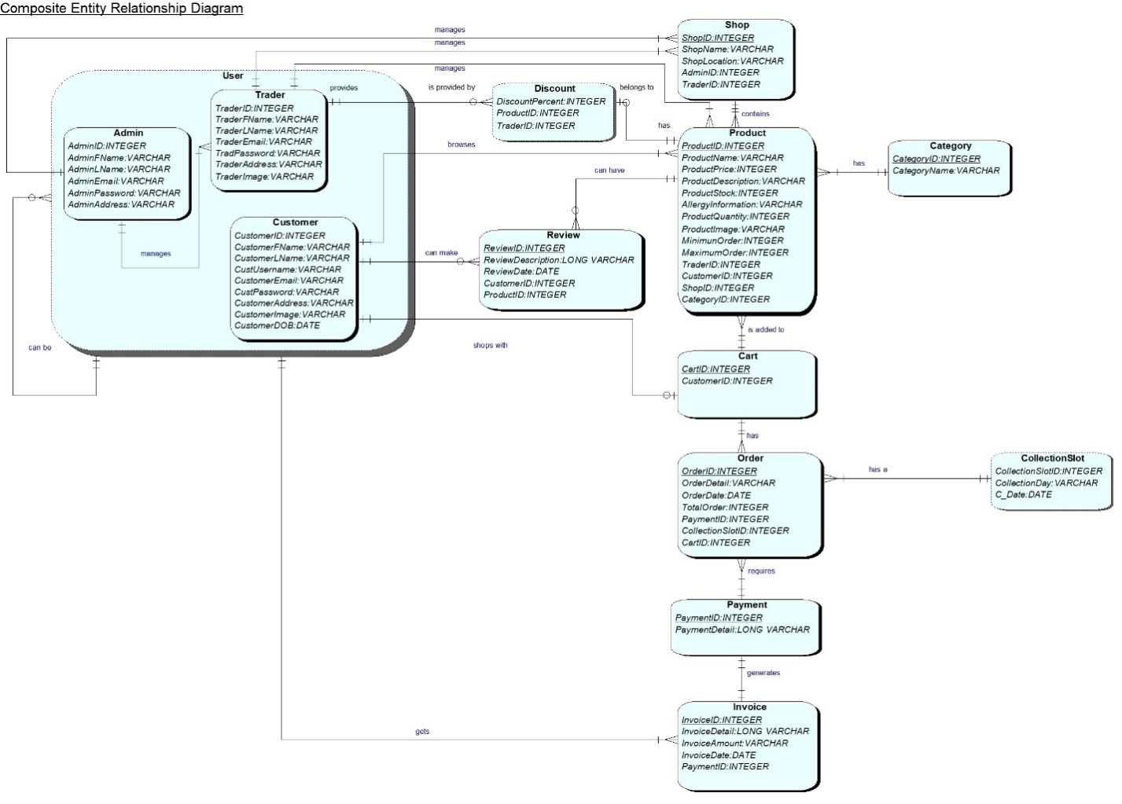

LOGICAL DIAGRAM

* **Admin** (AdminID, AdminFName, AdminLName, AdminEmail, AdminPassword, AdminAddress, AdminImage);
* **Trader** (TraderID, TraderFName, TraderLName, Trader_Email, TraderPassword, TraderAddress, TraderImage);
* **Customer** (CustomerID, CustomerFName, CustomerLName, CustomerUsername, CustomerEmail, CustomerPassword, CustomerAddress, CustomerImage, CustomerDOB);
* **Discount** (Discount_ID, DiscountPercent, ProductID, TraderID);
* **Shop** (ShopName, ShopLocation, AdminID, TraderID);
* **Category** (CategoryID, CategoryName, Category_Image);
* **Product**(ProductID, ProductName, ProductPrice, ProductDescription, ProductStock, AllergyInformation, ProductQuantity, ProductImage, MinimumOrder, MaximumOrder, TraderID, CustomerID, ShopID, CategoryID);
* **Cart** (CartID,p_image, p_desc, p_price, p_quantity, CustomerID);
* **Order** (OrderID, OrderDetail, OrderDate, TotalOrder, CollectionSlot, PaymentID, CartID);
* **Payment** (PaymentID, PaymentDetail);
* **Invoice** (InvoiceID, InvoiceDetail, InvoiceAmount, InvoiceDate, PaymentID);
* **Review** (ReviewID, ReviewDate, CustomerID, ProductID);

USE CASE DIAGRAMS

OVERVIEW USE CASE

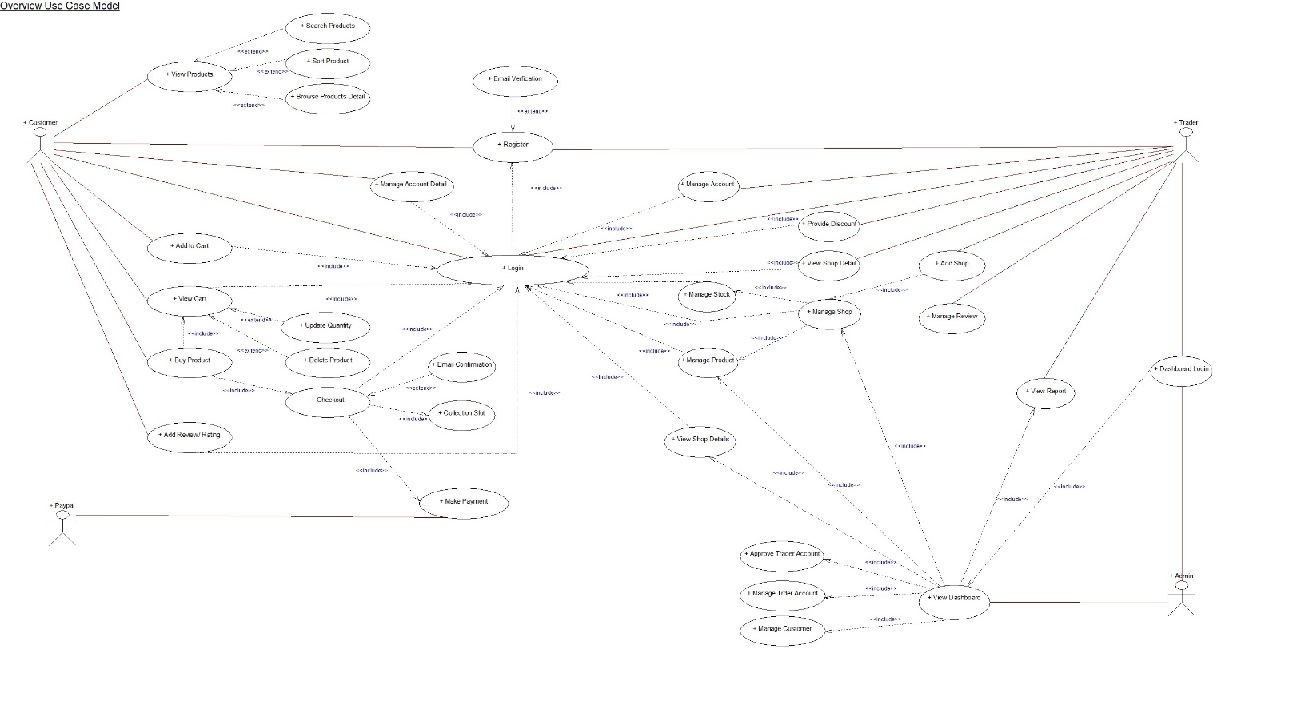

TRADER USE CASE

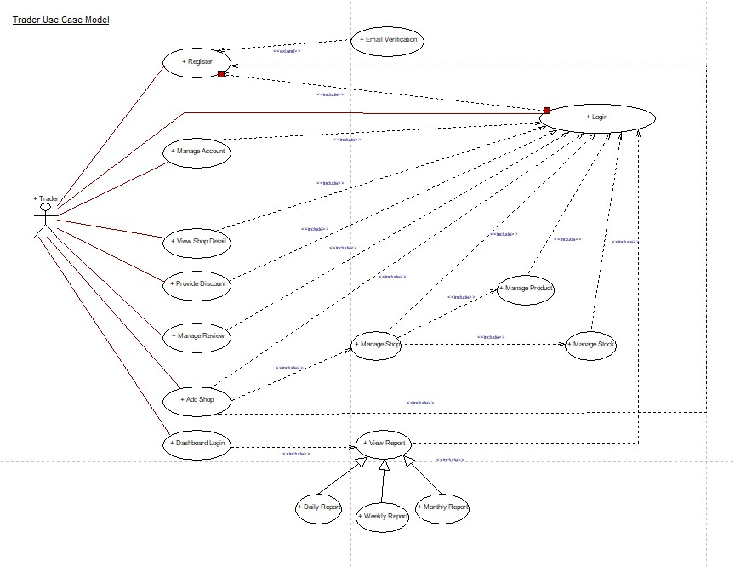

ADMIN USE CASE

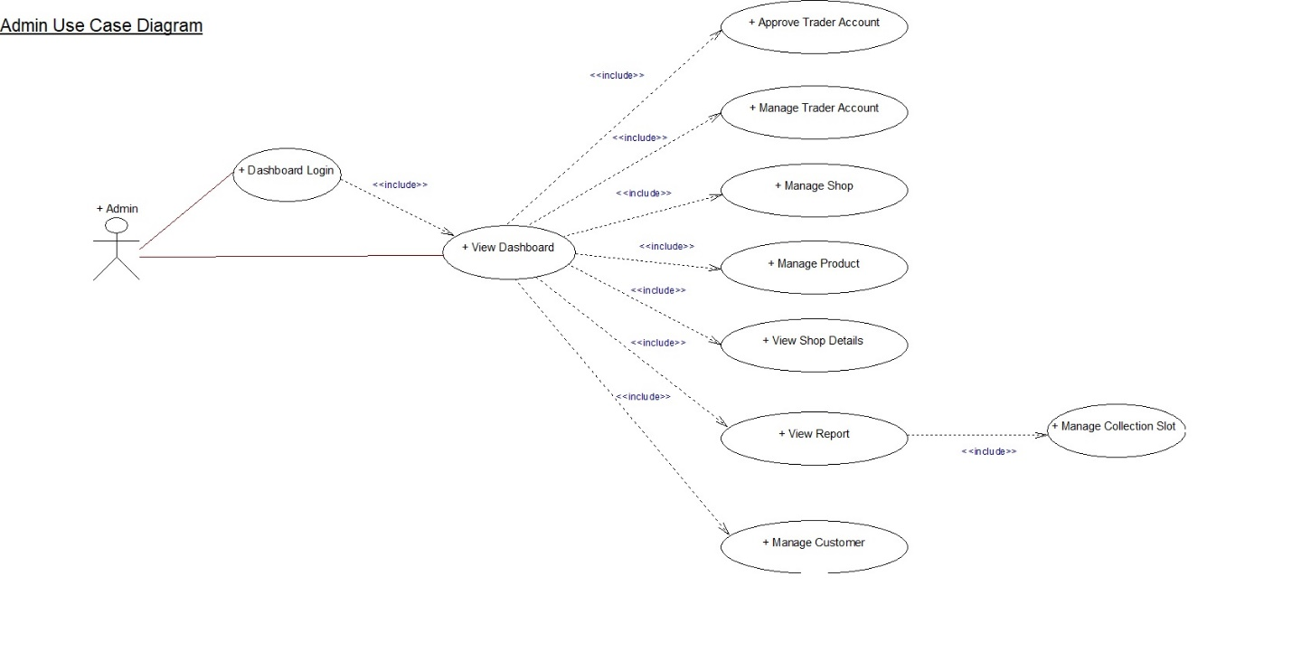

CUSTOMER USE CASE

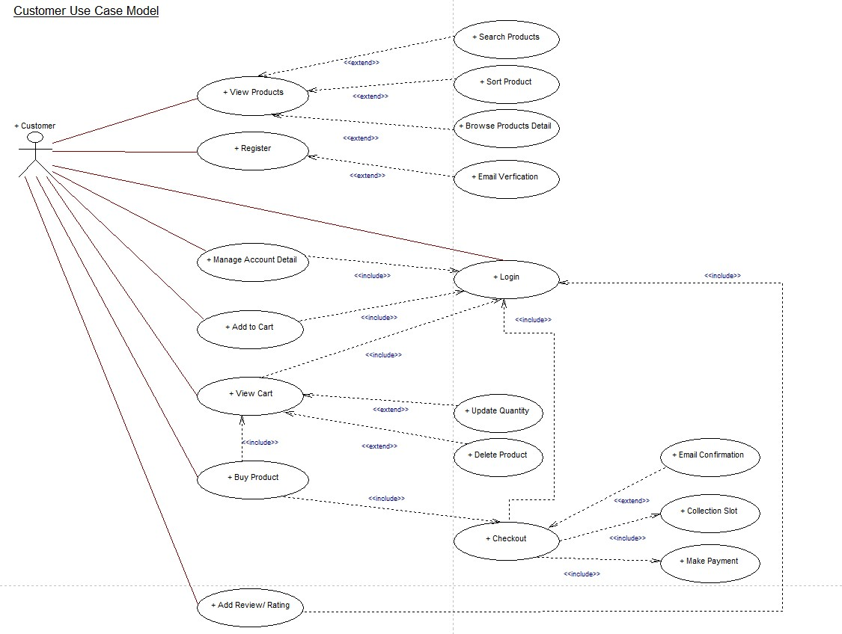

Functional Requirements

**Part A: Product Interface**

|  |  |  |
| --- | --- | --- |
| **Requirement ID** | **Description** | **MoSCoW** |
| **A1** | **An interface to allow customers to view products and buy them.** |  |
| A1 – 1 | All products will be displayed with a short name, a description, price, quantity, stock available, min order, max order, allergy information and will be associated with a trader. | M |
| A1 – 2 | Users will be able to navigate to product by shop or by product type. | M |
| A1 – 3 | Users will be able to search for products by open text search. | S |
| A1 – 4 | Users will be able to sort products appropriately. Example: price, alphabets. | S |
| A1 – 5 | Users will be able to search/sort items based on multiple search criteria. | C |
| **A2** | **The interface will allow customers to select products and add those products to cart for checkout.** |  |
| A2 – 1 | Logged in users will only be able to access the cart. | M |
| A2 – 2 | Registration should be done in order to login and add products to cart. | M |
| A2 – 3 | Users will be provided with a single cart to hold goods that spans all traders. | M |
| A2 – 4 | A single cart will have a single payment. | M |
| A2 – 5 | While placing and paying for an order collection slots should be identified in three slots in three different days i.e. 10-13, 13-16, 16-19 in the days Wednesday, Thursday and Friday. | M |
| A2 – 6 | A cart will contain all the products added by the customer with name, short description, quantity and an image. | S |
| A2 – 7 | A single cart can hold up to 20 products and a single payment is needed. | C |
| **A3** | **The interface to allow CRUD operations of products.** |  |
| A3 - 1 | Traders can add, delete and update products. | M |
| A3 – 2 | Clicking the update will show a form pre-populated with all the details of the products. Submitting the form will update the chosen product and display the updated information of that product. | S |
| A3 – 3 | A form will be provided to add a new product including all details and image. | S |
| A3 – 4 | Clicking the delete will remove the chosen product and update the displayed catalogue of products. | S |
| A3 - 5 | Management can delete the products that have very low sales. | S |

**Part B: Customer Interface**

|  |  |  |
| --- | --- | --- |
| **Requirement ID** | **Description** | **MoSCoW** |
| **B1** | **A facility to allow registered users to login** |  |
| B1 - 1 | A login form to collect username and password will be provided. | M |
| B1 – 2 | Server validation that informs users if they attempt to login using incorrect details. | M |
| B1 – 3 | Login link will be displayed on every pages of the site. | C |
| B1 - 4 | Reset password link will be provided if they forget their password. | C |
| **B2** | **A facility to allow new customers to register their account.** |  |
| B2 - 1 | A registration form that collects first name, last name, user name, password, email, address, age. | M |
| B2 - 2 | A user should be able to validate account through email address. | M |
| B2 - 3 | Customer account must be registered before they can place an order. | M |
| B2 – 4 | Username must be unique to each customer. | M |
| B2 – 5 | Account updates should be confirmed through emails. | M |
| B2 – 6 | Validation of all form fields to ensure none of the field is empty or unchecked. | S |
| B2 – 7 | Password must be encrypted before storing in the database. | C |
| B2 – 8 | The password length must be 8-10 length. | C |
| B2 – 9 | The username must have alphabets only. | C |
| B2 – 10 | The password must have at least one capital letter, a number and a symbol. | C |

**Part C: Trader Interface**

|  |  |  |
| --- | --- | --- |
| **Requirement ID** | **Description** | **MoSCoW** |
| **C1** | **An interface to allow trader to register their account.** |  |
| C1 – 1 | A form that minimally collects user id, user role, status, first name, last name, profile picture, status, dob, email. | M |
| C1 – 2 | Username must be unique to each trader. | M |
| C1 – 3 | Validation of all form fields to ensure none of the field is empty or unchecked. | S |
| C1 – 4 | Password must be encrypted before storing in the database | C |
| **C2** | **An interface to allow registered trader to login.** |  |
| C2 – 1 | A trader login that allows them to access to their details only. | M |
| C2 – 2 | A login form to collect username and password will be provided. | M |
| C2 – 3 | Server validation that informs users if they attempt to log in using incorrect details. | M |
| C2 – 4 | Trader should be able to view and update the details of their trader account. | M |
| C2 – 5 | Trader login will allow them to view reports on orders and stock levels. | M |
| C2 – 6 | Reset password link will be provided if they forget their password. | C |

**Part D: Management Interface**

|  |  |  |
| --- | --- | --- |
| **Requirement ID** | **Description** | **MoSCoW** |
| **D1** | **A facility to allow authenticated admin users to manage the activities presented by the system.** |  |
| D1 – 1 | After logging in the admin will have the access to manage the dashboard. | M |
| D1 – 2 | An interface to view the shop of each trader. | M |
| D1 – 3 | Management can deactivate customers account. | C |
| D1 – 4 | An interface will provide the traders access to range of daily reports of orders placed, weekly report of products sold and monthly report of sales. Monthly report will be able to be sorted alphabetically; total numbers of orders per products or total income per product. | M |
| D1 – 5 | Email confirmation should be sent to trader after signing up. | S |
| D1 – 6 | An interface to view the shop details of each trader. | S |

Non - Functional Requirements

**Part E: Non – functional Requirements**

|  |  |  |
| --- | --- | --- |
| **Requirement ID** | **Description** | **MoSCoW** |
| **E1** | **The website will have the following non-functional requirements.** |  |
| E1 - 1 | HTML/CSS template suited to the requirements. | M |
| E1 – 2 | The site should be viewable on mobile as well as desktop devices and viewable on the most popular browsers. | M |
| E1 – 3 | Apex Oracle used for the back-end. | M |
| E1 – 4 | Site built for maintainability: Files organized and comments added. | S |
| E1 – 5 | Template applied consistently throughout the website. | S |
| E1 - 6 | Implement Google map to locate the shops location. | W |

LOGO DESIGN



WIREFRAMES

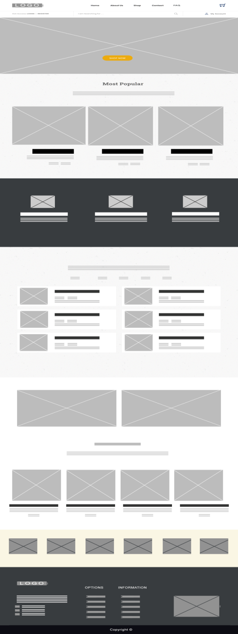Home Page

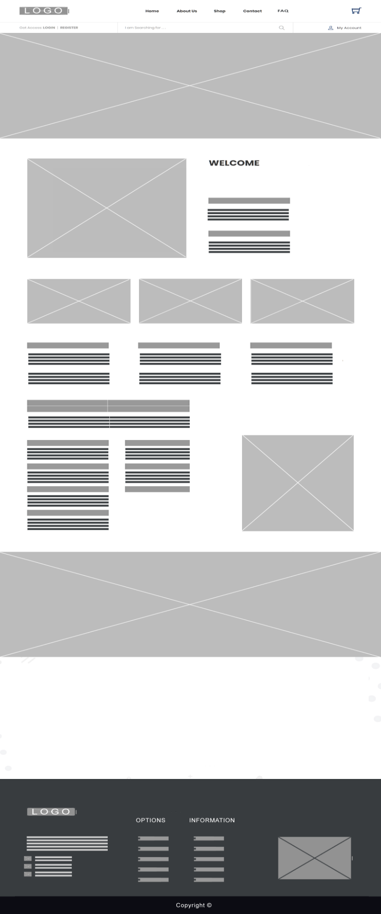About Page

Login

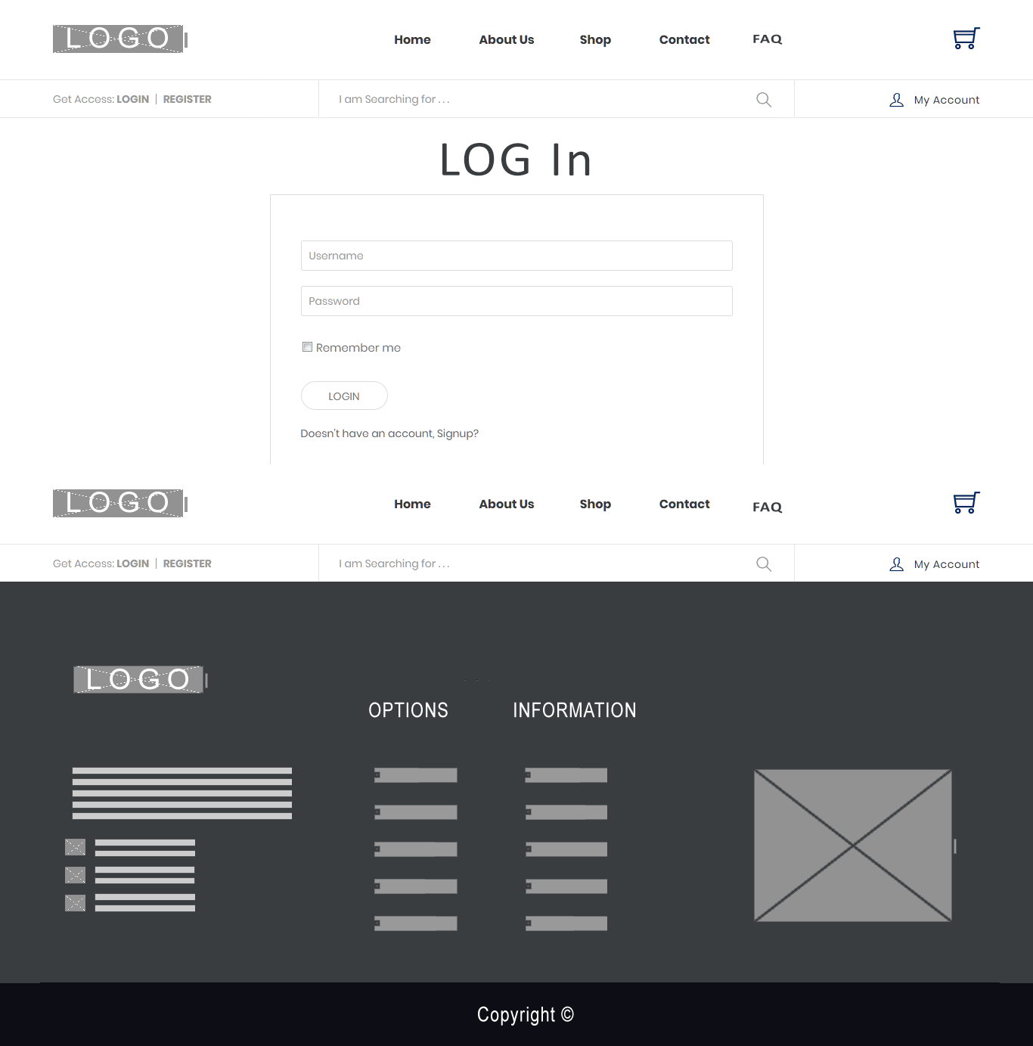

Register

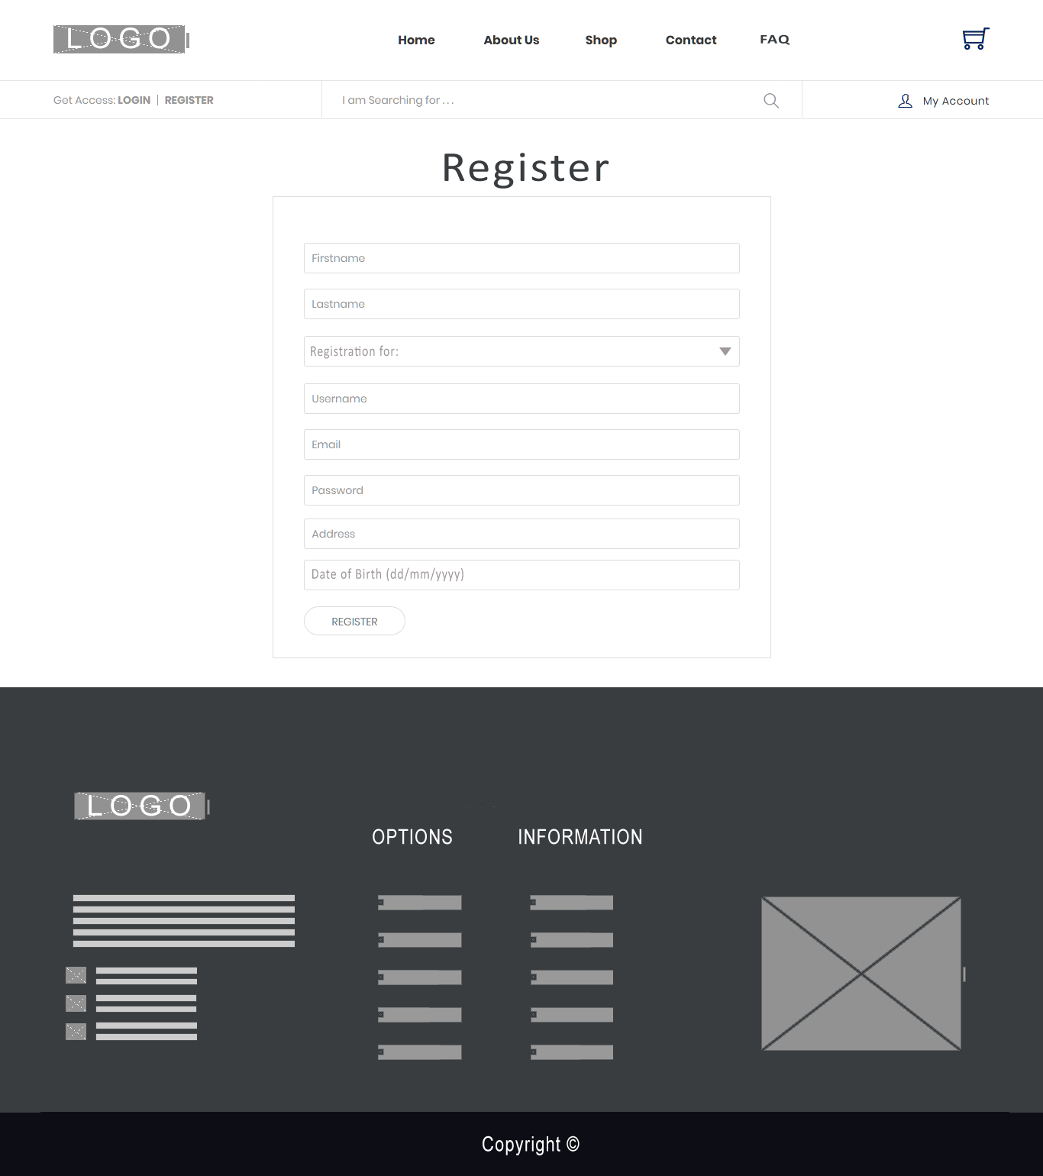

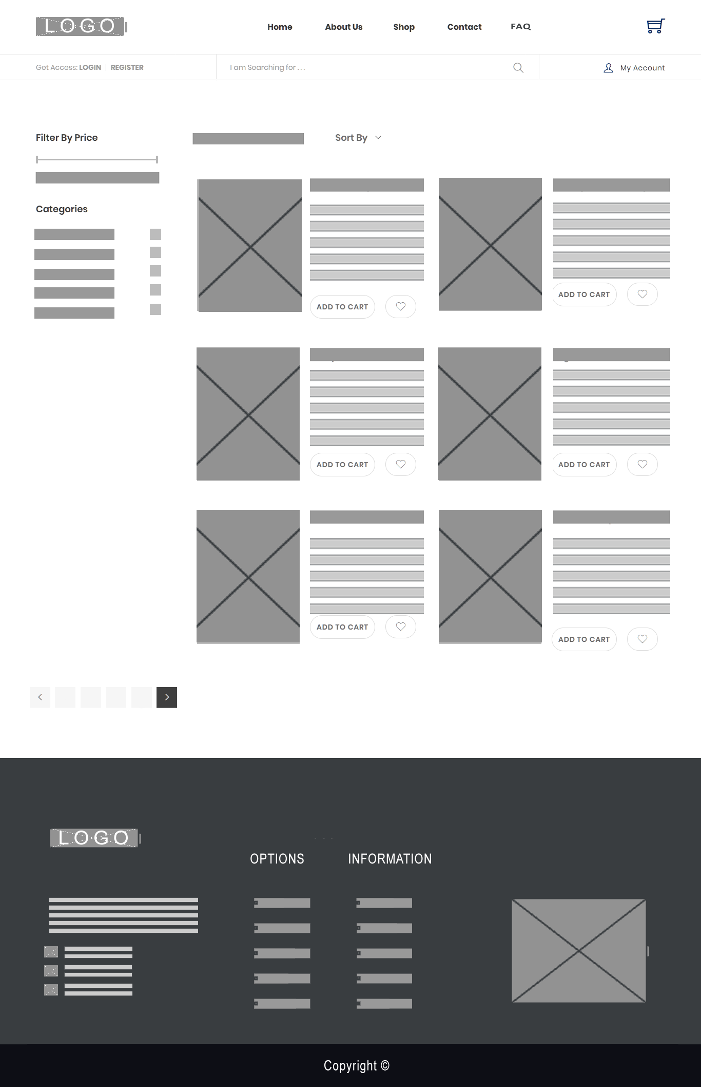Shops

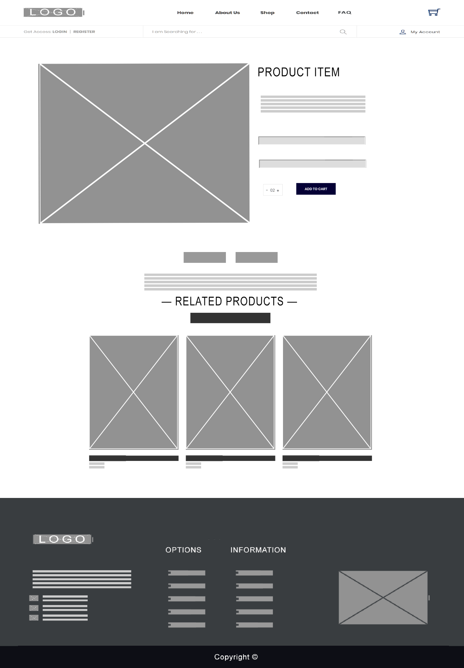Product Detail

Add Review and Rating



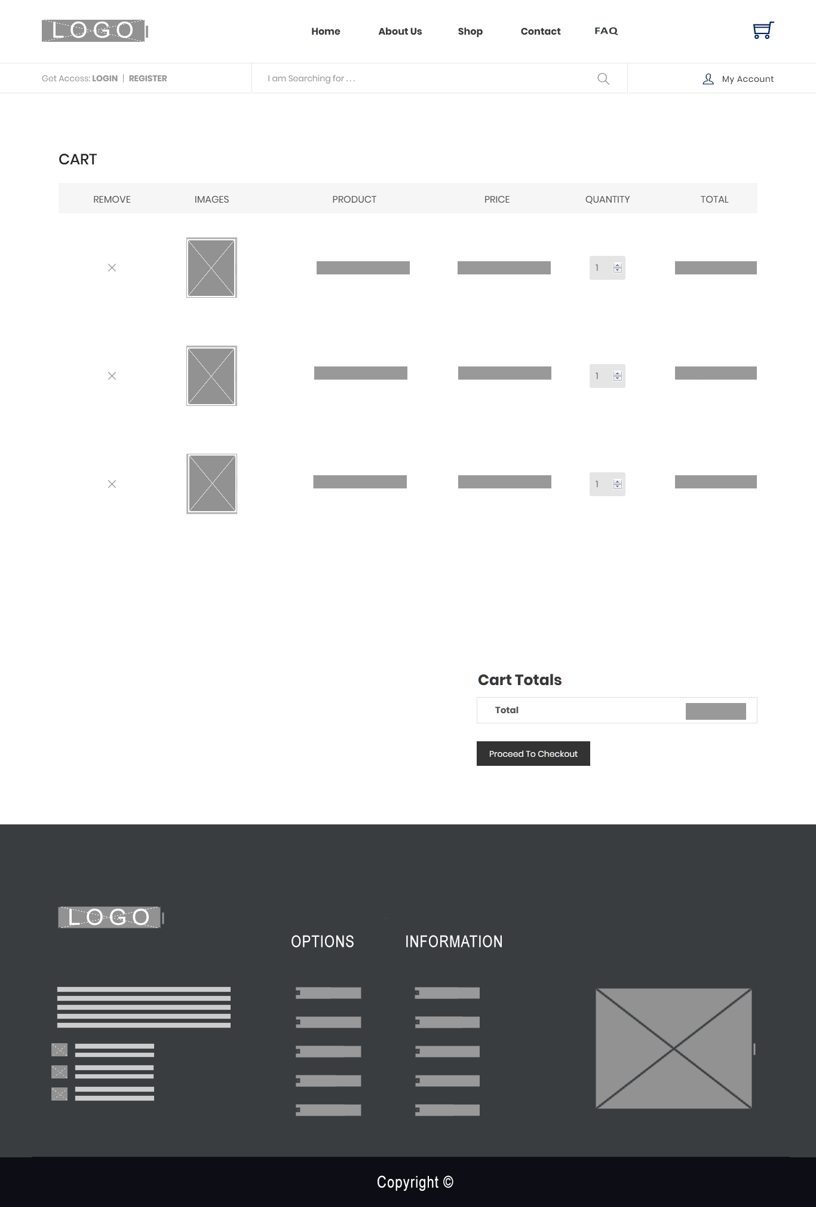Cart

Order

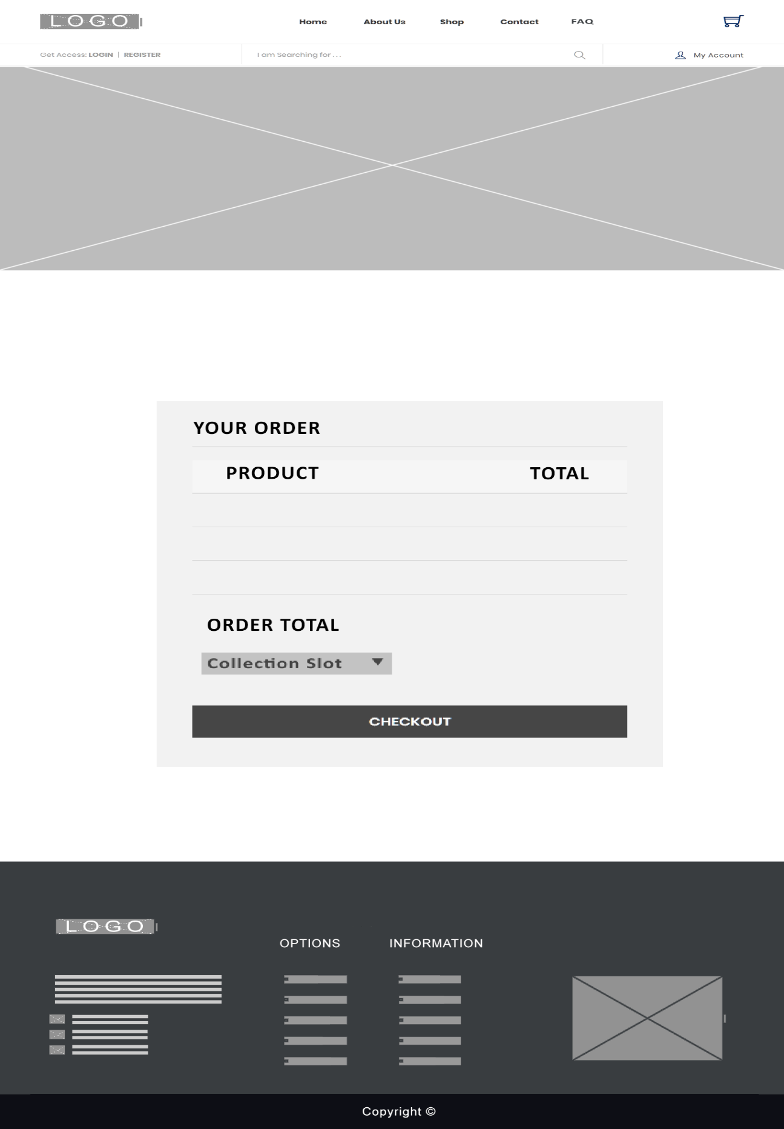

Invoice

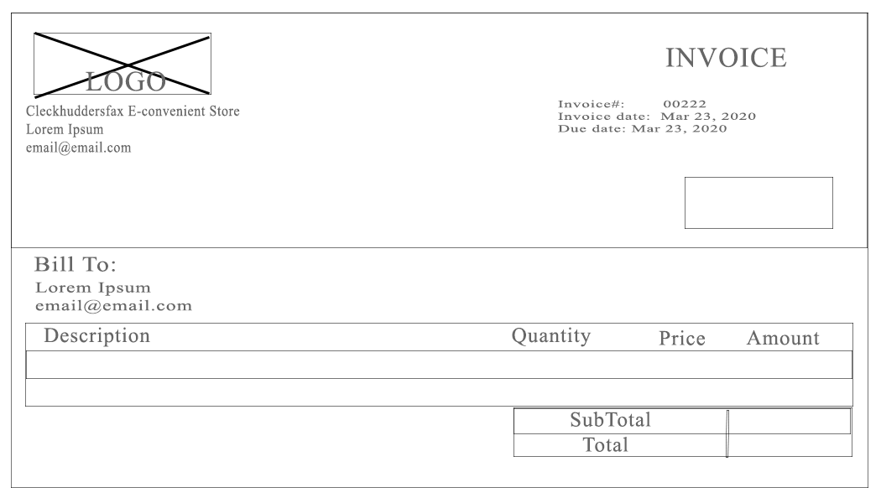

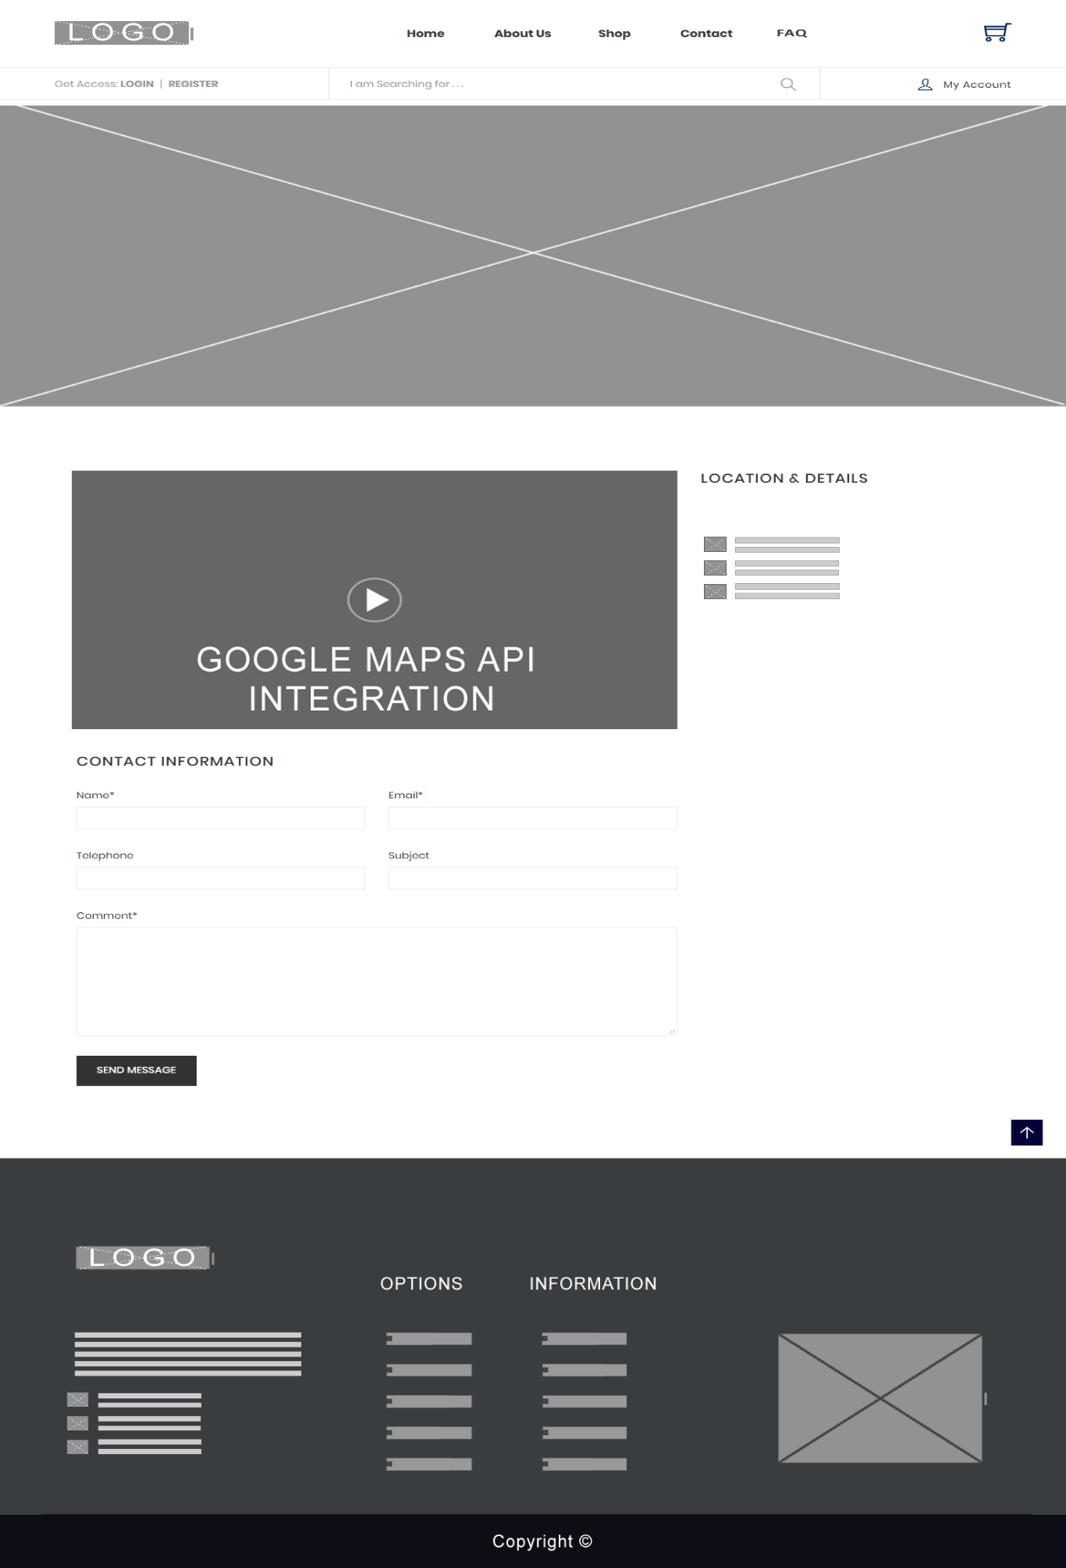Contact

FAQ

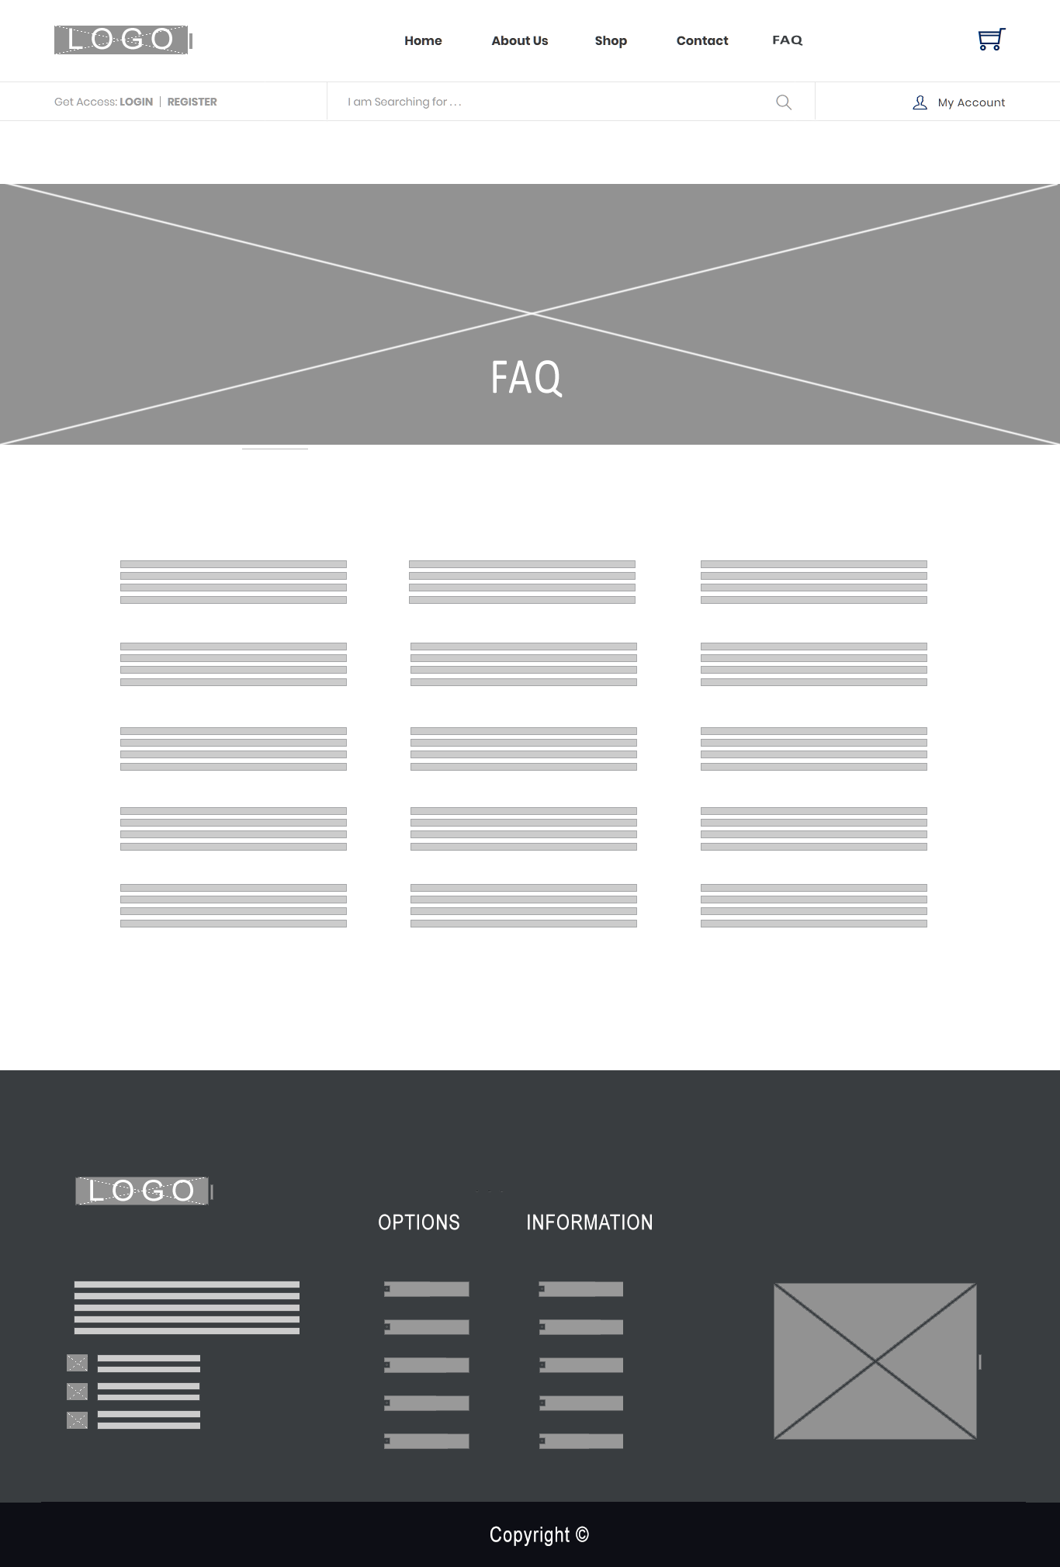

Customer Profile

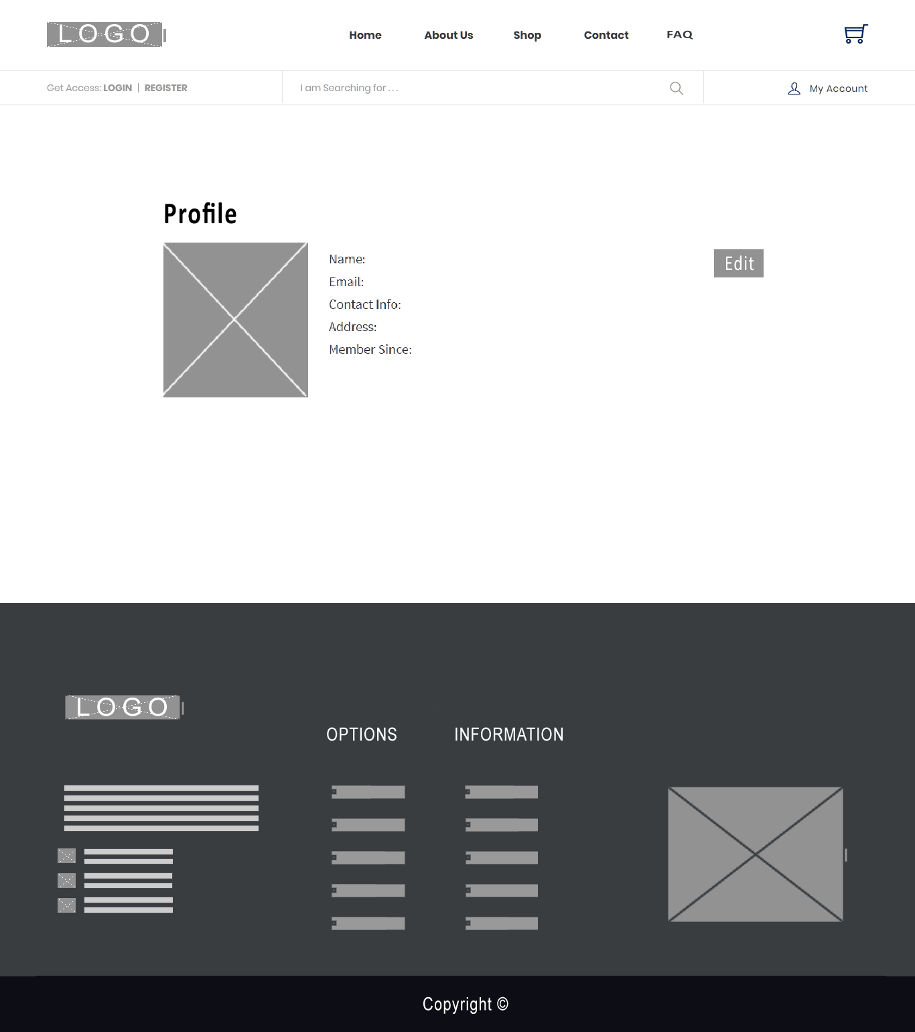

Login Customer Profile Update

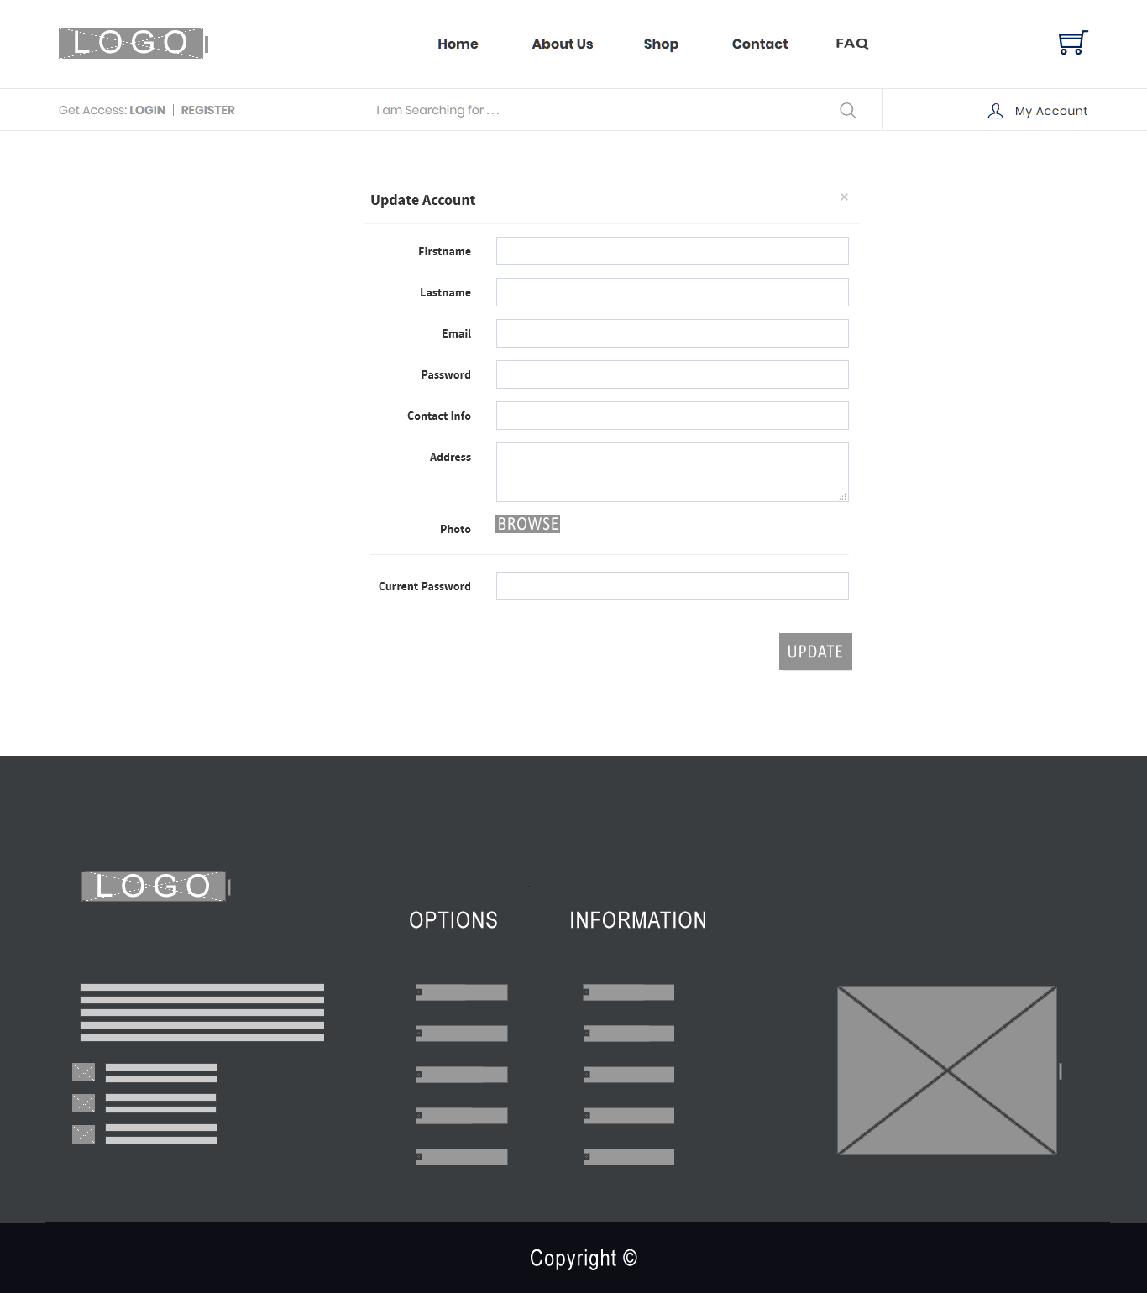

Admin Dashboard

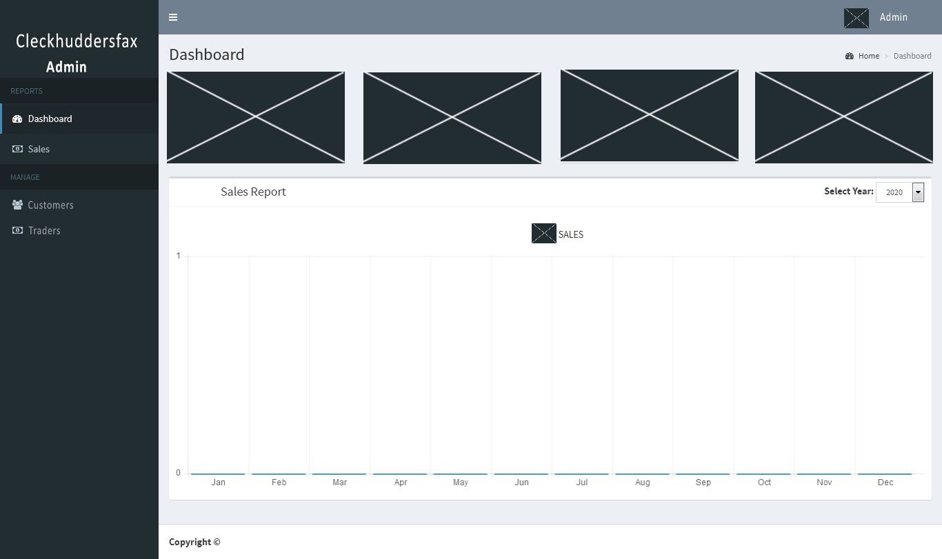

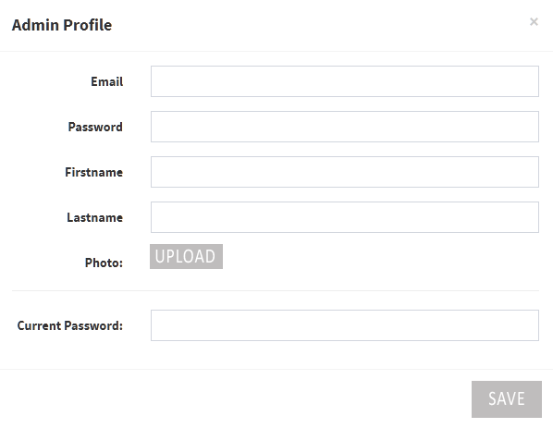Admin Profile

Manage Customers

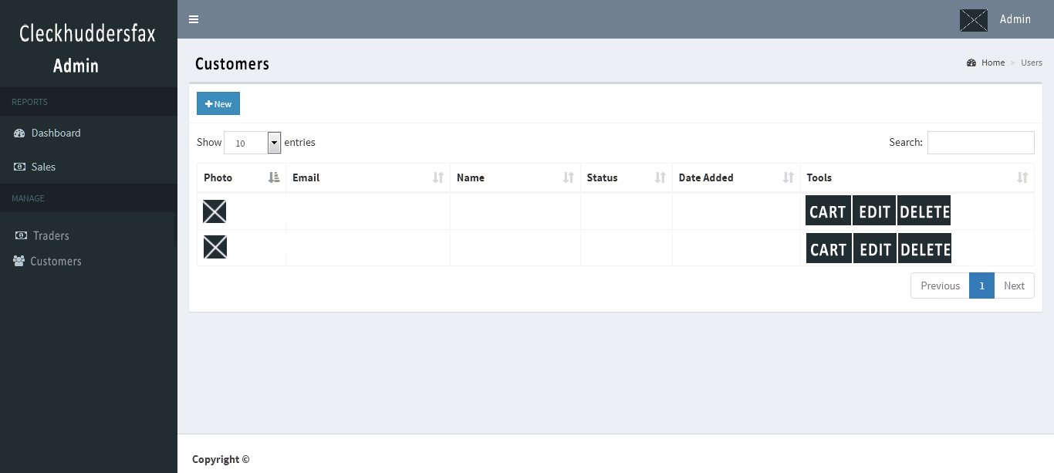

Manage Traders

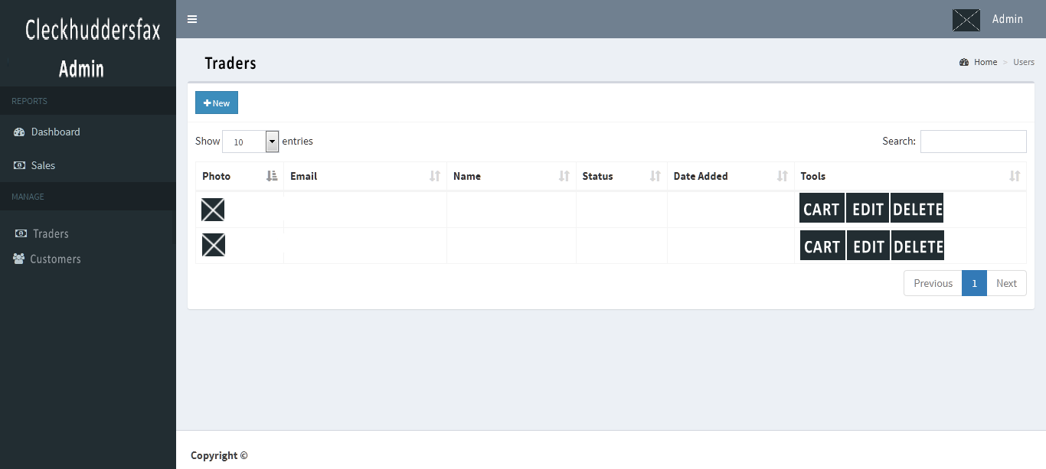

Admin Sales History

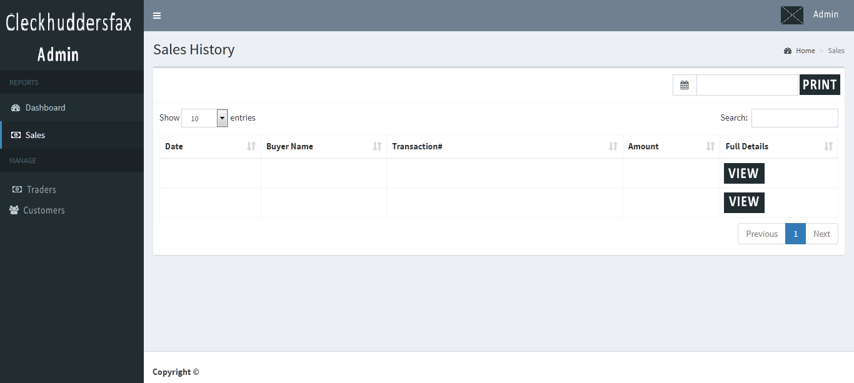

Trader Dashboard

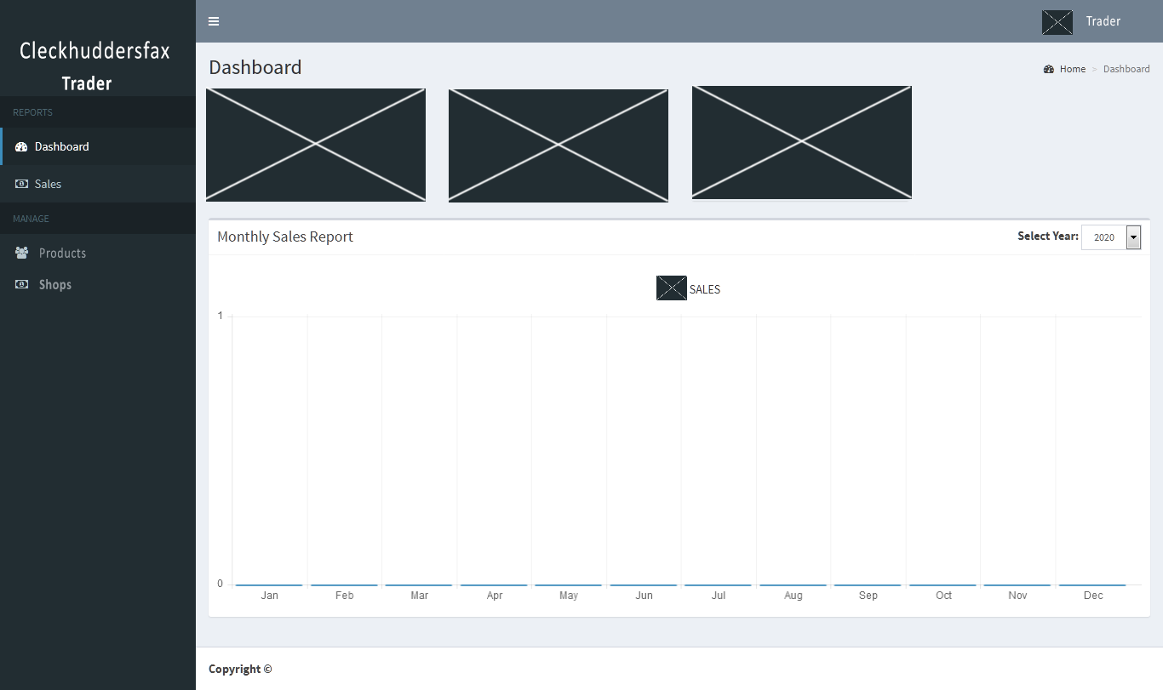

Trader Profile

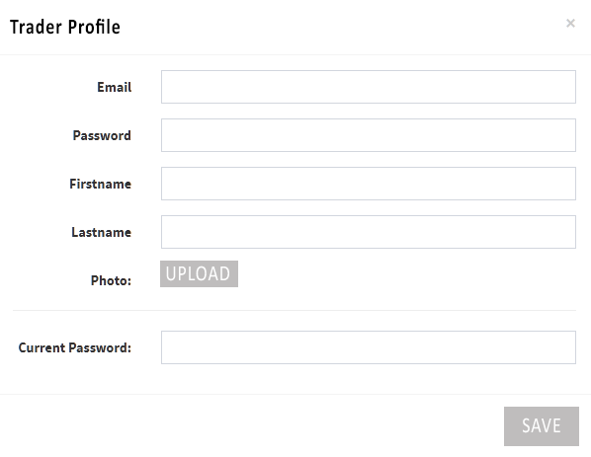

Product CRUD

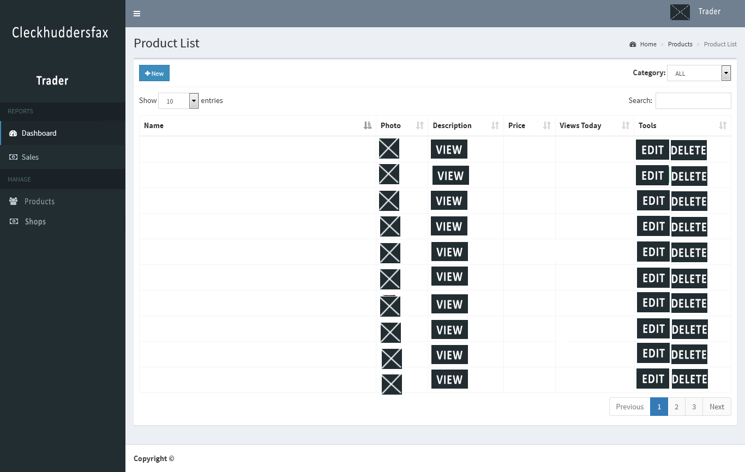

Trader Sales History

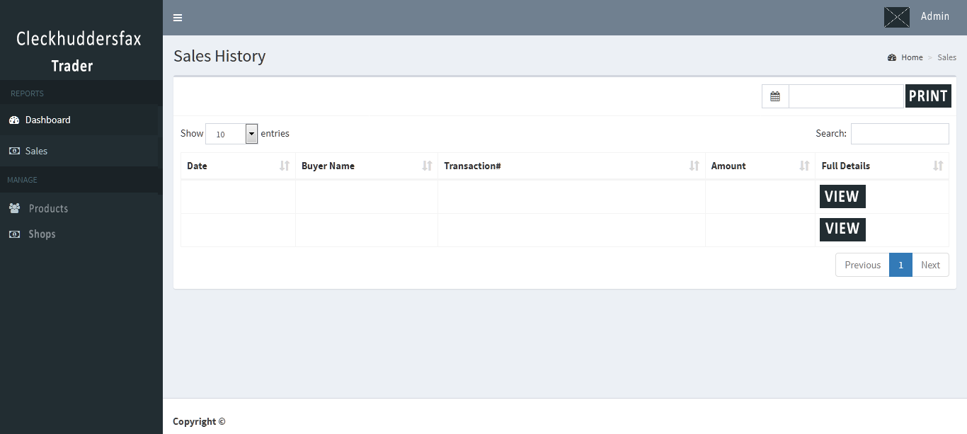

PRODUCTION PROJECT

Login

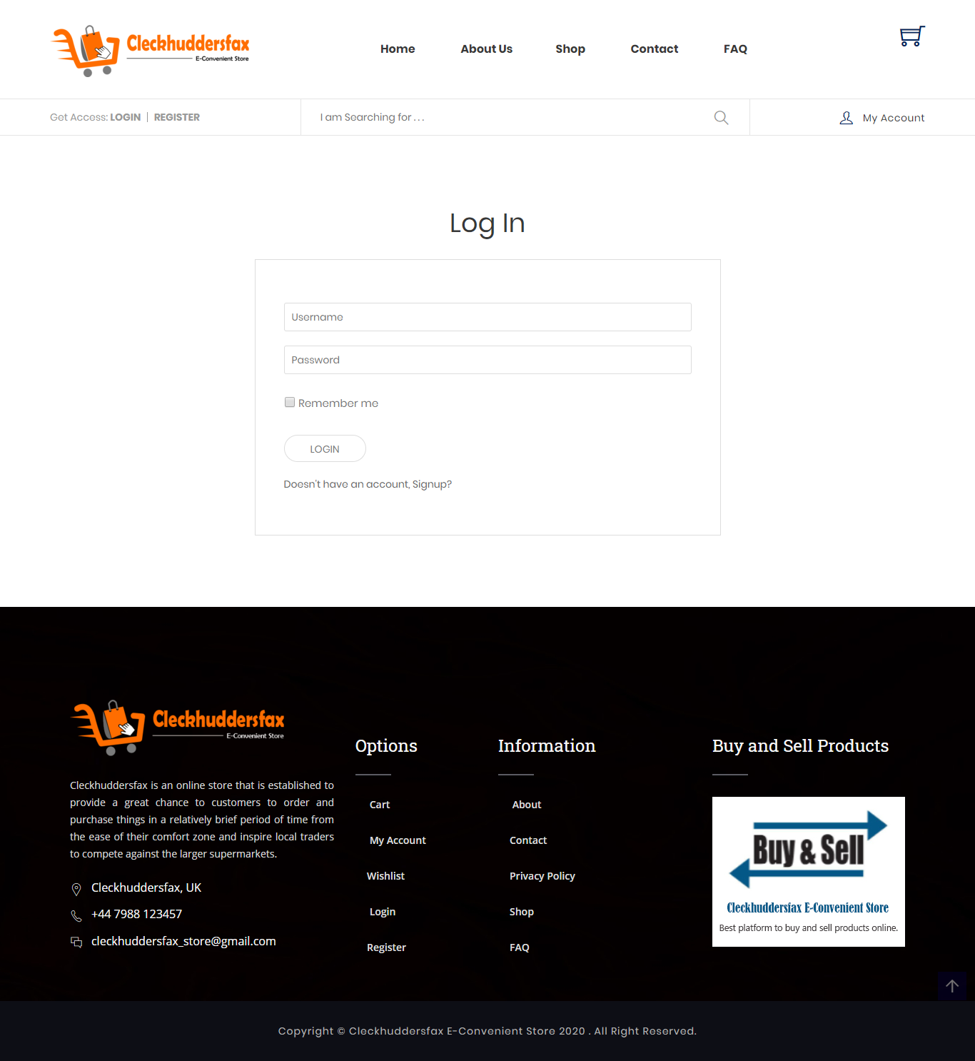

Register

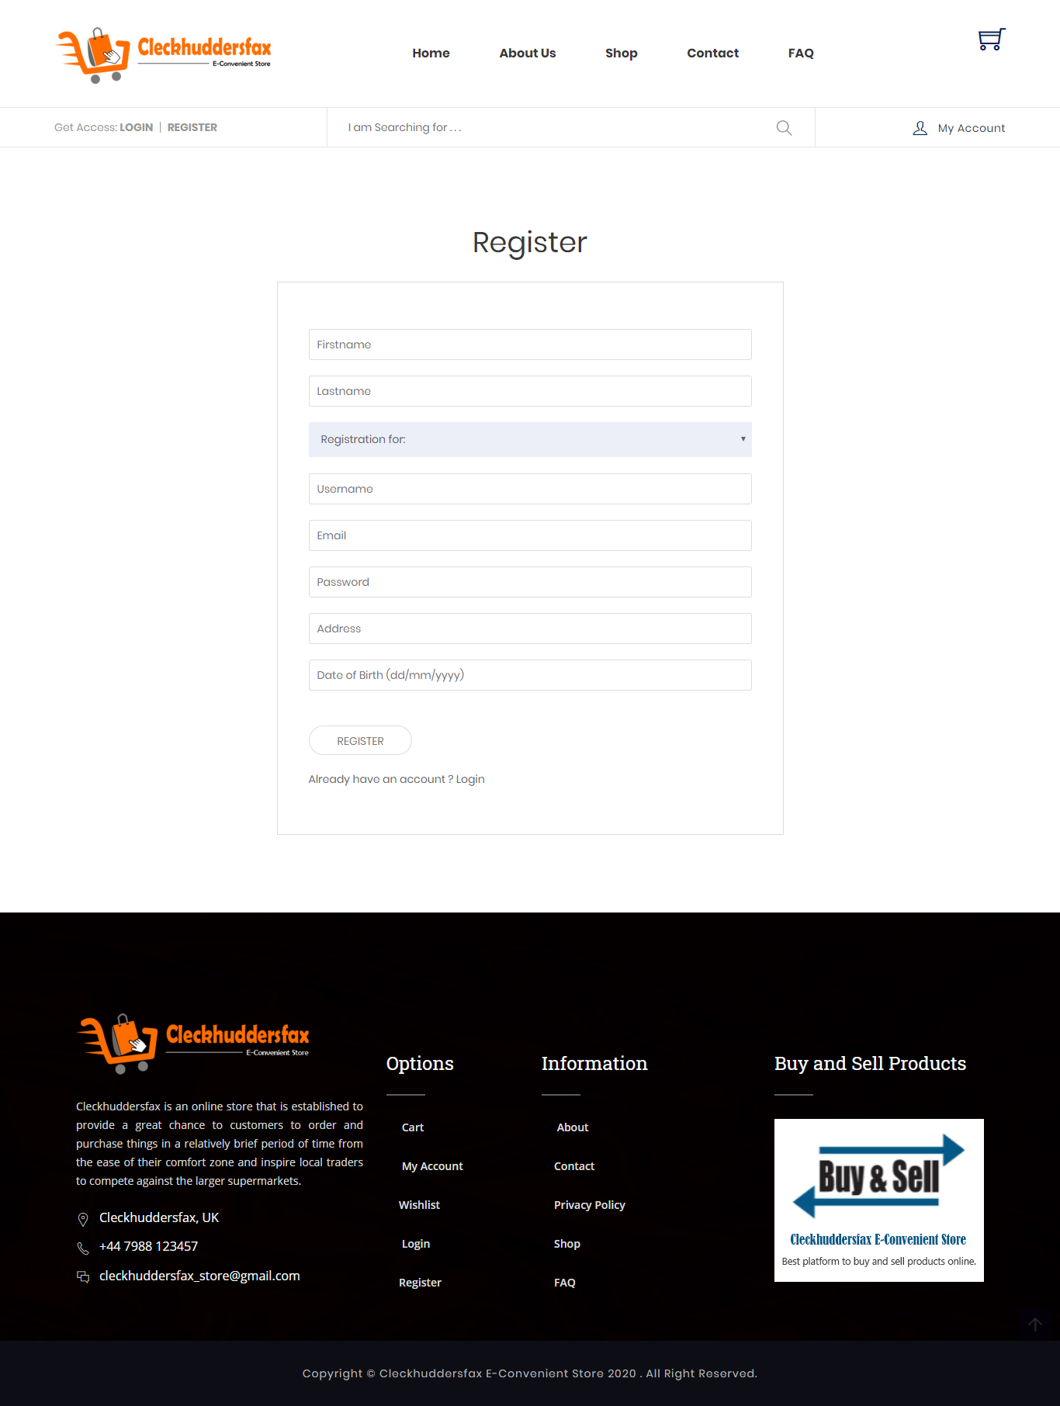

Cart

